Section I: Business Process Threads for Core Business

Aligned to the business scope of the REGULATION (EU) **No 952/2013** OF THE EUROPEAN PARLIAMENT AND OF THE COUNCIL of **9 October 2013** laying down the Union Customs Code (UCC) and its Delegated and Implementing Acts

This page intentionally left blank

Table of Contents

1. General Introduction 7

1.1 Document and WORK overview 7

1.1.1 Background And Objectives 7

1.1.2 General Approach 7

1.1.3 Intended Readership 8

1.2 Definitions 8

1.2.1 Methodology Related Definitions 8

1.2.2 Business Related Definitions 9

1.2.2.1 Organisation 9

1.2.2.2 Locations/Actors 10

1.3 Acronyms 12

1.4 References 14

1.5 Changes in the legislation 14

1.6 Assumptions 15

1.7 Symbolism used in the various models 16

1.8 Specific representations inside a process flow diagram 17

1.8.1 The Components of the process flow 21

1.8.1.1 Pools and Lanes 22

1.8.1.2 Events 22

1.8.1.3 Gateways 23

1.8.1.4 Tasks 24

1.9 Examples of textual description 24

1.9.1 Major Event 24

1.9.2 Process Pure NCTS 24

1.9.3 Result 25

1.10 Traceability between the DIFFERENT MODELS 27

2. “Pure” NCTS 28

2.1 Introduction 28

2.2 Interfaces with other IT systems 29

2.2.1 Risk analysis system 29

2.2.2 EOS Economic Operator Systems 30

2.2.3 UCC Customs Decisions system 30

2.2.4 UCC AES 30

2.2.5 EU Customs Single Window 31

2.3 L4-TRA-01-00-Transit Core Business Master Process 32

2.4 L4-TRA-01-01 Process Departure - Acceptance and Controls 35

2.5 L4-TRA-01-02-Process Departure – Release 49

2.6 L4-TRA-01-03-Process Arrival 57

2.7 L4-TRA-01-04-Process Movement at Customs Office of Transit 74

2.8 Handle enquiry 81

2.8.1 L4-TRA-01-05-Status Request 81

2.8.2 L4-TRA-01-06-Handle Enquiry - Enquiry Procedure (Option A) – 1st step Contacting the Holder of Transit Procedure 84

2.8.3 L4-TRA-01-07-Handle Enquiry - Enquiry Procedure (Option B)- 1st step Contacting Customs Office of Destination 88

2.9 Handle Recovery 94

2.9.1 L4-TRA-01-08-Handle Recovery - Recovery Procedure (Option A) 94

2.9.2 L4-TRA-01-09-Handle Recovery - Recovery Procedure (Option B)– IE143 'Recovery request' or IE150 from any office 100

2.10 L4-TRA-01-10-Process Invalidation/Cancellation 104

2.11 L4-TRA-01-11-Process Query Movement Information 108

2.12 L4-TRA-01-12-Process Incidents En Route 111

2.13 L4-TRA-01-13- Process Formalities Prior To Exit Of Goods At Customs Office Of Exit For Transit 116

2.14 Assist users in their daily work 120

2.14.1 Services 120

2.14.2 Customs’ movements state system 120

2.14.2.1 Forecast events system 125

2.14.2.2 Customs’ declarations state system 125

2.14.2.3 Trader’s declarations state system 126

2.14.2.4 Listing system 127

2.14.2.5 Enquiry state system 128

2.14.2.6 Recovery state system 128

Table of Figures

Figure 1: Example of a Process Flow Diagram 17

Figure 2: Example of Pools and Lanes 22

Figure 3: Example of a Start Event 23

Figure 4: Example of an Intermediate Event 23

Figure 5: Example of an End Event 23

Figure 6: Example of Gateway 24

Figure 7: Traceability between models 27

Figure 8: Overview of Transit Core Business (Part A) 32

Figure 9: Overview of Transit Core Business (Part B) 33

Figure 10: L4-TRA-01-01 Process Departure - Acceptance and Controls (Part A) 35

Figure 11: L4-TRA-01-01 Process Departure - Acceptance and Controls (Part B) 36

Figure 12: L4-TRA-01-02-Process Departure – Release (Part A) 49

Figure 13: L4-TRA-01-02-Process Departure – Release (Part B) 50

Figure 14: L4-TRA-01-03-Process Arrival (Part A) 57

Figure 15: L4-TRA-01-03-Process Arrival (Part B) 58

Figure 16: L4-TRA-01-03-Process Arrival (Part C) 59

Figure 17: L4-TRA-01-04-Process Movement at Customs Office of Transit Major Event 74

Figure 18: L4-TRA-01-05-Status Request Event 81

Figure 19: L4-TRA-01-06-Handle Enquiry - Enquiry Procedure (Option A) 84

Figure 20: L4-TRA-01-07-Handle Enquiry - Enquiry Procedure (Option B) Part A 88

Figure 21: L4-TRA-01-07-Handle Enquiry - Enquiry Procedure (Option B) Part B 89

Figure 22: L4-TRA-01-08-Handle Recovery - Recovery Procedure (Option A) Part A 94

Figure 23: L4-TRA-01-08-Handle Recovery - Recovery Procedure (Option A) Part B 95

Figure 24: L4-TRA-01-09-Handle Recovery - Recovery Procedure (Option B) 100

Figure 25: L4-TRA-01-10-Process Invalidation/Cancellation 104

Figure 26: L4-TRA-01-11-Process Query Movement Information 108

Figure 27: Process Incidents En Route (Part A) 111

Figure 28: Process Incidents En Route (Part B) 112

Figure 29: Process Formalities Prior To Exit Of Goods At Customs Office Of Exit For Transit (Part A) 116

Figure 30: Process Formalities Prior To Exit Of Goods At Customs Office Of Exit For Transit (Part B) 117

# 11General Introduction

## Document and WORK overview

### Background And Objectives

The main goal of this “Functional Transit System Specification” (FTSS) is to provide – next to the Functional Requirements Report – a document that the intended readership already familiar with. This document aims to identify the scope of the New Computerised Transit System (NCTS) and to provide detailed description of its functional specification. It is also intended to serve as a stable baseline for the NCTS detailed technical specification (see ‘Technical Transit System Specification’ [TSS-TSP-SYS]) DDNTA.

This document has been built on the "Functional Requirements Report (FRR). The FTSS document doesn't supersede the FRR which presents the detailed functional specification of the NCTS in its final situation (i.e. all Customs Offices working within the NCTS).

The FTSS document has been developed with a very structured and well proven methodology that supports the specification of NCTS from the perspective of analysing changes in the business process and data domains.

Following the adoption of the Union Customs Code Delegated (No 2015/2446) and Implementing Acts (No 2015/2447) there was a clear need for an update of the NCTS. The update requires changes both on Business Processes and Information Exchanges (IEs). The present document is aligned to these new UCC requirements. This document covers also the scope of the system for NCTS as identified by the MASP (Multi Annual Strategic Plan).

In the Business process domain, process flow diagrams and business process models (BPM) description are the models or work products that will be used to support the understanding and description of the business activities.

The State Transition Diagrams (STD), structure of the information to be exchanged and business rules lists will be the models to cover the Data domain.

All these models are presented in the “Definitions” and “Symbolism used in the various models” parts of this document.

System documentation to be read before or in parallel to this one includes:

1. “Functional Requirements Report and its annexes defining the functional system specifications

### General Approach

The detailed functional specification of the pure NCTS has been realised by further detailing business areas, process threads and process steps previously identified in the FSD document.

The business areas and process threads are those described in the FSD document, while the process steps have been decomposed into elementary business processes in order to guarantee that they can be performed by one person, at one location and one time.

The full business process documentation of this document will contain for each process thread within business areas (Transit Core Business, Transit Guarantee Processing Management, Transit Guarantee Validation Management), a diagram showing the main process flow, completed by textual description of the process flow components: events launching or triggering the process thread, elementary business processes and their results. The textual description will include reference to the organisation(s) responsible to perform the processes and to the location(s) where they are performed. The diagrams only show the location(s).

This documentation will also be enriched by indicating the reference to information to be exchanged between processes, when these exchanges involve processes performed at different locations.

The structure of the information to be exchanged will be fully supported by the data definition of the logical data model. This document identifies all processes involved in the scope of the full NCTS.

This document contains several sections and appendices.

SECTION I: BUSINESS PROCESS THREADS FOR CORE BUSINESS

* Chapter 1 - General Introduction: In the subsections of this chapter following areas are presented:
  + Document and work overview, along with a detailed list of abbreviations, references, locations, legislation changes.
  + Definitions of symbols used in the various models.
  + Textual description of the ARIS modes.
* Chapter 2 - Pure NCTS: In the subsection of this chapter following areas are presented:
  + Description of NCTS process threads.
  + Definition of basic terms
  + All core processes diagrams description.

SECTION II: BUSINESS PROCESS THREADS FOR GUARANTEE MANAGEMENT

* Detailed description of Guarantee Management Subsystem is included in respective document.

### Intended Readership

The intended readership for this document includes:

1. any person responsible for the functional and technical specification or implementation of the NCTS;
2. any person responsible for the definition of tests for the NCTS;
3. any other authorised body concerned with the NCTS including: EC/EFTA Joint Committee on Common Transit, the Steering Committee, Traders Associations.

## Definitions

### Methodology Related Definitions

Many definitions related to methodology, especially in the domain of Business process, are already provided in the referenced documents.

The table below lists additional definitions for terms related to the models of this document and for which the symbolism is explained in “1.8-Specific representations inside a process flow diagram”.

| Name | Description |
| --- | --- |
| Attribute | An attribute is a data element in which information is to be exchanged (IE). |
| Data group | A Data group is a set of data containing one or more attributes. |
| Event | An event is an occurrence that triggers the Business to respond to a predictable fashion. It may occur outside, but is important to the business process. The two categories of events are internal event (event that occurs within a process thread. It may result from the completion of another process, the meeting of a certain condition, or the arrival of a particular point in time) or external event (event that occurs outside the process thread). |
| Location | A location is the place where the business is performed. |
| Organisation | An organisation is a number of individuals acting in concerned way towards a common business purpose with allocated roles and responsibilities. |
| Result | A result is an outcome of the business response to an event. A result can be an external result (result that goes beyond the business area to affect its environment) and internal result (result that goes outside the process thread but will stay in the business area). A result can be major, if it is main response of a process thread to an event, or minor if it occurs in addition to the major result. |

### Business Related Definitions

Definitions of Organisation and Location have special importance in the way business activities in the process flow diagram and description are documented. Therefore, in the forthcoming chapters additional information on these areas along with an exhaustive list of Organisations and locations are provided.

#### Organisation

As stated in the table of definitions, an Organisation is a number of individuals acting in a concerned way towards a common purpose with allocated roles and responsibilities.

Within NCTS, Internal Organisations – partial responsible of System’s performance and External Organisations that provide information to NCTS are identified. In the following table, detailed description of all involved Organisations along with respective “End Users” is provided.

The table below gives the list of the organisations involved in the NCTS, completed with the list of Users, who belong to the organisations:

| Organisation | Internal/ External | Description | End Users |
| --- | --- | --- | --- |
| National Customs Administration | Internal | National Customs Administration of a country participating in the NCTS project. | 1. Customs Officers; 2. Data Manager for the National Domain; 3. System Administrator for National Domain. |
| DG TAXUD | Internal | Organisation responsible for the Transit Computerisation Project. | 1. System Business Owner 2. System Administrator for Common Domain. |
| Trader | External | Generic term for the Economic Operators who interact with the Transit procedures. | 1. Holder of Transit Procedure; 2. Authorised Consignor 3. Authorised Consignee |
| Guarantor | External | The financial organisation, for example a bank, which provides surety for a guarantee. | 1. Guarantor |

#### Locations/Actors

In previous chapter, it was mentioned that Location is the place where business is performed. Nonetheless, this definition should not be interpreted as the geographic term but as the place where various processes for a specific Transit Operation or maintenance of reference data are performed. Detailed list is described in below table.

|  |  |
| --- | --- |
| AES | The Automated Export System |
| Actual Customs Office Of Destination | The Customs Office where goods placed under the Transit procedure have been presented in order to complete the Transit Operation |
| Actual Customs Office Of Exit For Transit | The Customs Office competent for the place from where the goods leave the customs territory of the Union for a destination outside that territory. |
| Any Customs Office | Any Customs Office of Departure, Customs Office of Destination, Customs Office of Transit, Customs Office of Guarantee. |
| Competent Authority Of Enquiry At Departure | Customs Office responsible for the enquiry procedure at Departure. |
| Competent Authority Of Enquiry At Destination | Customs Office responsible for the enquiry procedure at Destination |
| Competent Authority Of Recovery At Departure | The Customs Authority responsible for recovery procedure at departure. |
| Competent Authority Of Recovery In Any Country | The Customs Authority responsible for recovery at any country other than the country at departure. |
| Customs Authority | Customs Office responsible for executing each particular process depending on the status of the movement. |
| Customs Office Of Departure | The Customs Office where the customs declaration placing goods under a transit procedure is accepted. |
| Customs Office Of Destination | The Customs Office where goods placed under the Transit procedure would have been presented to complete the Transit operation |
| Customs Office Of Guarantee | The Office where comprehensive guarantees data, flat-rate guarantees and associated NCTS vouchers data and guarantee waiver data are recorded. |
| Customs Office Of Guarantee | The Customs Office where a guarantee, other than an individual guarantee in the form of a cash deposit or vouchers, is lodged. |
| Customs Office Of Transit | (a) The Customs Office competent for the point of exit from the customs territory of the Union when the consignment is leaving that territory in the course of a transit operation via a frontier with a territory outside the customs territory of the Union other than a common transit country, or  (b) The Customs Office competent for the point of entry into the customs territory of the Union when the goods have crossed a territory outside the customs territory of the Union in the course of a transit operation. |
| Customs Office Requesting Competency For Recovery | Any Customs Office requesting to be competent for recovery |
| Customs Office of Exit for Transit | Customs Office responsible for the Exit for Transit procedure in the context of safety and security. Under this procedure the following tasks can be performed: 'request risk analysis', 'record risk analysis results', 'record control decision', 'record control results' and 'release goods'. |
| Customs Office of Incident Registration | The Customs Office of Incident Registration is the nearest customs authority of the Member State in whose territory the means of transport is located. |
| Customs Officer | The Customs Officer interacting with the system. |
| Customs Officer At Premises Of The Trader At Departure | Customs Officer at the Office of the Trade where a Transit Movement is initiated. |
| Declared Customs Office Of Destination | The Customs Office where goods placed under the Transit procedure would have been presented to complete the Transit operation, as planned in the declaration. Actual and declared Office of Destination are the same except in case of diversion. So, when diversion is not in the scope of the process thread they can be simply called ‘Office of Destination’ |
| Declared Customs Office Of Exit For Transit |  |
| Declared Customs Office Of Transit | The Customs Office, as it is declared, at the point of entry into a Contracting Party other than the Contracting Party of departure,  AND/OR  The Customs Office, as it is declared, at the point of exit from a Contracting Party when the consignment is leaving the customs territory of that Contracting Party in the course of a Transit operation via a frontier between a Contracting Party and a third country. |
| Guarantor | The financial organisation, for example a bank, which provides surety for a guarantee. |
| Holder Of The Transit Procedure | The person who lodges the Transit declaration, or on whose behalf that declaration is lodged or the person to whom the rights and obligations in respect of a customs procedure have been transferred. |
| Involved Customs Offices | Customs Office(s) that has (ve) received an IE001, IE003, IE050 or IE115, related to the movement. |
| NCTS | The New Computerised Transit System. |
| Premises Of The Trader In His Country | Premises of the Trader in the country where the Trader is established. |
| Premises Of The Guarantor | Office of person or financial organisation which provides surety for a guarantee. |
| Premises Of The Trader At Departure | Office of the Trader where a Transit Movement is Initiated. |
| Premises Of The Trader At Destination | Office of the Trader where the Transit consignment is received and where the Transit Movement ended. |
| Querying Authority | Authority for guarantee simplification, Customs Office of Guarantee, Customs Office of departure, or Customs Office of Recovery. |

## Acronyms

The following acronyms are used in this document.

| **Acronym** | **Description** |
| --- | --- |
| AAR | Anticipated Arrival Record |
| AEO | Authorised Economic Operator |
| AES | Automated Export System |
| ARIS | ARIS Architect – Modelling Tool |
| ATR | Anticipated Transit Record |
| BPM | Business Process Modelling |
| BPMN | Business Process Modelling Notation |
| COL | Customs Office List |
| CTC | Common Transit Countries |
| DA | Delegated Acts |
| DDNTA | Design Document for National Transit Application |
| DG TAXUD | Directorate General for Taxation and Customs Union |
| DTI | Direct Trader Input |
| EC | European Commission |
| EDI | Electronic Data Interchange |
| EEC | European Economic Community |
| EFTA | European Free Trade Association |
| ENS | Entry Summary Declaration |
| EORI | Economic Operators Registration and Identification |
| EOS | Economic Operator Systems |
| EU | European Union |
| EXS | Exit Summary Declaration |
| FRR | Functional Requirements Report |
| FSD | Functional Scope Document |
| FSS | Functional System Specifications |
| FTSS | Functional Transit System Specification |
| GRN | Guarantee Reference Number |
| IA | Implementing Acts |
| ID | Identifier |
| IE | Information Exchange |
| ISO | International Organisation for Standardisation |
| IT | Information Technology |
| L4 | Level 4: Functional Requirements BPM (BPMN) and Information Exchanges (MAD) |
| LRN | Local Reference Number |
| MASP | Multi Annual Strategic Plan |
| MRN | Master Reference Number |
| MS | Member State(s) |
| NACK | Non-Acknowledgement |
| NCF | Notification Crossing Frontier |
| NCTS | New Computerised Transit System |
| N/A | Not Applicable |
| Ref | Reference |
| SAD | Single Administrative Document |
| STD | State Transition Diagrams |
| TAD | Transit Accompanying Document |
| TCUIN | Third Country Unique Identification Number |
| TIN | Trader Identification Number |
| TIR | Transports Internationaux Routiers |
| TSAD | Transit Security Accompanying Document |
| UCC | Union Customs Code |
| UNECE | United Nations Economic Commission for Europe |

## References

|  |  |  |  |
| --- | --- | --- | --- |
| Reference | Title | Version | Date |
| Transit Manual | The Transit Manual | TAXUD/A2/TRA/003/2016- | 27.04.2016 |
| Convention | DECISION No 2/2007 OF THE EC-EFTA JOINT COMMITTEE ON COMMON TRANSIT  of […]  amending the Convention of 20 May 1987 on a common transit procedure | TAXUD/1642/2006 EN - final | 16 April 2007 |
| http://ec.europa.eu/taxation_customs/dds2/col/col_home.jsp?Lang=en | List of authorised Customs Offices for Community/common Transit operations, original source of the current "Customs Office List" published on the TAXUD website on EUROPA |  | 2017 |
| Functional Requirements Report | Functional Requirements Report and its annexes defining the functional system specifications |  | 2017 |
| UCC | [Union Customs Code](http://eur-lex.europa.eu/legal-content/EN/TXT/PDF/?uri=CELEX:32013R0952&rid=1) which was adopted on 9 October 2013 as Regulation (EU) No 952/2013 of the European Parliament and of the Council |  | 9/10/2013 |
| UCC/DA | [UCC Delegated Act](http://eur-lex.europa.eu/legal-content/EN/TXT/?uri=uriserv:OJ.L_.2015.343.01.0001.01.ENG&toc=OJ:L:2015:343:TOC) was adopted on 28 July 2015 as [Commission Delegated Regulation No 2015/2446](http://eur-lex.europa.eu/legal-content/EN/TXT/?uri=uriserv:OJ.L_.2015.343.01.0001.01.ENG&toc=OJ:L:2015:343:TOC) |  | 28/7/2015 |
| UCC/IA | The [UCC Implementing Act](http://eur-lex.europa.eu/legal-content/EN/TXT/?uri=uriserv:OJ.L_.2015.343.01.0558.01.ENG&toc=OJ:L:2015:343:TOC) was adopted on 24 November 2015 as [Commission Implementing Regulation No 2015/2447](http://eur-lex.europa.eu/legal-content/EN/TXT/?uri=uriserv:OJ.L_.2015.343.01.0558.01.ENG&toc=OJ:L:2015:343:TOC). |  | 24/11/2015 |

## Changes in the legislation

The New Computerised Transit System has required the adaptation of the existing legal provisions to satisfy, in particular, the new procedural and legal certainty needs.

The very first provisions have been integrated in the existing legal framework trough the adoption of:

* Αt European Community level for Community transit:

Commission Regulation (EC) No. 502 of 12 February 1999 amending Regulation (EEC) No. 2454/93 laying down provisions for the implementation of Council regulation (EEC) No. 2913/92 establishing the Union Customs Code;

* Αt conventional level for the Common Transit Procedure:
* Decision No 1/99 of the EC/EFTA Joint Committee on common transit of 12 February 1999 amending Appendices I, II and III of the Convention of 20 May 1987 on a common transit procedure.
* Union Customs Code (UCC), which is part of the modernisation of customs and serves as the new framework regulation on the rules and procedures for customs throughout the EU. Its substantive provisions have entered into force on 1 May 2016;
* UCC Delegated Act, which was adopted on 28 July 2015 as [Commission Delegated Regulation No 2015/2446](http://eur-lex.europa.eu/legal-content/EN/TXT/?uri=uriserv:OJ.L_.2015.343.01.0001.01.ENG&toc=OJ:L:2015:343:TOC); UCC Delegated Act has been modified twice: Articles 2, 3, 104, 106, 112, 113, 128, 138, 141, 144, 146, 181 and 184 were amended and Articles 122a, 124, 124a, 126, 126a and 129a to 129d, were added by the UCC Transitional Delegated Act in order to include some transitional provisions, which will apply until the relevant IT systems are fully operational. Articles 139 and 141 of the UCC Delegated Act have been corrected by a Commission Delegated Regulation.
* UCC Implementing Act, which was adopted on 24 November 2015 as [Commission Implementing Regulation No 2015/2447](http://eur-lex.europa.eu/legal-content/EN/TXT/?uri=uriserv:OJ.L_.2015.343.01.0558.01.ENG&toc=OJ:L:2015:343:TOC). It has been modified once by a [Commission Implementing Regulation](http://eur-lex.europa.eu/legal-content/EN/TXT/?uri=uriserv:OJ.L_.2017.149.01.0019.01.ENG&toc=OJ:L:2017:149:TOC) amending notably Articles 62, 68, 163 and 329(8). The amendment enters into force on 14 June 2017.

## Assumptions

The following general assumptions have been made in writing this document:

1. The NCTS will only deal with the Union/Common/TIR Transit procedure and will not consider any specificity for countries not signatory to the Common Transit Convention at the time of writing.
2. Functionality is not bound by the current Transit legislation. The impact of the NCTS on the legislation will be studied by DG TAXUD's legal team who will be responsible for the required legislative amendments.
3. All Customs Offices in a Customs Administration are supposed to be able to access any data stored in that Customs Administration, subject to National Administration profiles for access for offices and individuals, even if that data was initially dedicated to a specific Customs Office. In order to illustrate this assumption, two examples are given here under:
4. The information to be exchanged IE001 Anticipated Arrival Record (AAR) (which is identified in the process thread ‘’L4-TRA-01-02- Process Departure - Release”) is an information provided by an Office of Departure to the declared Office of Destination. The assumption makes that information (IE001) available to Offices of Destination other than the one declared, providing those Offices belong to the same Customs administration as the declared Office of Destination.
5. The management of authorisations to use simplified procedure, given to the Trader, is under the responsibility of the organisation “National Customs Administration” at the location “National Domain Central Services Office”. The assumption makes that information available to all Offices of Departure and Offices of Destination provided that those Offices belong to the same Customs administration as the Central service. With this assumption, the Office of Departure is able to verify that the Trader who submits a declaration under simplified procedure is authorised to do so. For the same reason, the Office of Destination is able to verify that the Trader who notifies an arrival under simplified procedure is authorised to do so.
6. NCTS data will be kept on-line for a specified time to allow link with external systems i.e. other national computerised customs procedures. Only one process is foreseen, at destination, to present this data to these external systems. Authorised Consignees/Consignors require electronic connections (EDI). Wherever human intervention is involved, no response time can be guaranteed by NCTS. If response time is critical and no response is received in a pre-defined delay, default actions will have to be defined. E.g. Authorised Consignees should be informed about the Customs Officer’s decision to control the goods after the reception of unloading remarks in a very short delay. Therefore, a reminder should be sent by NCTS to the Customs Officer if his decision is not provided after a pre-defined delay. For these process steps where human intervention is involved, without defined rules, NCTS does not guarantee response time.

## Symbolism used in the various models

This document contains models which support the description of the business processes (Business process model view) and the description of data that NCTS will manipulate and store (Data model view).

We provide here the list of the models belonging to the Business process model view, for which we will also provide in the following headings details on the symbolism used:

1. A diagram providing a graphical representation of the Transit business thread. This diagram is called a **process flow diagram**. It shows how the business arranges its processes to respond to external events (e.g.: Transit consignment arrives at destination) and to produce results (e.g.: Presentation rejected at destination). This specific technique allows for full understanding of the Transit business before detailing the information technology solution supporting those processes. Many businesses have similar processes, but the arrangement of the processes—the *dynamics* or process flow—may be very different.
2. Textual description of the components of the Transit business thread and shown on the process flow diagram:
3. the (major and minor) **events** that launch the thread;
4. the **processes** that are involved in the thread;
5. the (major and minor) **results** produced by the thread.
6. When applicable, specific assumptions, constraints or remarks will be provided for each of the elements[1].

The Data model view will be limited to the following two models:

1. The model of the State Transition Diagram presents the life cycle of the data, showing the different states and the way, it goes from one state to the next one. State Transition Diagrams are provided for the most significant process threads.
2. During the execution of the Transit business threads, information is exchanged between processes

## Specific representations inside a process flow diagram

The following diagram is an example of a process flow diagram which represents which represents the “Process Query Movement Information” at any Customs Office:

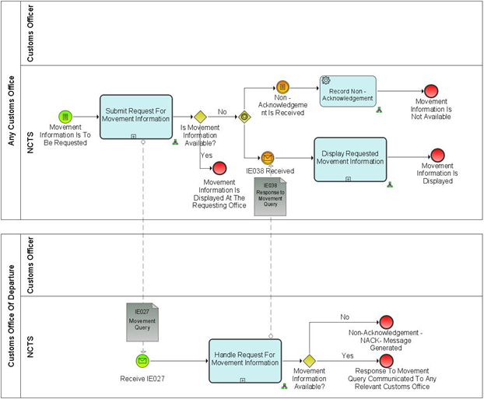

9

8

7

4

5

6

11

3

1

2

10

Figure 1: Example of a Process Flow Diagram

Process flows are composed by the following elements:

: **Pool**

1

: **Lane**

2

|  |  |  |  |
| --- | --- | --- | --- |
| **Group** | **Object** | **Type** | **Attribute / Definition** |
| Lanes and Pools |  | Uncollapsed pool | A Pool may have internal activities, in the form of the Process that will be executed – “Uncollapsed Pool” |
|  | Collapsed pool | A Pool may have no internal activities, i.e., it can be a “black box” – “Collapsed Pool”. |
|  | Lanes | A **Lane** is a subdivision of a pool and is used to organize and categorize activities. |

: **Start Events**

3

|  |  |  |  |
| --- | --- | --- | --- |
| **Group** | **Object** | **Type** | **Attribute / Definition** |
| Events |  | Empty start event | An **Empty start event** used for a subprocess that starts when the flow is triggered by its parent process. |
|  | Conditional start event | A **Conditional start event** is triggered when a condition becomes true. |
|  | Message start event | A **Message start** **event** is used when an IE is received and it triggers the process. |

: **Intermediate Events**

4

|  |  |  |  |
| --- | --- | --- | --- |
| **Group** | **Object** | **Type** | **Attribute / Definition** |
| Events |  | Intermediate message event | **Intermediate message event** is triggered when an IE (Information Exchange) is received. |
|  | Intermediate timer event | **Intermediate timer event** acts as a delay mechanism based on a specific time - date or a specific cycle. |
|  | Intermediate conditional event | **Intermediate conditional event** is used to demonstrate the fulfilment of a condition that is outside the process in scope. On a specific condition which is not an explicit output of the preceding object. |

: **Gateway**

5

|  |  |  |  |
| --- | --- | --- | --- |
| **Group** | **Object** | **Type** | **Attribute / Definition** |
| Gateway |  | Exclusive gateway | **Exclusive gateway** routes the sequence flow to exactly one of the outgoing branches |
|  | Event based gateway | An event-based gateway allows the sequence flow to be routed to the subsequent event/task, whichever is to occur first |
|  | Parallel gateway | In a **parallel gateway** all outgoing branches are activated simultaneously |

: **Tasks**

6

|  |  |  |  |
| --- | --- | --- | --- |
| **Group** | **Object** | **Type** | **Attribute / Definition** |
| Tasks |  | Send Task | **Send Task** indicates the automated activity of sending a notification. |
|  | Receive task | **Receive Task** is designed to receive an IE |
|  | Service task [2] | **Service Task** an automated task performed by the system without human intervention. This is used to indicate automated tasks which does not involve an IE, yet the ARIS object is called a service task. |
|  | User task | **User Task** typical “workflow” task where a human actor performs the task with the assistance of a software application. This task could be scheduled through a task list manager of some sort. |

: **Call Activity - Subprocess**

7

|  |  |  |  |
| --- | --- | --- | --- |
| **Group** | **Object** | **Type** | **Attribute / Definition** |
| Call Activity |  | Call activity (Always collapsed) | A **Call Activity** triggers another standalone process, which relates to one business function. |
| Subprocess |  | Subprocess [3] | **Subprocess** is aset of activities that have a logical sequence that meet a clear purpose. It is compound in that it can be broken down into a finer level of detail |

: **End Events**

8

|  |  |  |  |
| --- | --- | --- | --- |
| **Group** | **Object** | **Type** | **Attribute / Definition** |
| Events |  | Empty end event | An **Empty end event** is the standard modelling to end the process. |
|  | Terminate end event | A **Terminate end event** triggers the immediate termination of a process |

: **Information Exchange**

9

|  |  |  |  |
| --- | --- | --- | --- |
| **Group** | **Object** | **Type** | **Attribute / Definition** |
| Data objects |  | Information exchange | An Information Exchange object represents the content of communication between two processes, actors etc. |

: **Sequence Flow**

10

|  |  |  |  |
| --- | --- | --- | --- |
| **Group** | **Object** | **Type** | **Attribute / Definition** |
| Flow |  | Sequence Flow | A Sequence Flow is used to show the order that Activities will be performed in a Process |

: **Message Flow**

11

|  |  |  |  |
| --- | --- | --- | --- |
| **Group** | **Object** | **Type** | **Attribute / Definition** |
| Flow |  | Message Flow | An Information Exchange object represents the content of communication between two processes, actors etc. |

### The Components of the process flow

The following section provide basic components applied in BPMN in L4.

#### Pools and Lanes

2

1

Pools represent actors, and more specifically roles (as presented on 0

Locations/Actors), in a process. Each pool contains the activities performed by that actor or role.

For example:

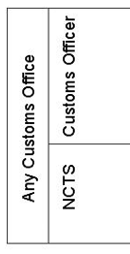

Figure 2: Example of Pools and Lanes

A lane is a subdivision of a pool. Lanes are used to indicate the split between the physical user and the system.

Interaction between lanes of the same pool is modelled by sequence flow (full line – indicating ‘what comes next’).

10

11

Interaction between pools is modelled by message flows (dotted line).

#### Events

Events represent something that happens at a specific time, and is not specifically an “action” (like a task). Events affect the flow of the model and usually have a cause (trigger) or an impact (result). There are three types of Events, based on when they affect the flow: Start, Intermediate, and End. For each of these event types a small introduction will be provided with some specific guidelines, like which subtypes are used for modelling within the EU Customs BPM projects.

* *Start Event:*

3

A start event is modelled when the event starts a *(sub) process* or a *call activity* and causes a sequence of processes to start or to restart after an end event. The *event* is represented as a green 1 thin-lined event.

For example:

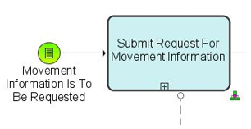

Figure 3: Example of a Start Event

If a process is started due to the end of another process, the start event is to have the exact same name as the end event in the previous process.

4

* *Intermediate Event:*

An intermediate event is modelled when the event occurs within the process. The symbol used is an orange 2 thin-lined event.

For example:

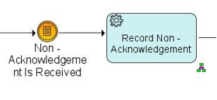

Figure 4: Example of an Intermediate Event

8

* *End Event:*

An end event is modelled when the event ends the process. The symbol used is a red thick-lined event.

For example:

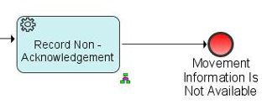

Figure 5: Example of an End Event

#### Gateways

5

A gateway is used to control the divergence and convergence of sequence flows in the process. In addition, loops are modelled with a gateway. Icons within the diamond shape of the Gateway will indicate the type of flow control behavior.

For example:

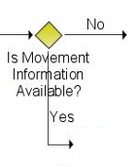

Figure : Example of Gateway

#### Tasks

6

A task or ‘activity’ is modelled when something has to be performed that takes time and/or resources. The relation between these activities will be modelled as a sequence flow, when it concerns something that comes next, or a message flow, when there is interaction between the roles (pools).

## Examples of textual description

Textual description is provided for the following components of a Transit business thread:

1. events;
2. process in the context of the pure NCTS
3. results.

### Major Event

Each event is described by:

1. Event’s Name;

**1**

1. Who produces the event (Organisation);

**2**

1. Where the event happens (Location);

**3**

1. Event’s description.

**4**

|  |
| --- |
| Customs Officer requests movement information |
| Organisation : National Customs Administration  **2** |
| Location : Customs Office of Departure, Customs Office of Destination, Customs Office of Guarantee, Customs Office of Transit  **1** |
| A Customs Officer with an appropriate level of authorisation and access to NCTS at any Customs Office, requests the movement information for a movement with a given MRN.  **3**  N.B. This includes the case of an en-route control, if access to the NCTS is available. |

**4**

### Process Pure NCTS

Processes

Each process is described by the following attributes:

1. Process Name;

**1**

1. Process identification;

**2**

1. Who performs the process (Organisation);

**3**

**4**

1. Where the process is performed (Location);

**4**

1. Which constraints apply (blank if no constraints apply);

**5**

1. What activities are included in the process (process description)

**656**

1. Which information is exchanged between two locations;

**7**

Final situation description, where System exits the process. (this final situation is not meant to duplicate what is said in the description of what the process does but only mentions the most relevant information).

**85**

|  |  |
| --- | --- |
| Submit request for movement information  **1** | Process: L4-TRA-01-11-01 |
| Organisation : National Customs Administration | |
| Location : Customs Office of Departure, Customs Office of Destination, Customs Office of Guarantee, Customs Office of Transit  **2**  **3** | |
| Constraint : The movement information may be located in a different country (that of the Customs Office of Departure).  **4** | |
| A Customs Officer submits a request for movement information based on a given MRN.  **6**  **5**  NCTS looks for the movement:   * when the movement information is available at the Office where the request is submitted, NCTS retrieves and displays it to the Customs Officer immediately. * when the movement information is not available at the Office where the request is submitted, NCTS notifies the Customs Officer that the information is not available and automatically sends (IE027) a request to the Country of Departure.   **7**  The requesting Customs Offices receives (IE038) the response to the request. NCTS displays the received information or the received error message.  **8**  Final situation :  The movement information is returned or a request for movement information is submitted to the Customs Office of Departure. | |

### Result

**1**

Each result is described by:

**1**

1. Result Name;

**1**

1. Who uses the result (Organisation);

**2**

1. Where the result is used (Location);

**3**

1. Result description.

|  |
| --- |
| Movement information displayed  **4** |
| Organisation : National Customs Administration |
| Location : Customs Office of Departure, Customs Office of Destination, Customs Office of Guarantee, Customs Office of Transit  **3**  **2**  **1** |
| The information on the requested movement is displayed.  **4** |

The model contains a description of the results, who uses them (Organisation) and where they are used (Location)[4].

## Traceability between the DIFFERENT MODELS

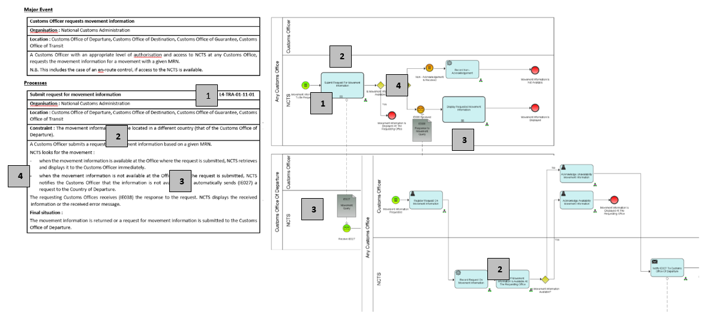

Figure : Traceability between models

* Start event for process “Customs Officer requests movement information”.

**1**

* Process “Submit Request For Movement Information” textual and graphical description

**2**

* Information to be exchanged is identified with letters IE followed by numeric identifier (e.g. IE027 and IE038).

**3**

* Gateway is used to identify if movement's information is available or not.

**4**

# “Pure” NCTS

## Introduction

This section presents the various business process threads of the Transit core business.

This introduction (and only this introduction) provides a description and a graphical overview of the core business which is not intended to be neither exhaustive nor methodologically correct. It is rather intended to highlight the major items of the core business and the links that exist between them. These major items will then be described in the rest of this section.

The major process threads are:

* process departure;
* process movement at Customs Office of Transit;
* process arrival;
* handle enquiry.

Clearly, these process threads are inter-dependent, e.g. the processing of a Transit movement crossing a frontier will happen after the processing at departure. The ‘link’ between those two processes is the journey of the consignment from the Customs Office of Departure to the Customs Office of Destination via Offices of Transit. This link appears in the diagram below, but not in the process threads themselves.

Major item of the core business is that NCTS delivers data for Safety and Security risk analysis and communicates the results of risk analysis and control results between the offices concerned.

**An overview of the main path is:**

The movement is initiated. Thereafter, the Holder of the Transit Procedure receives the NCTS Accompanying Document or MRN of Transit Declaration in an electronically readable format and the vehicle with the consignment goes to the first Customs Office of Transit (if any). In normal procedure, as per Article 41 of Appendix 1 of CTC, in case of CTC country, Customs Office of Departure has to provide printout of TAD to the Declarant.

The following might happen not at all or several times. The consignment arrives at a Customs Office of Transit where the processing of crossing a frontier occurs. Afterwards, the consignment leaves either to the next Customs Office of Transit, or to its final destination.

Normally, the consignment arrives at destination. The goods are presented to the Customs Office of Destination which processes the arrival. Once the arrival processing is complete, the Customs Office of Departure writes-off the movement.

In case the Customs Office of Departure does not receive any feed-back about the arrival of the movement within the expected period, an enquiry procedure is started. Depending on the result of the enquiry, taxes and duties might be collected. In all cases, sooner or later, the movement is written-off.

The following diagram depicts that main path, but for purposes of clarity without showing details such as:

* amendments;
* declaration validation, acceptance and verification;
* risk analysis;
* control processes either at departure or at destination;
* handling of control results;
* possibility to have a route without Customs Office of Transit or with more than one Customs Office of Transit;
* diversion.

The following Transit procedures are processed by NCTS:

* Common Transit, which is used for the movement of goods among the EU member states and Common Transit Convention countries and between the Common Transit Convention Countries themselves;
* Union Transit (applicable only to EU member states), which is the procedure that provides for the movement, under Customs control, of goods that are not in free circulation through the Union and for the movement of free circulation of goods in certain circumstances. It comprises of two separate procedures:
* The External Union Transit procedure (T1) and
* The Internal Union Transit Procedure (T2);
* TIR Transit (applicable only to EU member states) which allows the movement of goods internationally over one or more frontiers and where some portion of the journey between the start and end of the TIR operation is conducted by road.

NCTS caters for the lodgement of the safety and security data together with a Transit declaration. This data can be lodged for Entry of Goods and Exit purposes.

## Interfaces with other IT systems

The following interfaces with other IT systems apply only to EU Member States:

### Risk analysis system

* NCTS interfaces with the national risk analysis systems of the Member States and ensures that risks analysis is initiated once the transit data is received and validated by the NCTS.
* The national risk analysis systems of the Member States carry out the required risk analysis and sends the risk analysis results together with control recommendation back to NCTS.
* Risk analysis result codes, control recommendation codes, control types and control result codes are defined on an EU level and are managed in the national risk analysis systems; they are not transparent to NCTS.
* NCTS forwards the risk analysis results, control recommendations and control results related to a specific transaction to the relevant Customs Offices involved in the process.

### EOS Economic Operator Systems

* Where the regulation requires or allows Traders to be registered in EOS, a unique EORI is assigned to that Trader by the relevant Member State. The EORI number is managed and registered in EOS.
* Where EOS registered Traders are to be declared in an NCTS message, the EORI number shall be declared.
* When validating a received NCTS message, NCTS consults the EOS in order to check the provided EORI number.
* If the declared EORI number is not valid or if it is not declared where it is required, NCTS rejects the transit data set using the appropriate NCTS error message.
* Authorised Economic Operators and their AEO-certificates are registered and managed in EOS.
* When validating a received data set, NCTS consults the EOS to check whether the appropriate Traders are registered as AEO and whether they have a valid AEO-certificate of the relevant type. The query will be performed based on the declared EORI or TCUIN.
* Where NCTS checks the provided data against the validated data authorised by Customs preferably the common database to be consulted. Alternatively, a national replica can be consulted, provided that the necessary frequency of the synchronisation is ensured.

### UCC Customs Decisions system

* The Customs Decisions system allows the electronic processing and central storage of the applications and authorisations and publication of the list of holders on the Internet. The IT system will facilitate the necessary consultations between MS' customs authorities during the decision taking period and the management of the authorisations process.
* When validating a received data set for which authorizations are valid in more than one MS, NCTS consults the UCC Customs Decision system to check the existence and validity of the customs decisions.

### UCC AES

In order to synchronize the transit and export procedures in a harmonized way and to avoid open movements, NCTS needs to interface with AES when export is followed by transit. This is part of the so-called national domain.

For both external and internal transit, NCTS will inform AES:

* In case goods are released for Transit;
* In case goods are not released for Transit.

NCTS will inform AES:

* In case of Control Results. When Control Results are communicated to the Customs Office of Departure, NCTS will inform AES that there is positive/negative Control Results. In case of negative Control Results, NCTS will inform AES about the discrepancies for the movement identified.

Finally, for the exception case of recovery, NCTS will inform AES at the start of the recovery.

### EU Customs Single Window

* EU Customs Single Window enables economic operators to lodge electronically and once only all the information required by customs and non-customs legislation for EU cross-border movements of goods.
* Single Window will allow parties involved in trade and transport to lodge standardised information and documents with a single entry point to fulfil all transit-related regulatory requirements.

## L4-TRA-01-00-Transit Core Business Master Process

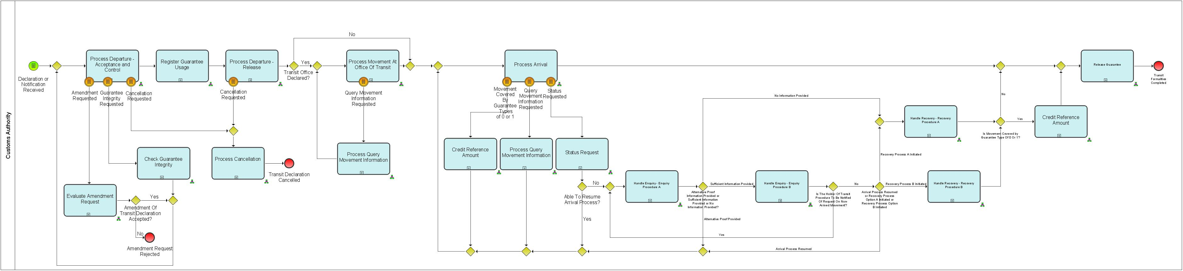

Figure 8: Overview of Transit Core Business (Part A)

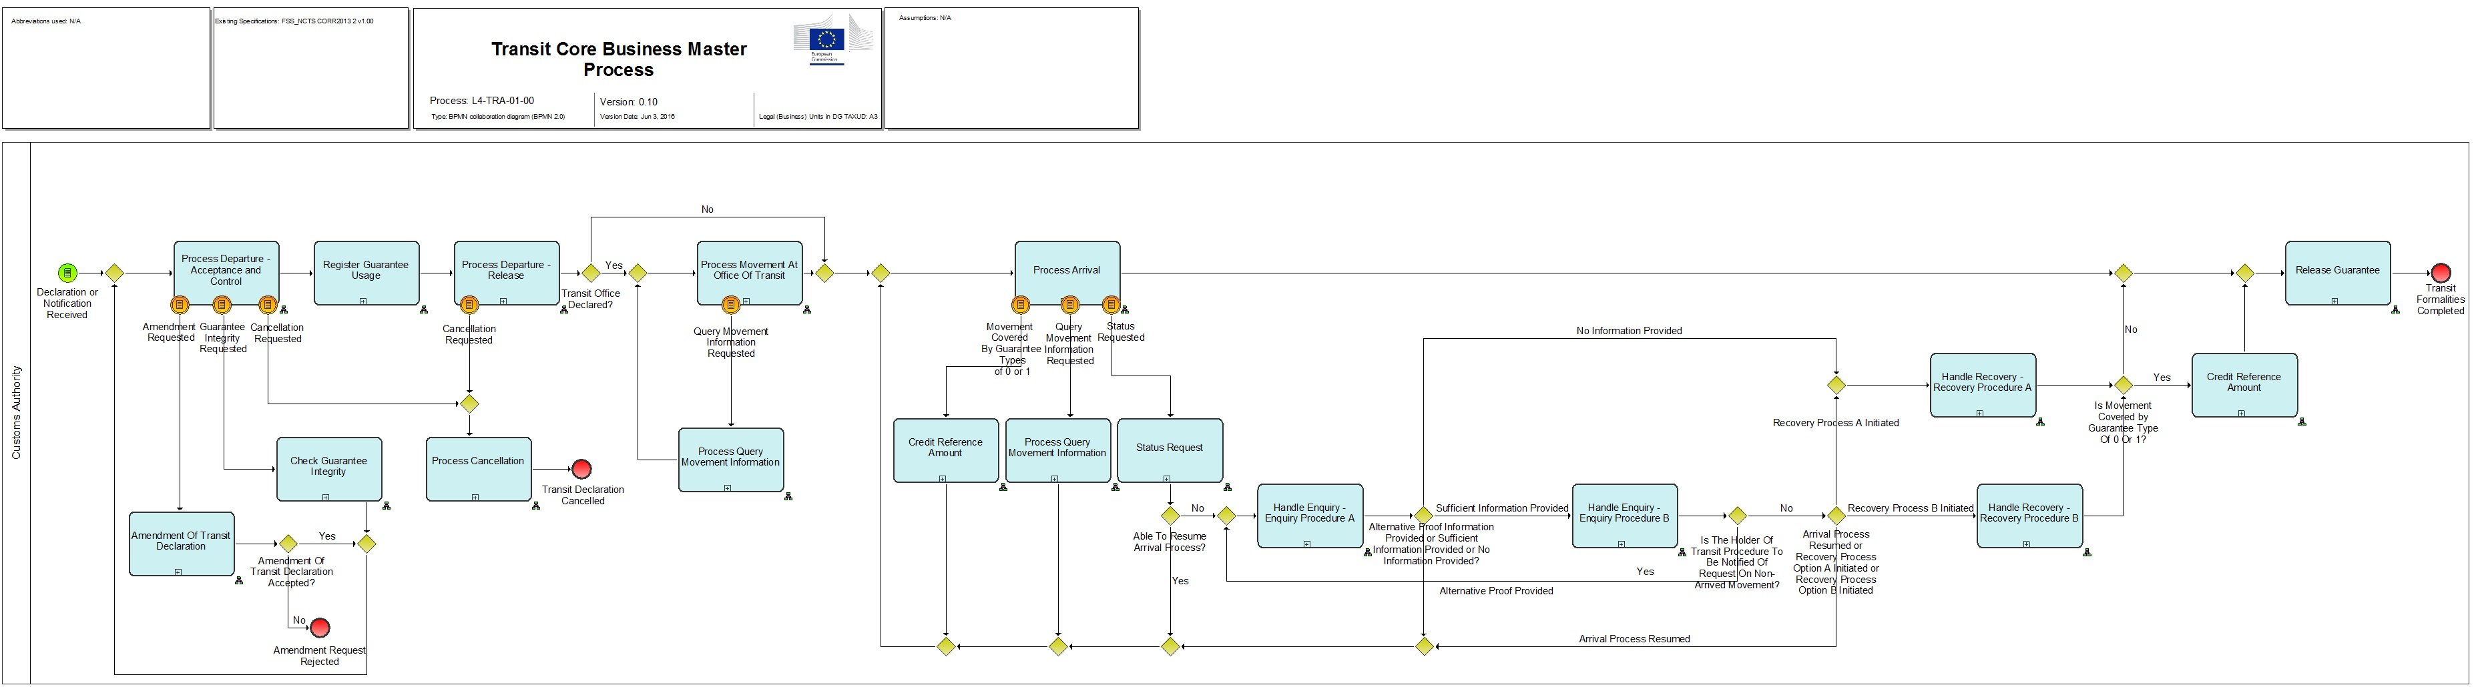

Figure 9: Overview of Transit Core Business (Part B)

In this overview, it is interesting to highlight the parts of processing that may be fully automated.

Unless human intervention is specifically required by national policy, NCTS will allow fully automated processing of:

* process departure (from declaration reception to release for Transit);
* process arrival (from presentation to release of the goods);
* write-off movement.

Though this automated processing will occur for most movements of Authorised Traders (Exporters and Consignees), it will only happen under the following strict conditions:

* at departure (see UNdep.195):
* the declaration is formally valid and;
* the declaration is submitted within the hours agreed for that purpose and;
* the risk analysis[5] does not propose to control the goods and / or documents and;
* the verification of data indicates no problems.
* at destination (see UNdes.165):
* the notification is submitted within the hours agreed for that purpose and;
* the risk analysis does not propose to control the consignment and;
* the unloading remarks indicate no problems.
* write-off:
* no discrepancies are reported.

## L4-TRA-01-01 Process Departure - Acceptance and Controls

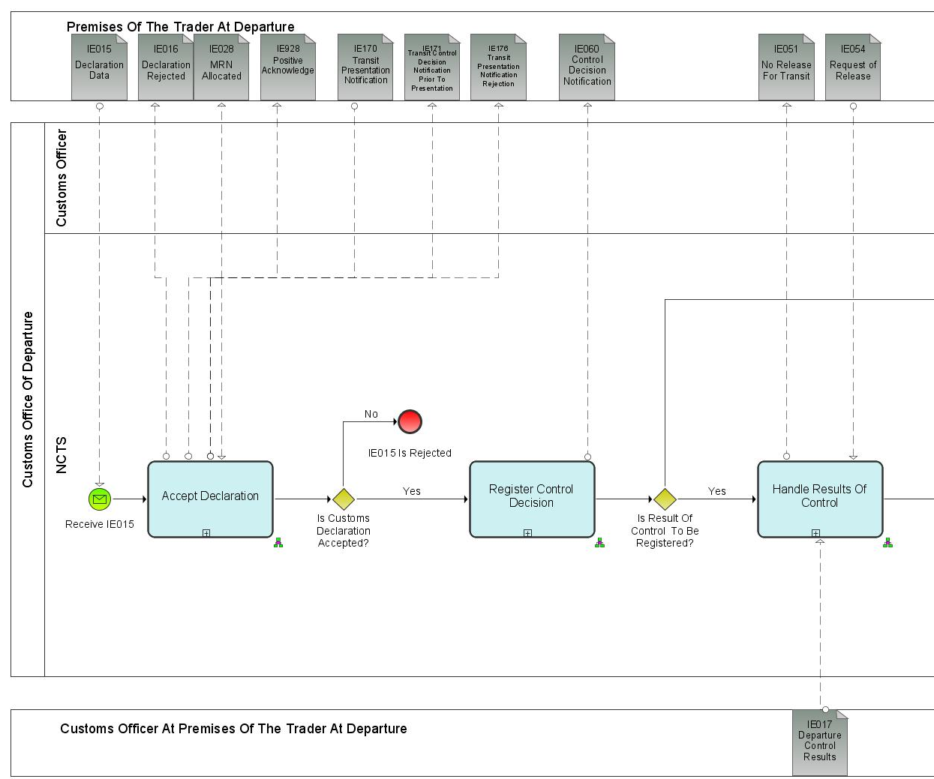

Figure 10: L4-TRA-01-01 Process Departure - Acceptance and Controls (Part A)

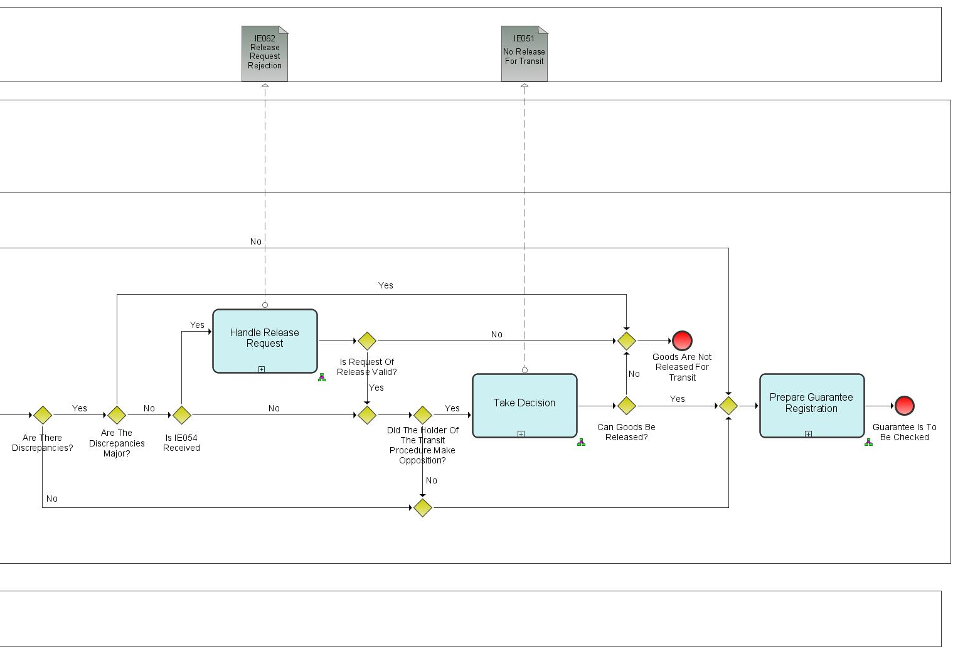

Figure 11: L4-TRA-01-01 Process Departure - Acceptance and Controls (Part B)

Major Event

|  |
| --- |
| Holder of the Transit Procedure initiates movement |
| Organisation : Trader |
| Location : Premises of the Trader at Departure or Customs Office of Departure |
| The Holder of the Transit Procedure or Authorised Consignor initiates the Union / Common Transit movement. |

Minor Events

|  |
| --- |
| Holder of the Transit Procedure submits an amendment |
| Organisation : Trader |
| Location : Premises of the Trader at Departure or Customs Office of Departure |
| The Holder of the Transit Procedure submits an amendment to his declaration. |

|  |
| --- |
| Holder of the Transit Procedure requests release |
| Organisation : Trader |
| Location : Premises of the Trader at Departure or Customs Office of Departure |
| After a control, the Holder of the Transit Procedure communicates his advice (opposition or non-opposition) on minor revisions by performing a release request. The request must arrive within the time limit at the Customs Office of Departure. |

|  |
| --- |
| Release request timer expired |
| Organisation : National Customs Administration |
| Location : Customs Office of Departure |
| At the expiration of the timer ‘Declaration awaiting release request' the declaration data is put in an idle state. |

|  |
| --- |
| Time to release |
| Organisation : National Customs Administration |
| Location : Customs Office of Departure |
| The timer ‘Awaiting for automatic release’ under simplified procedure has expired, no decision to control was made; the preparation of the guarantee registration can start. |

Processes

|  |  |
| --- | --- |
| Accept Declaration | Process: L4-TRA-01-01-01 |
| Organisation : National Customs Administration | |
| Location : Customs Office of Departure | |
| Constraint :  If NCTS is also used for the purpose of safety and security and the Customs Office of Departure is located in an EU Member State or in case safety and security data are lodged in a CTC country and the Customs Office of Transit is the Customs Office of Entry, then full safety and security related risk analysis for all the goods shall be performed additionally within the prescribed time limits. | |
| Description :  The declaration data must be submitted (IE015) by electronic means to the Customs Office of Departure (except where the Business Continuity Procedure applies (Annex 72-04 of IA)).  The Holder of the Transit Procedure must provide a Local Reference Number (IE015.TRANSIT OPERATION. LRN) that allows the Holder of the Transit Procedure and the Customs Office of Departure Officer to reference the data in the NCTS. The Holder of the Transit Procedure shall specify whether the NCTS declaration shall be used for the purpose of safety and security (IE015.TRANSIT OPERATION. 'Security' is set to '1' (ENS), ‘2’ (EXS) and ‘3’ (ENS and EXS) or not (IE015. TRANSIT OPERATION. 'Security' is set to ‘0’ (Not used for safety and security purposes’). NCTS validates data contained in IE015 and performs checks if the provided LRN is unique. In case declaration validation fails (IE015 is rejected), the Holder is notified via IE016 (rejection reason included IE016.FUNCTIONAL ERROR. Error Reason).  Upon validation completion and where an EORI number or a third country unique identification number is declared, NCTS validates it against EOS (Economic Operators system) and completes the Trader data in the declaration. If the EORI number or a third country unique identification number is not valid, the transit declaration will be rejected (IE016). Where a Holder of the Transit Procedure Identification Number is declared and it is a country code of the group 'Common Transit outside the Union' (CTC) Holder of the Transit Procedure Identification Number, NCTS does not validate it against EORI but checks its existence later against the Guarantee Management System.  In case of valid authorization IE015 is recorded in the NCTS, the MRN is generated and provisionally allocated to the declaration. A positive acknowledgement (IE928) is communicated to the Trader.  **Transit declaration with reduced data set**  A Transit declaration with reduced data requirements (D2) (IE015.TRANSIT OPERATIONS. Reduced Dataset Indicator is ‘1’) can be used for:   * The transport of goods by rail; * The transport of goods by air and sea where the electronic transport document cannot be used.   The applicants applying for Transit simplifications must fulfil the Authorised Economic Operator (AEO) criteria specified in Articles 39(a) (b) and (d) of the UCC.  **Acceptance of Declaration Declared Under Normal Procedure:**  When a Transit declaration is submitted (IE015) under normal procedure (IE015.CONTROL is absent), NCTS checks whether the location of goods where the consignment can be controlled is declared (IE015. LOCATION OF GOODS is present). If this is the case the declared location of goods is validated.  If an invalid location of goods is declared, the transit declaration is rejected and the Holder of the Transit procedure is notified (IE016) that the declaration is invalid with the reason of the rejection. The process ends at this point. Upon communication of Positive Acknowledgement (IE928), NCTS registers whether Goods are present or not where there are two options:   * If Goods are presented, the Customs Office of Departure accepts the declaration and the MRN is definitively allocated to the Transit Operation and communicated (IE028) to the Trader at Departure. * If Goods are not presented, NCTS requests and records Risk Analysis Results and the Customs Officer decides whether to control or not the Goods prior of presentation. The decision is recorded in NCTS and timer “Awaiting for Presentation Notification” (30 days duration) is initiated. In addition, in case of positive decision then NCTS sends message IE171 ”Transit Control Decision Notification Prior to Presentation” to the Trader to notify him/her on the Goods control.   + If Τimer expires and Goods are not presented then Transit Declaration (IE015) is rejected and NCTS notifies the Trader with message IE176 “Transit Presentation Notification Rejection”.   + If Goods are to be presented within 30 days the Trader has to submit an IE170 “Transit Presentation Notification” which is validated in NCTS.     - In case of negative validation results, IE170 is rejected and NCTS notifies the Trader with message IE176 and the Transit Declaration is rejected. The Trader is able to resend IE170, in case that the time limit of 30 days has not expired;     - In case validation results are positive, IE170 is recorded in NCTS and timer “Awaiting for Presentation Notification” stops. The Customs Office of Departure accepts the declaration and the MRN is definitively allocated to the Transit Operation and communicated (IE028) to the Trader at Departure.   **Acceptance of Declaration Declared Under Simplified Procedure:**  When declaration is submitted (IE015) under simplified procedure (IE015. CONTROL is present), NCTS checks that the Holder of the Transit Procedure who is responsible for the declaration (IE015. HOLDER OF THE TRANSIT PROCEDURE. 'Holder of the Transit Procedure identification n°') is indeed authorised to use simplified procedure at that Customs Office of Departure.  NCTS checks also the declared ‘Location of goods’ (IE015. LOCATION OF GOODS) where Customs can control the consignment. There are 2 options:   1. The Trader has not declared an ‘Authorised place’ (IE015. LOCATION OF GOODS.Type Of Location is not ‘B’): in this case NCTS considers that the location of goods is the one specified in the authorisation for the Customs Office of Departure; 2. The Trader has declared an ‘Authorised place’ (IE015. LOCATION OF GOODS.Type Of Location is ‘B’): in this case NCTS checks it against the various authorised places, for the Customs Office of Departure in question, specified in the authorisation.   When a Holder of the Transit Procedure uses seals (IE015.TRANSPORT EQUIPMENT.SEAL NUMBER) then NCTS checks them against the seals mentioned in the authorisation. NCTS checks also the goods in order to be sure that none of them is excluded from the authorisation.  If the Holder is not authorised to use simplified procedure or if he has declared an invalid ‘Authorised location of goods’ (including the case of no indication of one location amongst the several authorised locations for the Customs Office of Departure in question) or invalid seals, NCTS rejects the declaration and notifies (IE016) the Trader that the declaration is invalid, giving the reason of the rejection.  When the declaration is valid, a positive acknowledge is communicated (IE928) to the Trader and the declaration data is recorded in the NCTS. NCTS registers the decision if there is a presentation notification and respective results are recorded in the NCTS where there are two options:   * If Goods are presented, the Customs Office of Departure accepts the declaration and the MRN is definitively allocated to the Transit Operation and communicated (IE028) to the Trader at Departure. * If Goods are not presented, NCTS requests and records Risk Analysis Results and the Customs Officer decides whether to control or not the Goods prior of presentation. The decision is recorded in NCTS and timer “Awaiting for Presentation Notification” (30 days duration) is initiated. In addition, in case of positive decision then NCTS sends message IE171 ”Transit Control Decision Notification Prior to Presentation” to the Trader to notify him/her on the Goods control.   + If Τimer expires and Goods are not presented then Transit Declaration (IE015) is rejected and NCTS notifies the Trader with message IE176 “Transit Presentation Notification Rejection”.   + If Goods are to be presented within 30 days the Trader has to submit an IE170 “Transit Presentation Notification” which is validated in NCTS.     - In case of negative validation results, IE170 is rejected and NCTS notifies the Trader with message IE176 and the Transit Declaration is rejected. The Trader is able to resend IE170, in case that the time limit of 30 days has not expired.     - In case validation results are positive, IE170 is recorded in NCTS and timer “Awaiting for Presentation Notification” stops. The Customs Office of Departure accepts the declaration and the MRN is definitively allocated to the Transit Operation and communicated (IE028) to the Trader at Departure. When the declaration is submitted (IE015) under simplified procedure, a timer “Awaiting for automatic release” is started to progress towards an automatic release after the timer has expired.   **Risk Analysis :**  NCTS triggers the risk analysis process which is carried out by the national risk analysis system. The declaration data is sent to the risk analysis system/s and processed against risk rules (including common risk criteria and standards where applicable). The risk analysis system sends back the risk analysis result (coded and/or textual) together with the control recommendation.  NCTS registers the risk analysis result and control recommendation.  If risk was identified, the process continues with the control task. If the declaration is declared under simplified procedure the timer “Awaiting for automatic release” is stopped. The Customs Officer is alerted and asked to register a control decision (L4-TRA-01-01-03-Register Control Decision).  If no risk was identified or if risk analysis could not be performed the process continues with the Guarantee Registration. If the declaration is declared under simplified procedure NCTS awaits the timer “Awaiting for automatic release” to expire.  Exception in case of business continuity (Annex72-04) :  Where the decision to apply the business continuity procedure is taken, any transit data with LRN or MRN allocated to the transit operation shall be withdrawn from the electronic transit system on the basis of information provided by a person who lodged a transit data into the electronic transit system. However, in case of unavailability of the computerised system of the holder of the procedure and/or network between him and the customs authority or in case of unavailability of the authorised consignor’s computerised system and/or network between him and the customs authority the customs authority may allow the holder of the procedure to submit the transit declaration in one copy (making use of the SAD or the TAD/TSAD) to the Customs Office of Departure in order to have it processed by the electronic transit system.  Final situation :  If the declaration is not valid or if the location where the consignment can be controlled is not valid, the declaration is rejected.  In the other cases and only after presentation of goods, the declaration is accepted and a new MRN is generated and allocated. The Trader is notified of the rejection or the acceptance of the declaration. The result of the risk analysis is known. The state of the Transit Operation is set to ‘Accepted’. | |

|  |  |
| --- | --- |
| **Evaluate amendment request** | **Process: L4-TRA-01-01-02** |
| **Organisation :** National Customs Administration | |
| **Location :** Customs Office of Departure | |
| **Constraint :** If NCTS is also used for the purpose of safety and security and if the Customs Office of Departure is located in an EU Member State, then full safety and security related risk analysis for all the goods shall be performed additionally within the prescribed time limits (see regulation). | |
| **Description :**  This process handles amendment requests on the whole declaration data (IE013), this means that the amendment flag (IE013.Amendment type flag) indicates that it concerns an amendment on the declaration data (and not only on the guarantee details). The amendment request transports all values of the original declaration altered with the requested amendments. NCTS checks that the amendment is made on an already accepted declaration, i.e. it checks that the MRN is allocated.   * If this is not the case then the amendment is automatically rejected, the rejection reason is registered and returned (IE005) to the Holder of Transit procedure. The rejected amendment request will have no influence on the original declaration because there is no accepted declaration available. The evaluation process of the received amendment request stops here. * NCTS checks that the Customs Office of Departure still can accept an amendment request. It can no longer accept an amendment request when one of the following conditions is met:  1. The Holder of Transit procedure has been informed (IE060) that the Customs Authorities intend to examine the goods; 2. The Customs Authorities have established that the particulars in question are incorrect; 3. The Customs Authorities have released the goods.   If this is the case then the amendment is automatically rejected, the rejection reason is registered and returned (IE005) to the Holder of Transit Procedure. The rejected amendment request will have no influence on the original declaration because the amendment request came too late in the declaration data handling process. The evaluation process of the amendment request stops here.   * NCTS performs an automatic validation and negative results, if any, are communicated (IE005) to the Holder of Transit procedure. The validation process can be a completely automatic process, however there are some exceptions. A human intervention is always required in case a Holder of Transit procedure alters the ‘Type of goods’ (IE013.GOODS ITEM. COMMODITY. CLASSIFICATION. Commodity Code - Combined Nomenclature Code and/or IE013. GOODS ITEM. COMMODITY. Description of Goods) or the ‘Quantity’ ((IE013.TRANSIT OPERATION. Total number of items) or (IE013.TRANSIT OPERATION. Total Packages) or (IE013.TRANSIT OPERATION. Gross Mass (kg)) or (IE013. GOODS ITEM. PACKAGING. Number of packages) or (IE013. GOODS ITEM.GOODS MEASURE. Gross Mass (kg)). In both cases the system notifies the Customs Officer of the fact that he must decide whether he can accept the amendment or not.   Whether the amendment request data is valid or not, it will have an influence on the original declaration processing. The processing of the original declaration identified by the MRN is stopped and set back to this process (‘L4-TRA-01-01-02-Evaluate Amendment Request’). When the system is not able to treat the request fully automatically, then it will notify the Customs Officer of the fact that a Trader is requesting an amendment on his declaration. The notification is performed when:   * the Customs Officer is requested to accomplish the formal validation process (as explained above), or, * at the point of registration of the control results (see process ‘L4-TRA-01-01-04-Handle Results Of Control’), the system notifies the Customs Officer, that an amendment request is received while Customs was performing a control, he must take a decision if he can accept it or not.   Under simplified procedure the ‘Awaiting For Automatic Release’ timer is restarted (if not yet expired). It is also possible that the guarantee for the original declaration is already registered, as a consequence this guarantee must be cancelled (see process 'L4-TRA-02-06-Cancel Guarantee Usage' in the document ' FSS-UCS NCTS Section II-BUSINESS PROCESS THREADS FOR GUARANTEE MANAGEMENT-Re-SfA- v4.20.doc').  If the amendment request is invalid, then the reasons for rejection are returned (IE005) to the Holder of Transit procedure.  If the amendment is accepted, it is registered into NCTS, then the acceptance is communicated (IE004) to the Holder of Transit Procedure.  Under simplified procedure the ‘Awaiting For Automatic Release’ is restarted at its initial value.  Full risk analysis is performed based on the amended data and results are recorded according to process L4-TRA -01-01-01-Accept Declaration.  If the declaration was declared under normal procedure:   * If risk is identified, the Customs Officer is alerted. * The next step is to decide to control.   If the declaration is declared under simplified procedure:   * If risk (e.g. related to safety and security) is identified, the timer “Awaiting For Automatic Release” is stopped. The Customs Officer is alerted and asked to register a control decision (L4-TRA-01-01-03-Register Control Decision). * In any other case, NCTS awaits the timer “Awaiting For Automatic Release” to expire.   **Final situation :**  The amendment is rejected because it was not related to an accepted declaration, the state of the Transit Operation does not change, or the amendment is rejected because it came too late in the declaration processing, the state of the Transit Operation does not change, or   * the amendment is rejected because it failed to pass the validation process, the state of the Transit Operation is set to ‘Declaration under amendment’, or * it is accepted, the state of the Transit Operation is set to ‘Accepted’. | |

|  |  |
| --- | --- |
| Register control decision | Process: L4-TRA-01-01-03 |
| Organisation : National Customs Administration | |
| Location : Customs Office of Departure | |
| Constraint : | |
| Description :  If the risk analysis results stated that goods shall not be loaded/released at departure because there are reasonable grounds for the Customs Office of Departure to consider that the introduction of the goods into the customs territory of the Union would pose such a serious threat to the safety and security of the Union that immediate intervention is required or if preventive measures should be taken at the Customs Office of Departure, then NCTS alerts the Customs Officer.  The decision to control is always recorded in NCTS. This information will be used to handle any new amendment submitted after this stage. A Trader can submit an amendment request (IE013) between the moment the decision to control was made, and the capturing of the results of a control.  On request of a Customs Officer the accepted declaration is printed on paper (IE119[6]) in order to allow the Customs Officer to perform a control of the consignment.  If the declaration is declared under simplified procedure, the timer ‘Awaiting For Automatic Release’ is stopped.   * In case it is decided to control the goods, the Holder of the Transit Procedure is notified (IE060) of the decision to control. * In case it is decided not to control the goods, the timer ‘Awaiting For Automatic Release’ is restarted.   If the declaration is declared under normal procedure:   * In case it is decided to control the goods, the Holder of the Transit Procedure is notified (IE060) of the decision to control in order to allow him to be present during the control (declaration amendments are no longer accepted by the Customs Office of Departure). The accepted declaration is printed on paper on demand of a Customs Officer, in order to allow him to perform a control of the consignment.   Final situation :  If the decision to control is registered, the state of the Transit Operation is set to ‘Under Control’.  If the decision not to control is registered, the Guarantee registration is prepared (L4-TRA-01-01-07-Prepare Guarantee Registration). | |

|  |  |
| --- | --- |
| Handle results of a control | Process: L4-TRA-01-01-04 |
| Organisation : National Customs Administration | |
| Location : Customs Office of Departure | |
| Constraint : | |
| Description :  In any case, i.e. in case of minor, major or no discrepancies, the results of a control are registered at the Customs Office of Departure. NCTS records type of control performed and the results of this control per type.  The following circumstances can be encountered:   1. The control revealed no discrepancies, the controlled goods together with the ‘Satisfactory’ control results are registered. After calculation of the duties and taxes (see process ‘L4-TRA-01-01-07-Prepare Guarantee Registration’) the processing continues with ‘L4-TRA-01-02-01-Evaluate Guarantee Registration Result’, except for guarantee type 'B' for which no registration is required. 2. The control revealed minor discrepancies and the Holder of the Transit Procedure gives his advice right away (IE017.TRANSIT OPERATION. Release requested flag is present), in this case he makes no opposition (i.e. he accepts the revisions). Customs registers the controlled goods and revises the declaration data based upon the results of a control and the ‘Satisfactory’ control results are logged.After calculation of the duties and taxes (see process ‘L4-TRA-01-01-07-Prepare Guarantee Registration’) the processing continues with ‘L4-TRA-01-02-01-Evaluation of Guarantee Registration Result’, except for guarantee type 'B' for which no registration is required. 3. When minor discrepancies occurred and the Holder of Transit procedure gives his advice right away (IE017.TRANSIT OPERATION. Release requested flag is present), and he makes opposition (i.e. he does not accept the revisions), the movement can no longer be released. Customs records the controlled goods and revises the declaration data based upon the results of a control. The declaration is put in an idle state where it waits until further action. 4. Minor discrepancies are detected during the control of the goods and/or supporting documents. The Holder of Transit procedure has not yet communicated his advice (IE017.TRANSIT OPERATION. Release requested flag is absent) on minor revisions. A timer “Declaration awaiting release request” is started to protect a non-release request of the goods coming from the Holder of Transit procedure. The Customs Officer records the controlled goods and revises the declaration data. 5. The control revealed major discrepancies or reasonable grounds for the Customs Office of Departure to consider that the introduction of the goods into the customs territory of the Union would pose a serious threat to the safety and security of the Union. The controlled goods, major discrepancies and the ‘Unsatisfactory’ control results are registered. The Customs Office of Departure notifies (IE051) the Holder of Transit procedure that the movement may not go to Destination, sanctions may be applied.   Final situation :   * There are no discrepancies, the satisfactoryresults of the control are logged, the state of the Transit Operation is set to ‘Guarantee under registration’, or * There are minor discrepancies and   + the advice of the Trader is known, and he makes opposition, the state of the Transit Operation is set to ‘Idle’,   + the advice of the Trader is known, and he makes no opposition, the guarantee can be registered, the state of the Transit Operation is set to ‘Guarantee under registration’, or * There are minor discrepancies and Customs wait for a release request, the state of the Transit Operation is set to ‘Under release request’, or * There are major discrepancies or the threat to the safety and security of the Union is confirmed and the unsatisfactory control results are registered, the movement may not go to destination, the state of the Transit Operation is set to ‘Not released for Transit’. | |

|  |  |
| --- | --- |
| Handle release request | Process: L4-TRA-01-01-05 |
| Organisation : National Customs Administration | |
| Location : Customs Office of Departure | |
| Constraint : | |
| Description :  A goods release request is received (IE054) from a Trader, who could not give his advice on minor revisions right away.   * Opposition:   When the Trader makes opposition (IE054.TRANSIT OPERATION. Release requested = ‘No’) (i.e. he does not accept the revisions), the movement cannot be released. The timer ‘Declaration awaiting release request’ is stopped. The declaration is put in an idle state where it waits until further action.   * No opposition:   When the Trader makes no opposition (IE054.TRANSIT OPERATION. Release requested = ‘Yes’) (i.e. he accepts the revisions), the movement can still be released. The timer ‘Declaration awaiting release request’ is stopped. The ‘Satisfactory’ control results are registered. After calculation of the duties and taxes (see process ‘L4-TRA-01-01-07-Prepare Guarantee Registration’), the processing continues with the registration of the guarantee.   * Invalid:   The release request received fails to pass the validation process. The rejection of the release request is communicated (IE062) to the Holder of Transit procedure with reasons.  Put declaration in idle state  A goods release request is not received (IE054) from a Trader in time (the timer “Declaration awaiting release request” has expired). NCTS will automatically put the declaration in an idle state waiting for further action.  Final situation :  The release request is invalidated, the state of the Transit Operation stays in ‘Under release request’, or the declaration is put in an idle state, the state of the Transit Operation is set to ‘Idle’, or the guarantee is ready to be registered and the state of the Transit Operation is set to ‘Under guarantee registration’, or the release request is not received and the declaration is put in an idle state, the state of the Transit Operation is set to ‘Idle’. | |

|  |  |
| --- | --- |
| Verify goods and/or supporting documents at Trader | Process: Manual Process |
| Organisation : National Customs Administration | |
| Location : Premises of the Trader at Departure | |
| Constraint :  The execution of this process is always under simplified procedure.  Customs must arrive within the agreed time period of the authorisation.  The registration of the results of a control should be done by a Customs Officer. This implies the definition of information to be exchanged allowing the communication of the so called ‘Departure control results (IE017)’. This IE is shown on the diagram (as input IE to the L4-TRA-01-01-04-Handle Results Of Control). To prove the validity of the IE017, the Customs Officer will add a code to the IE017. This code (a random number) is generated by the Customs system just before the Customs Officer goes to the goods place. | |
| Description :  The verification of the goods and/or supporting documents and/or seals is a manual process performed by a Customs Officer at the goods place.  When minor discrepancies occur, they are communicated to the Holder of Transit procedure. In order to solve the discrepancies, Customs will perform minor revisions on the declaration data so that it is still possible to release the movement for Transit in case the revisions are accepted by the Holder of Transit procedure.  The Holder of Transit procedure evaluates if he can agree with (make no opposition) the minor revisions. He can give his advice, opposition or no opposition, right away (IE017.TRANSIT OPERATION. Release requested), or later when he is not able to respond at that time.  When major discrepancies occur or when the Customs Office of Departure has reasonable grounds to consider that the introduction of the goods into the customs territory of the Union would pose a serious threat to the safety and security of the Union, then the Customs Officer will go back to the Customs Office of Departure with the unsatisfactory results of a control (IE1196).  The decision about what is a ‘minor’ discrepancy or what is a ‘major’ discrepancy is made by each National Administration.  Final situation :  Control is performed by the Customs Officer and optionally the seals are affixed or re-affixed.  If any, the minor revisions are communicated to the Holder of Transit procedure. | |

|  |  |
| --- | --- |
| Take decision | Process: L4-TRA-01-01-06 |
| Organisation : National Customs Administration | |
| Location : Customs Office of Departure | |
| Constraint : | |
| Description :  When the Customs Officer decides that the movement cannot be released then the ‘Unsatisfactory’ control results are logged.  The Customs Office of Departure notifies (IE051) the Holder of Transit procedure that the movement may not go to Destination, sanctions may be applied. When the Customs Officer decides that the movement can still be released then the ‘Satisfactory’ control results are logged. After calculation of the duties and taxes (see process ‘L4-TRA-01-01-07-Prepare Guarantee Registration’), the processing continues with ‘L4-TRA-02-03-Register Guarantee Usage’.  Final situation :  Either unsatisfactory control results are registered and the movement cannot be released, the state of the Transit Operation is set to ‘Not released for Transit’, or,  Satisfactory control results are registered, the state of the Transit Operation is set to ‘Under guarantee registration’. | |

|  |  |
| --- | --- |
| Prepare guarantee registration | Process: L4-TRA-01-01-07 |
| Organisation : National Customs Administration | |
| Location : Customs Office of Departure | |
| Constraint : Simplified procedure only | |
| Description :  The guarantees can be checked and registered. Duties and taxes are calculated: manually by the Customs Officer or automatically when such a facility is provided in the national application. The amount calculated is registered in NCTS.  Final situation :  Duties and taxes are calculated, the state of the Transit Operation is set to ‘Under guarantee registration’. | |

Major Result

|  |
| --- |
| Check of the guarantees has been asked |
| Organisation : National Customs Administration |
| Location : Customs Office of Departure |
| A check and registration of the guarantee(s) has been asked. This result activates the Customs Office of Departure to ask for the check of guarantees which triggers the process “L4-TRA-01-02-01-Evaluation Of Guarantee Registration Result’”. |

|  |
| --- |
| Goods not released for Transit |
| Organisation : National Customs Administration |
| Location : Premises of the Trader at Departure or Customs Office of Departure |
| The movement is not released because of major discrepancies detected by the Customs Officer or because of safety and security reasons. The Holder of Transit procedure is notified of the fact that he may not go to destination. |

Minor Results

|  |
| --- |
| MRN communicated to Holder of Transit Procedure |
| Organisation : National Customs Administration |
| Location : Premises of the Trader at Departure or Customs Office of Departure |
| The MRN is communicated to the Holder of Transit procedure. The Holder of Transit procedure will use it to complete other documents not related to the NCTS (import / export). |

|  |
| --- |
| Holder of Transit Procedure notified of rejection |
| Organisation : National Customs Administration |
| Location : Premises of the Trader at Departure or Customs Office of Departure |
| The Holder of Transit procedure is notified of the fact that the declaration is rejected. |

|  |
| --- |
| Holder of Transit Procedure notified of a control |
| Organisation : National Customs Administration |
| Location : Premises of the Trader at Departure or Customs Office of Departure |
| The Holder of Transit Procedure is notified of the fact that Customs will perform a control on the consignment. |

|  |
| --- |
| Holder of Transit Procedure notified of minor discrepancies |
| Organisation : National Customs Administration |
| Location : Customs Office of Departure |
| The Holder of Transit Procedure is notified of the fact that Customs will perform minor revisions before the movement can be released. |

|  |
| --- |
| Holder of Transit Procedure notified of release request rejection |
| Organisation : National Customs Administration |
| Location : Premises of the Trader at Departure or Customs Office of Departure |
| The Holder of Transit procedure is notified of the fact that his request to release the goods is invalid. |

|  |
| --- |
| Amendment accepted by Customs Office of Departure |
| Organisation : National Customs Administration |
| Location : Premises of the Trader at Departure or Customs Office of Departure |
| The amendment is accepted. The acceptance is communicated to the Holder of Transit procedure. |

|  |
| --- |
| Amendment rejected by Customs Office of Departure |
| Organisation : National Customs Administration |
| Location : Premises of the Trader at Departure or Customs Office of Departure |
| The amendment is rejected. The rejection is communicated to the Holder of Transit procedure. |

|  |
| --- |
| Cancellation of the guarantee has been asked |
| Organisation : National Customs Administration |
| Location : Customs Office of Departure |
| The amendment of the declaration is accepted. The guarantee for the original declaration was already registered, so it must be cancelled. |

Constraints

1. Calculation of duties & taxes
2. Due to the facts that:

* the calculation of the duties & taxes involved in a movement is a national matter;
* the computerisation of this calculation implies a detailed description of the goods (by means of commodity codes), their value and the related rates of duties & taxes, which will not be present in all declarations;

1. The estimation of the duties & taxes will be done as stated in process ‘L4-TRA-01-01-07-Prepare Guarantee Registration’.
2. In any case, the Customs Officer will be allowed to use the service "enter/modify the calculated/proposed amount" (see under Heading ‘2.14.2’: The Customs Officer at Departure).

Remark

1. Papers in case of continuity procedure

* The filing service offered by the NCTS only covers filing at departure of SAD paper declarations and presented by Holders of Transit procedure, and associated documents.

In the pure NCTS environment, the NCTS Accompanying Document or MRN of Transit Declaration in an electronically readable format (TAD/TSAD) is the only paper-based document printed by the system at departure, during the initiation of a movement. The NCTS Accompanying Document or MRN of Transit Declaration in an electronically readable format is optional (upon the request of the Holder of the Procedure). In normal procedure, as per Article 41 of Appendix 1 of CTC, in case of CTC country, Customs Office of Departure has to provide printout of TAD to the Declarant.

## L4-TRA-01-02-Process Departure – Release

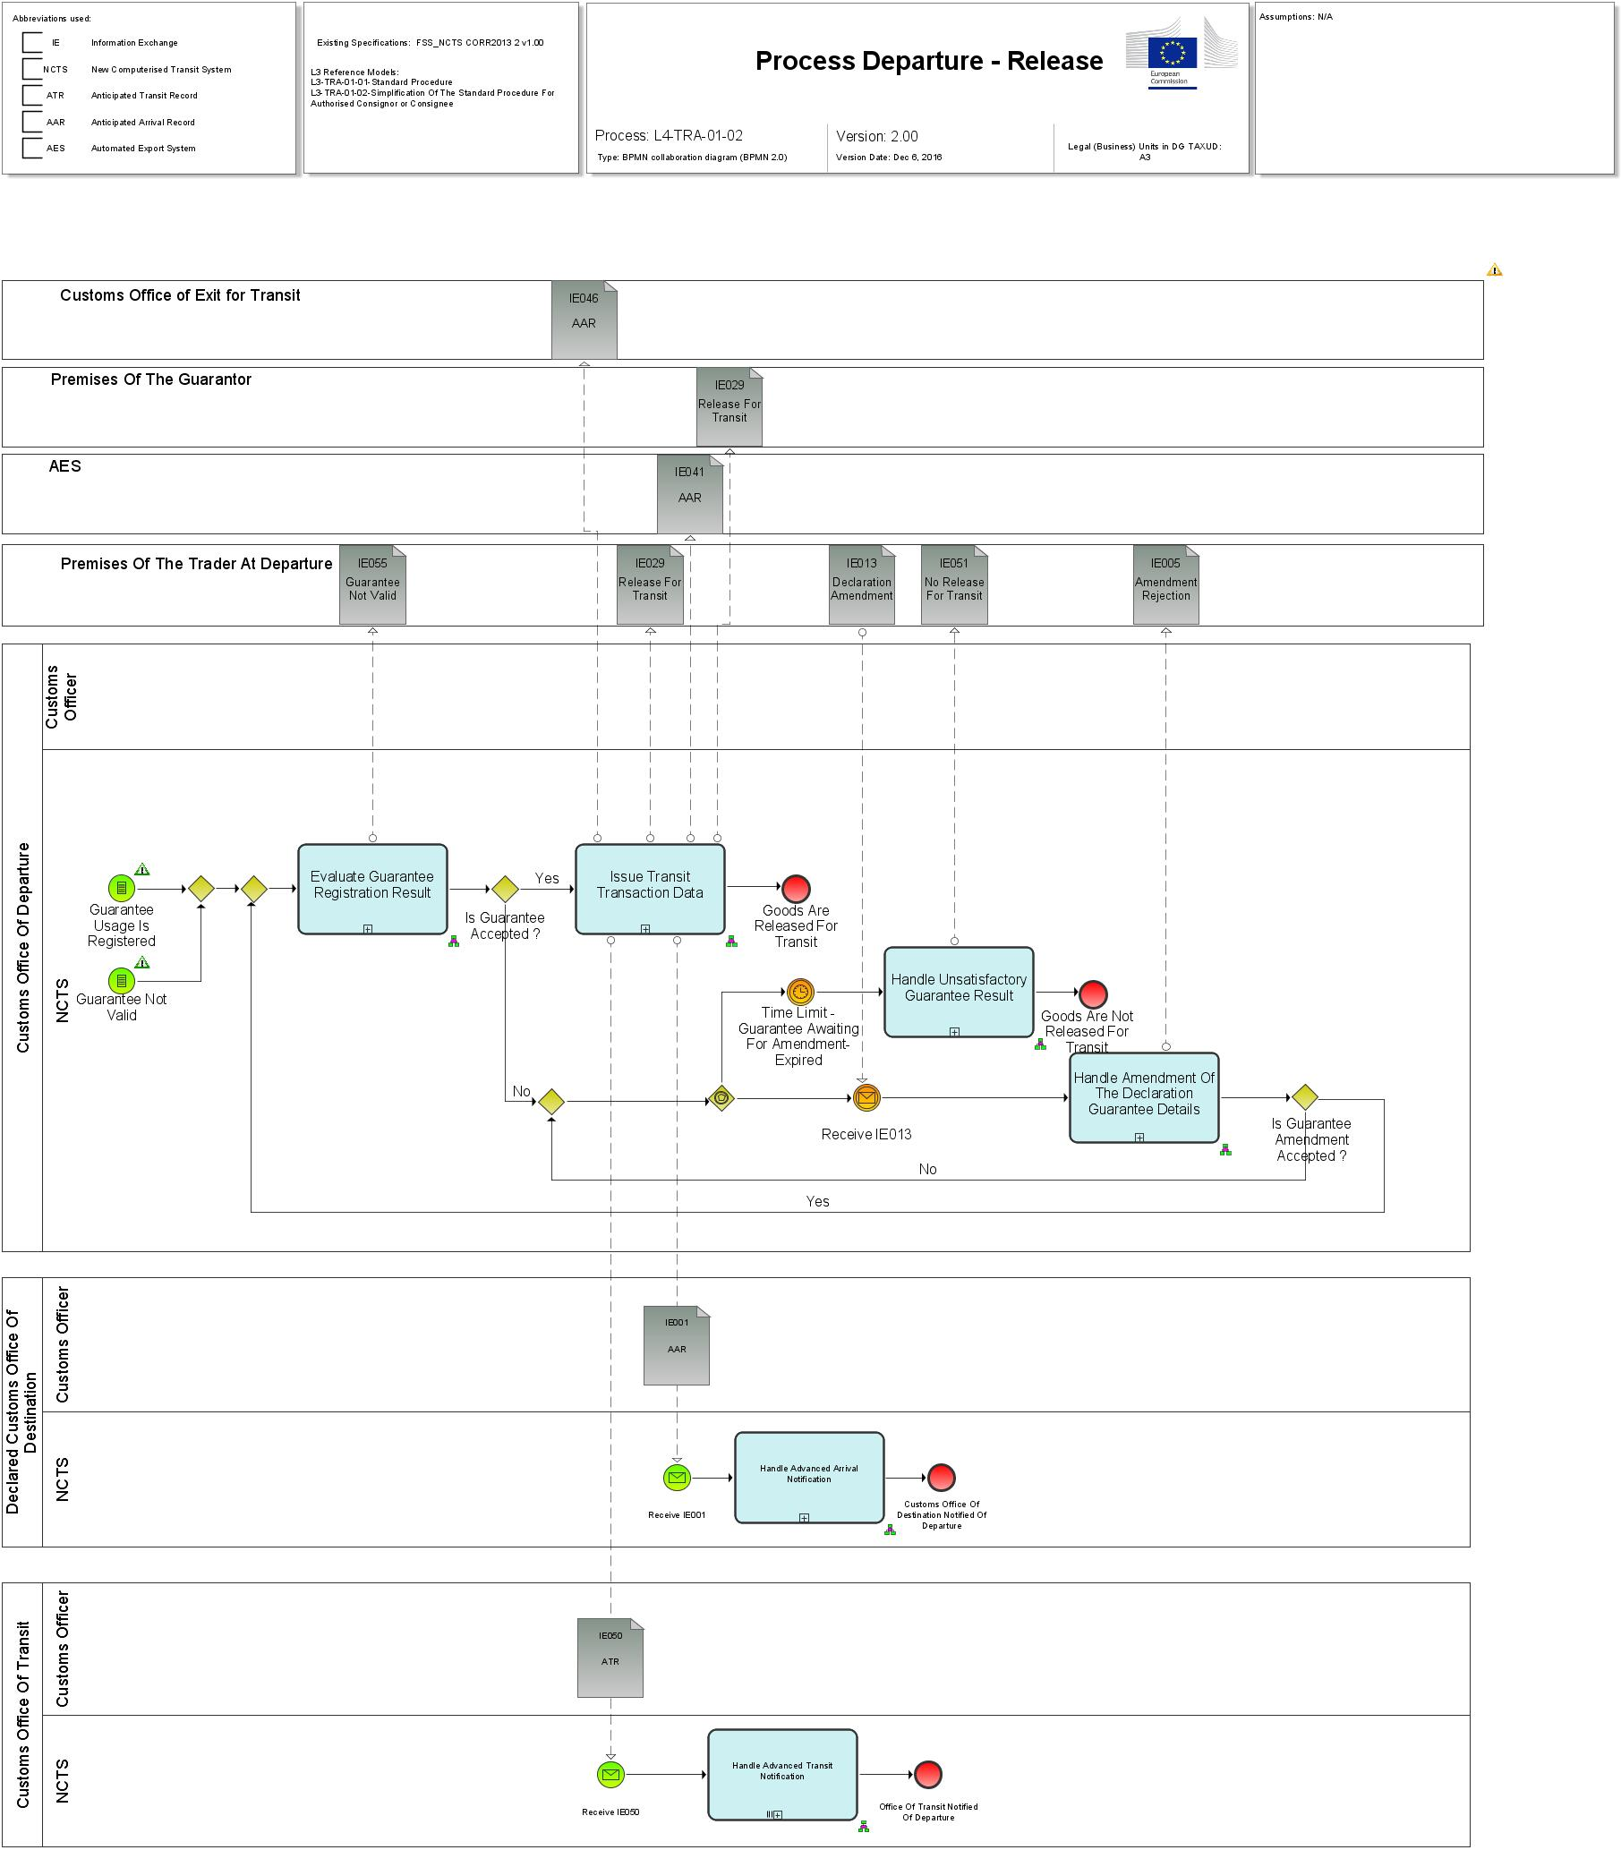

Figure 12: L4-TRA-01-02-Process Departure – Release (Part A)

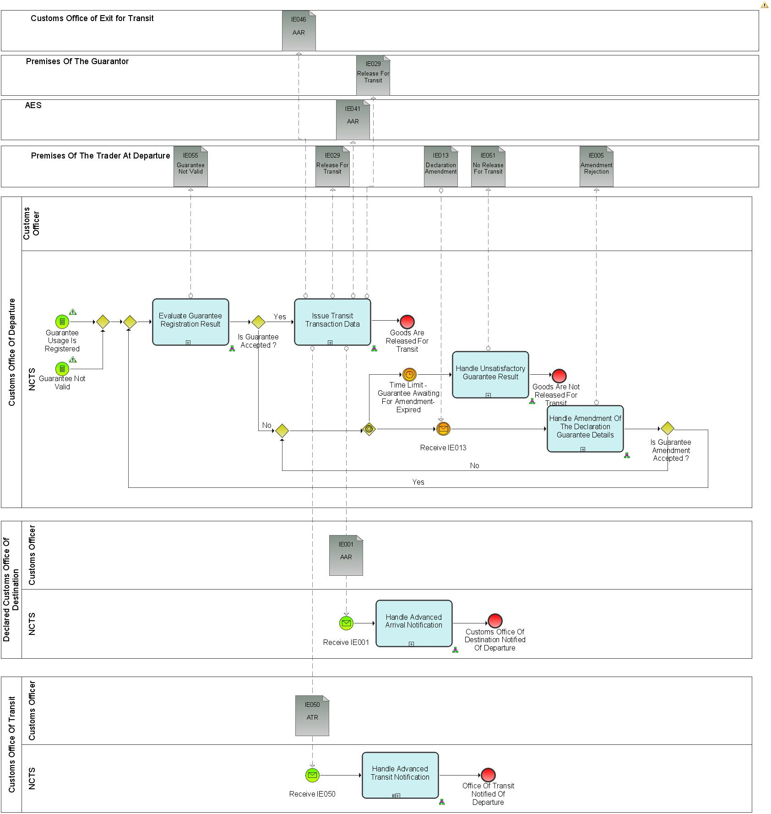

Figure 13: L4-TRA-01-02-Process Departure – Release (Part B)

Major Event

|  |
| --- |
| Guarantee check results are available |
| Organisation : National Customs Administration |
| Location : Customs Office of Departure |
| The results of the check and registration of the guarantees are available (Guarantee Usage is registered or Guarantee not valid). |

Minor Events

|  |
| --- |
| Holder of Transit Procedure amends the declaration guarantee details |
| Organisation : Trader |
| Location : Premise of Holder of Transit Procedure at Departure or Customs Office of Departure |
| The Holder of Transit procedure or Authorised Consignor amends the original guarantee details in order to avoid a non-release for Transit. |

|  |
| --- |
| Guarantee amendment timer expires |
| Organisation : National Customs Administration |
| Location : Customs Office of Departure |
| At the expiration of the timer ‘Guarantee Awaiting For Amendment” the declaration is automatically not released for Transit. |

Processes

|  |  |
| --- | --- |
| Evaluate guarantee registration result | Process: L4-TRA-01-02-01 |
| Organisation : National Customs Administration | |
| Location : Customs Office of Departure | |
| Constraint : | |
| Description :  When one of the checks of the registration of the guarantee usage failed, the Holder of Transit procedure is notified (IE055) that the declared guarantee is not valid.  The Holder of Transit procedure has the possibility to amend the invalid guarantee, so that the movement can still be released. A timer “Guarantee Awaiting For Amendment” is started to protect a non-amendment of the guarantee.  When all the checks of the registration of the guarantee usage are successful, then the movement is ready to be issued.  Final situation :  Either the guarantee is registered, the state of the Transit Operation is set to ‘Guarantee registered’, or the Holder of Transit procedure has to amend the guarantee, the state of the Transit Operation is set to ‘Guarantee under amendment’. | |

|  |  |
| --- | --- |
| Issue Transit transaction data | Process: L4-TRA-01-02-02 |
| Organisation : National Customs Administration | |
| Location : Customs Office of Departure | |
| Constraint :  If two or more of the Offices of Transit belong to the same National Administration, then only one ATR is sent (IE050) to the National Administration in question.  Safety and security risk analysis results shall be exchanged between the Union and other countries only if there is a legal basis for doing so. | |
| Description :  The three following dates are defined in the appropriate way when the movement is issued:   * The expected arrival date of the movement at the Customs Office of Destination (time allowed for the movement) is based only on the countries of departure and destination. The timer “Awaiting of Receipt of Arrival Advice” is started. If no arrival advice has arrived by the date fixed and the timer “Awaiting of Receipt of Arrival Advice” is expired, an enquiry will have to be started according to Handle Enquiry (process starts with L4-TRA-01-05 Status Request). * The date when the control results are expected to be returned from the Customs Office of Destination. The timer “Awaiting Receipt of Control Results” is started. This date is the expected arrival date plus a fixed number of days commonly defined by the national administrations (6 calendar days). If no control result is received by the date fixed and the timer “Awaiting Receipt Of Control Results” is expired, an enquiry will have to be started according to “Handle Enquiry” (process starts with L4-TRA-01-05 Status Request). * The expected arrival date of the movement at the Offices of Transit (INTENDED OFFICES OF TRANSIT (AND COUNTRY). Date and Time of arrival) * If the Transit declaration is used for security purposes (TRANSIT OPERATION. Security = '1’(ENS) and * If the Customs Office of Transit is located in an EU Member State.   This piece of information is used for risk analysis purposes in the context of safety and security.  The anticipated arrival record (AAR) is sent (IE001) to the Declared Customs Office of Destination (IE015.CUSTOMS CUSTOMS OFFICE OF DESTINATION. Customs Office of Destination (and country)).  If the Transit declaration is used for security purposes (TRANSIT OPERATION. Security = ‘2’ (EXS) or ‘3’ (ENS and EXS), a notification of the anticipated arrival record (AAR) is sent (IE046) to Customs Office of Exit for Transit. Customs Office of Exit for Transit is responsible for the record of the risk analysis results, the record of control decision, the record of control results and the release of goods.  In addition, and only for the EU Member States, in case the Goods are released for Transit, the System identifies if Transit follows Export and an anticipated arrival record (AAR) (IE041) notification is sent to AES.  An anticipated transit record (ATR) is sent (IE050) to each declared Customs Office of Transit (IE015. INTENDED OFFICES OF TRANSIT (AND COUNTRY). Intended offices of transit (and country)).  The risk analysis results shall be included in the anticipated arrival record (IE001/IE041/IE046) and in the anticipated transit record (IE050) in the following cases only:   * IE001:   + The Customs Office of Departure and the Customs Office of Destination are both located in an EU Member State. * IE046:   + The Customs Office of Departure and Customs Office of Exit for Transit are located in an EU Member State. * IE050:   + The Customs Office of Departure and the Customs Office of Transit are both located in an EU Member State.   The release is communicated (IE029) to the Trader and the Guarantor. The release information (IE029) corresponds always to the current (latest) version of the Transit operation data. This means that it contains the amended declaration data (if any) and/or the revised declaration data after a control (if any) and completed with the departure control results. At the request of the Holder of the Transit Procedure the NCTS Accompanying Document or MRN of Transit Declaration in an electronically readable format (TAD) is printed under the responsibility of the Customs Office of Departure, either at the Customs Office of Departure or at the Authorised Consignor’s premises.  Final situation :  The Transit transaction is issued; the declared Office(s) of Transit, the declared Customs Office of Destination and the NCTS Accompanying Document or MRN of Transit Declaration in an electronically readable format is printed and provided on the request of the Holder of Transit Procedure; the movement may go to destination, the state of the Transit Operation is set to ‘Movement released’. In case Transit follows Export, the Customs Office of Exit for Transit and AES are informed. | |

|  |  |
| --- | --- |
| Handle advanced Transit notification | Process: L4-TRA-01-02-03 |
| Organisation : National Customs Administration | |
| Location : Declared Customs Office of Transit | |
| Constraint :  If NCTS is also used for the purpose of safety and security, then full safety and security related risk analysis for all the goods shall be performed within the prescribed time limits under following conditions:   * The Customs Office of Transit is located in an EU Member State. | |
| **Description** :  The Office(s) of Transit receive(s) (IE050) and store(s), in advance, the movement description information of any movement in which it is declared as Customs Office of Transit (IE015. INTENDED OFFICES OF TRANSIT (AND COUNTRY). Intended offices of transit (and country)), i.e. it needs the movement description information before the arrival of the consignment, in the form of an anticipated Transit record (ATR).  If risk analysis results are communicated by the Customs Office of Departure, the results shall be recorded.  If the constraint is met:   * Full safety and security related risk analysis for all the goods shall be initiated by NCTS and performed by the national risk application according to the rules set out by the risk management framework. The national risk analysis system generates the risk analysis code. If the identified risk relates to a specific goods item of the transit declaration, the relevant goods item number shall be identified by the national risk analysis system. * The national risk analysis system records the risk analysis results in the NCTS transit declaration. If the risk analysis result relates to a specific goods item, then the relevant goods item is recorded (RISK ANALYSIS. Item number). In any other case the ’RISK ANALYSIS. Item number’ remains unused. * Random risk parameters shall be used additionally.   **Final situation :**  Office(s) of Transit is (are) ready to receive the consignment, the state of the Transit Operation is set to ‘ATR Created’. | |

|  |  |
| --- | --- |
| Handle advanced arrival notification | Process: L4-TRA-01-02-04 |
| Organisation : National Customs Administration | |
| Location : Declared Customs Office of Destination | |
| Constraint : | |
| Description :  The Declared Customs Office of Destination receives and stores (IE001), in advance, the movement description information of any movement in which it is declared as Customs Office of Destination (IE015. CUSTOMS OFFICE OF DESTINATION (AND COUNTRY). Customs Office of Destination (and country)), i.e. it needs the movement description information before the arrival of the consignment, in the form of an anticipated arrival record (AAR).  The Customs Office of Destination executes an automatic risk analysis on the received anticipated arrival record. If risk analysis results are communicated by the Customs Office of Departure, the results shall be recorded.  Control decision shall be based on the risk analysis result.  Final situation :  Customs Office of Destination is ready to receive the consignment; the state of the Transit Operation is set to ‘AAR Created’. | |

|  |  |
| --- | --- |
| Handle unsatisfactory guarantee result | Process: L4-TRA-01-02-05 |
| Organisation : National Customs Administration | |
| Location : Customs Office of Departure | |
| Constraint : | |
| Description :  When after an invalidation of the declared guarantee(s), the Holder of Transit procedure does not amend the guarantee in time (timer “Guarantee Awaiting for Amendment” expires), the system registers automatically the unsatisfactory control results in order to have a history log of the declaration. The system also notifies (IE051) the Holder of Transit procedure that the goods are not released for Transit.  Final situation :  The goods are not released, the state of the Transit Operation is set to ‘Not released for Transit’. | |

|  |  |
| --- | --- |
| Handle amendment of the declaration guarantee details | Process: L4-TRA-01-02-06 |
| Organisation : National Customs Administration | |
| Location : Customs Office of Departure | |
| Constraint : | |
| Description :  This process handles amendment requests on the declaration guarantee details (IE013), this means that the amendment flag (IE013.Amendment type flag) indicates that it concerns an amendment on the declaration guarantee details (and not on the entire declaration data). The amendment request (IE013) transports only the values of the guarantee.  The Customs Office of Departure receives (IE013) a guarantee amendment within the agreed time limit, this means before the expiration of the ‘Guarantee Awaiting for Amendment’ timer.  When the guarantee amendment failed to pass the formal validation process performed by the system, or when the amendment request contains other data to amend than guarantee details, it is rejected. The Customs Office of Departure notifies (IE005) the Holder of Transit procedure of the invalidation of the guarantee amendment with reasons.  When the formal validation process is successful, NCTS accepts the amended guarantee data and the processing continues with the check and the registration of the Guarantee. The timer “Guarantee Awaiting For Amendment” is stopped.  Final situation :  Either the guarantee amendment is valid, the state of the Transit Operation is set to ‘Guarantee under registration’, or the guarantee amendment is rejected, the state of the Transit Operation stays ‘Guarantee under amendment’. | |

Major Result

|  |
| --- |
| Movement may go to destination |
| Organisation : National Customs Administration |
| Location : Customs Office of Departure |
| The Union/Common Transit movement may start and go to the destination. |

Minor Results

|  |
| --- |
| Goods released for Transit |
| Organisation : National Customs Administration |
| Location : Premise of Trader at Departure or Customs Office of Departure |
| The NCTS Accompanying Document or MRN of Transit Declaration in an electronically readable format is printed upon request from the Holder of Transit Procedure or its representative. It is also can be printed by Authorised Consignor. In normal procedure, as per Article 41 of Appendix 1 of CTC, in case of CTC country, Customs Office of Departure has to provide printout of TAD to the Declarant. |

|  |
| --- |
| Enquiry initiation timer started |
| Organisation : National Customs Administration |
| Location : Customs Office of Departure |
| The timer that initiates an enquiry procedure is started. |

|  |
| --- |
| Customs Office of Transit notified of Departure |
| Organisation : National Customs Administration |
| Location : Declared Customs Office of Transit |
| The declared Office(s) of Transit is (are) notified of the departure and where relevant of the risk analysis results of a movement. |

|  |
| --- |
| Customs Office of Destination notified of Departure |
| Organisation : National Customs Administration |
| Location : Declared Customs Office of Destination |
| The declared Customs Office of Destination is notified of the departure and where relevant of the analysis results of a movement. |

|  |
| --- |
| Holder of Transit procedure notified of negative guarantee result |
| Organisation : National Customs Administration |
| Location : Premise of Trader at Departure or Customs Office of Departure |
| The Holder of Transit Procedure or Authorised Consignor is notified of the fact that the declared guarantee was not acceptable. |

|  |
| --- |
| Holder of Transit procedure notified of the invalidity of the guarantee details |
| Organisation : National Customs Administration |
| Location : Premise of Trader at Departure or Customs Office of Departure |
| The Holder of Transit Procedure or Authorised Consignor is notified of the fact that the amended guarantee details were not valid. |

|  |
| --- |
| Customs Office of Exit for Transit notified of transit release |
| Organisation : National Customs Administration |
| Location : Customs Office of Exit for Transit |
| The Customs Office of Exit for Transit is notified of transit release. |

|  |
| --- |
| AES notified of transit release |
| Organisation : National Customs Administration |
| Location : Customs Office of Exit for AES |
| The Customs Office of Exit for AES is notified of transit release. |

|  |
| --- |
| AES notified of no release for transit |
| Organisation : National Customs Administration |
| Location : Customs Office of Exit for AES |
| The Customs Office of Exit for AES is notified of no release for transit. |

The results “Goods not released for Transit” and “Check of the guarantees has been asked” are explained under Heading 2.4. L4-TRA-01-01 Process Departure - Acceptance and Controls.

## L4-TRA-01-03-Process Arrival

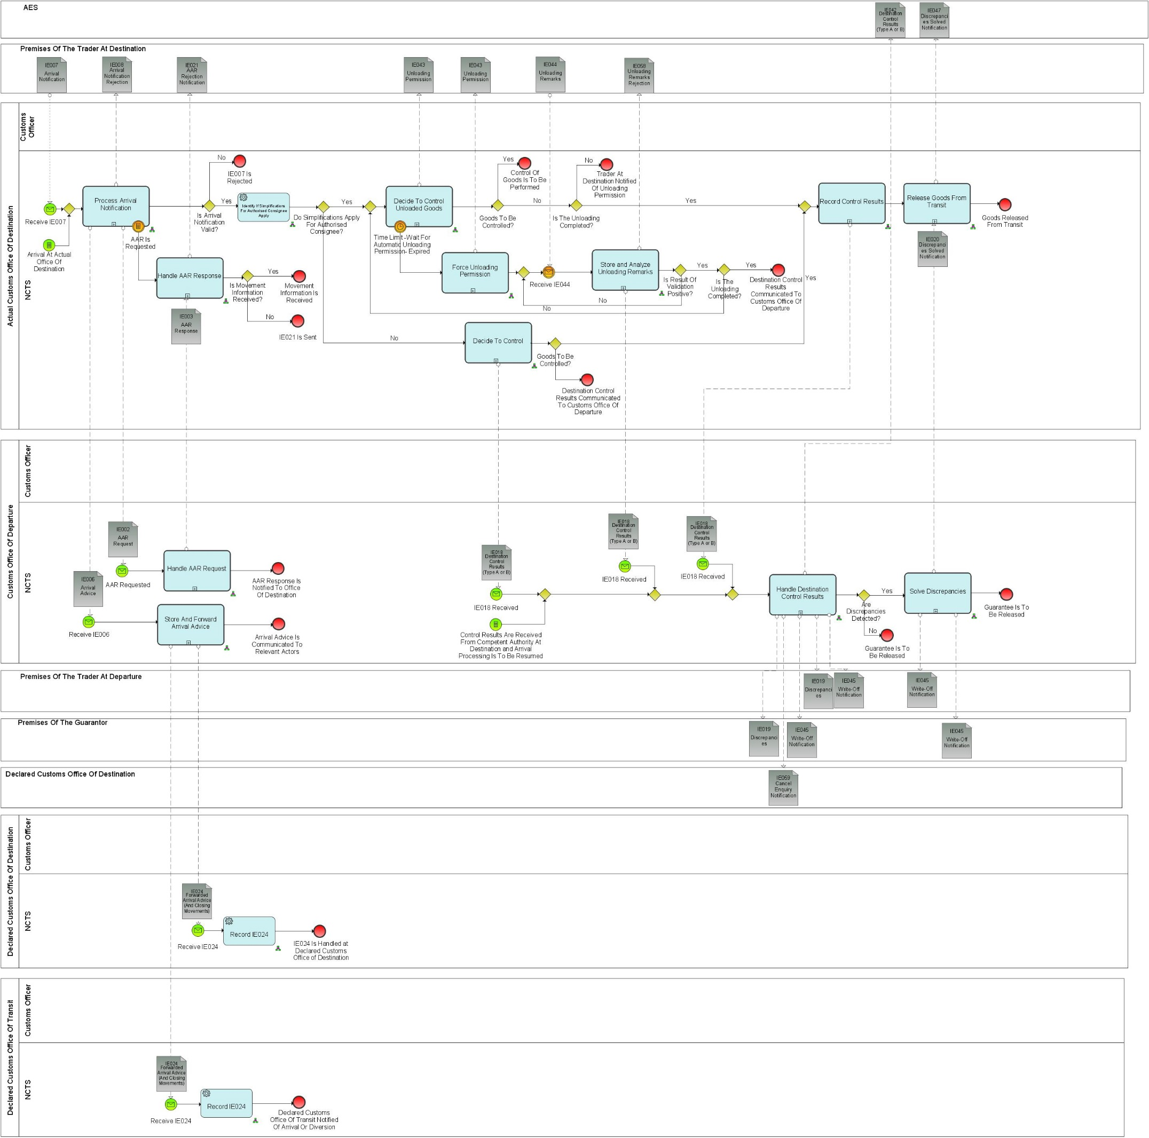

Figure 14: L4-TRA-01-03-Process Arrival (Part A)

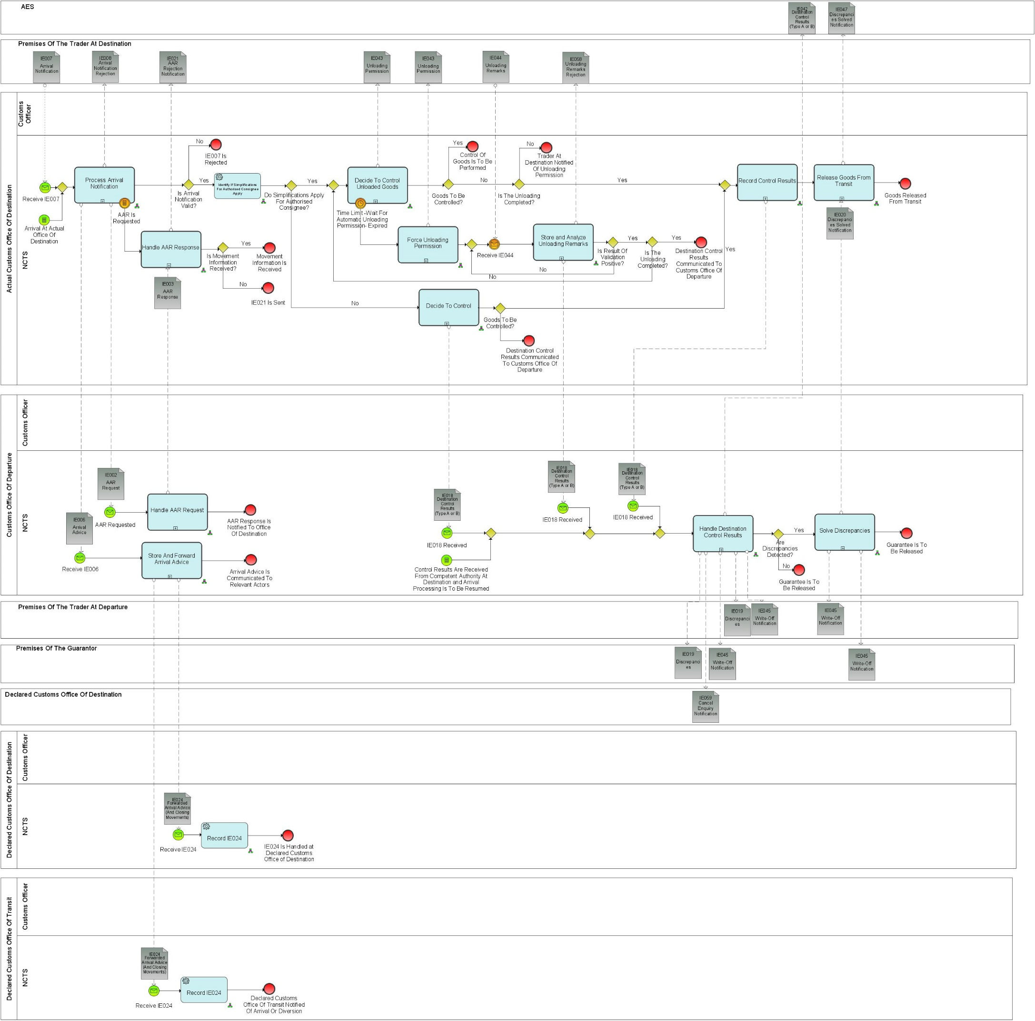

Figure 15: L4-TRA-01-03-Process Arrival (Part B)

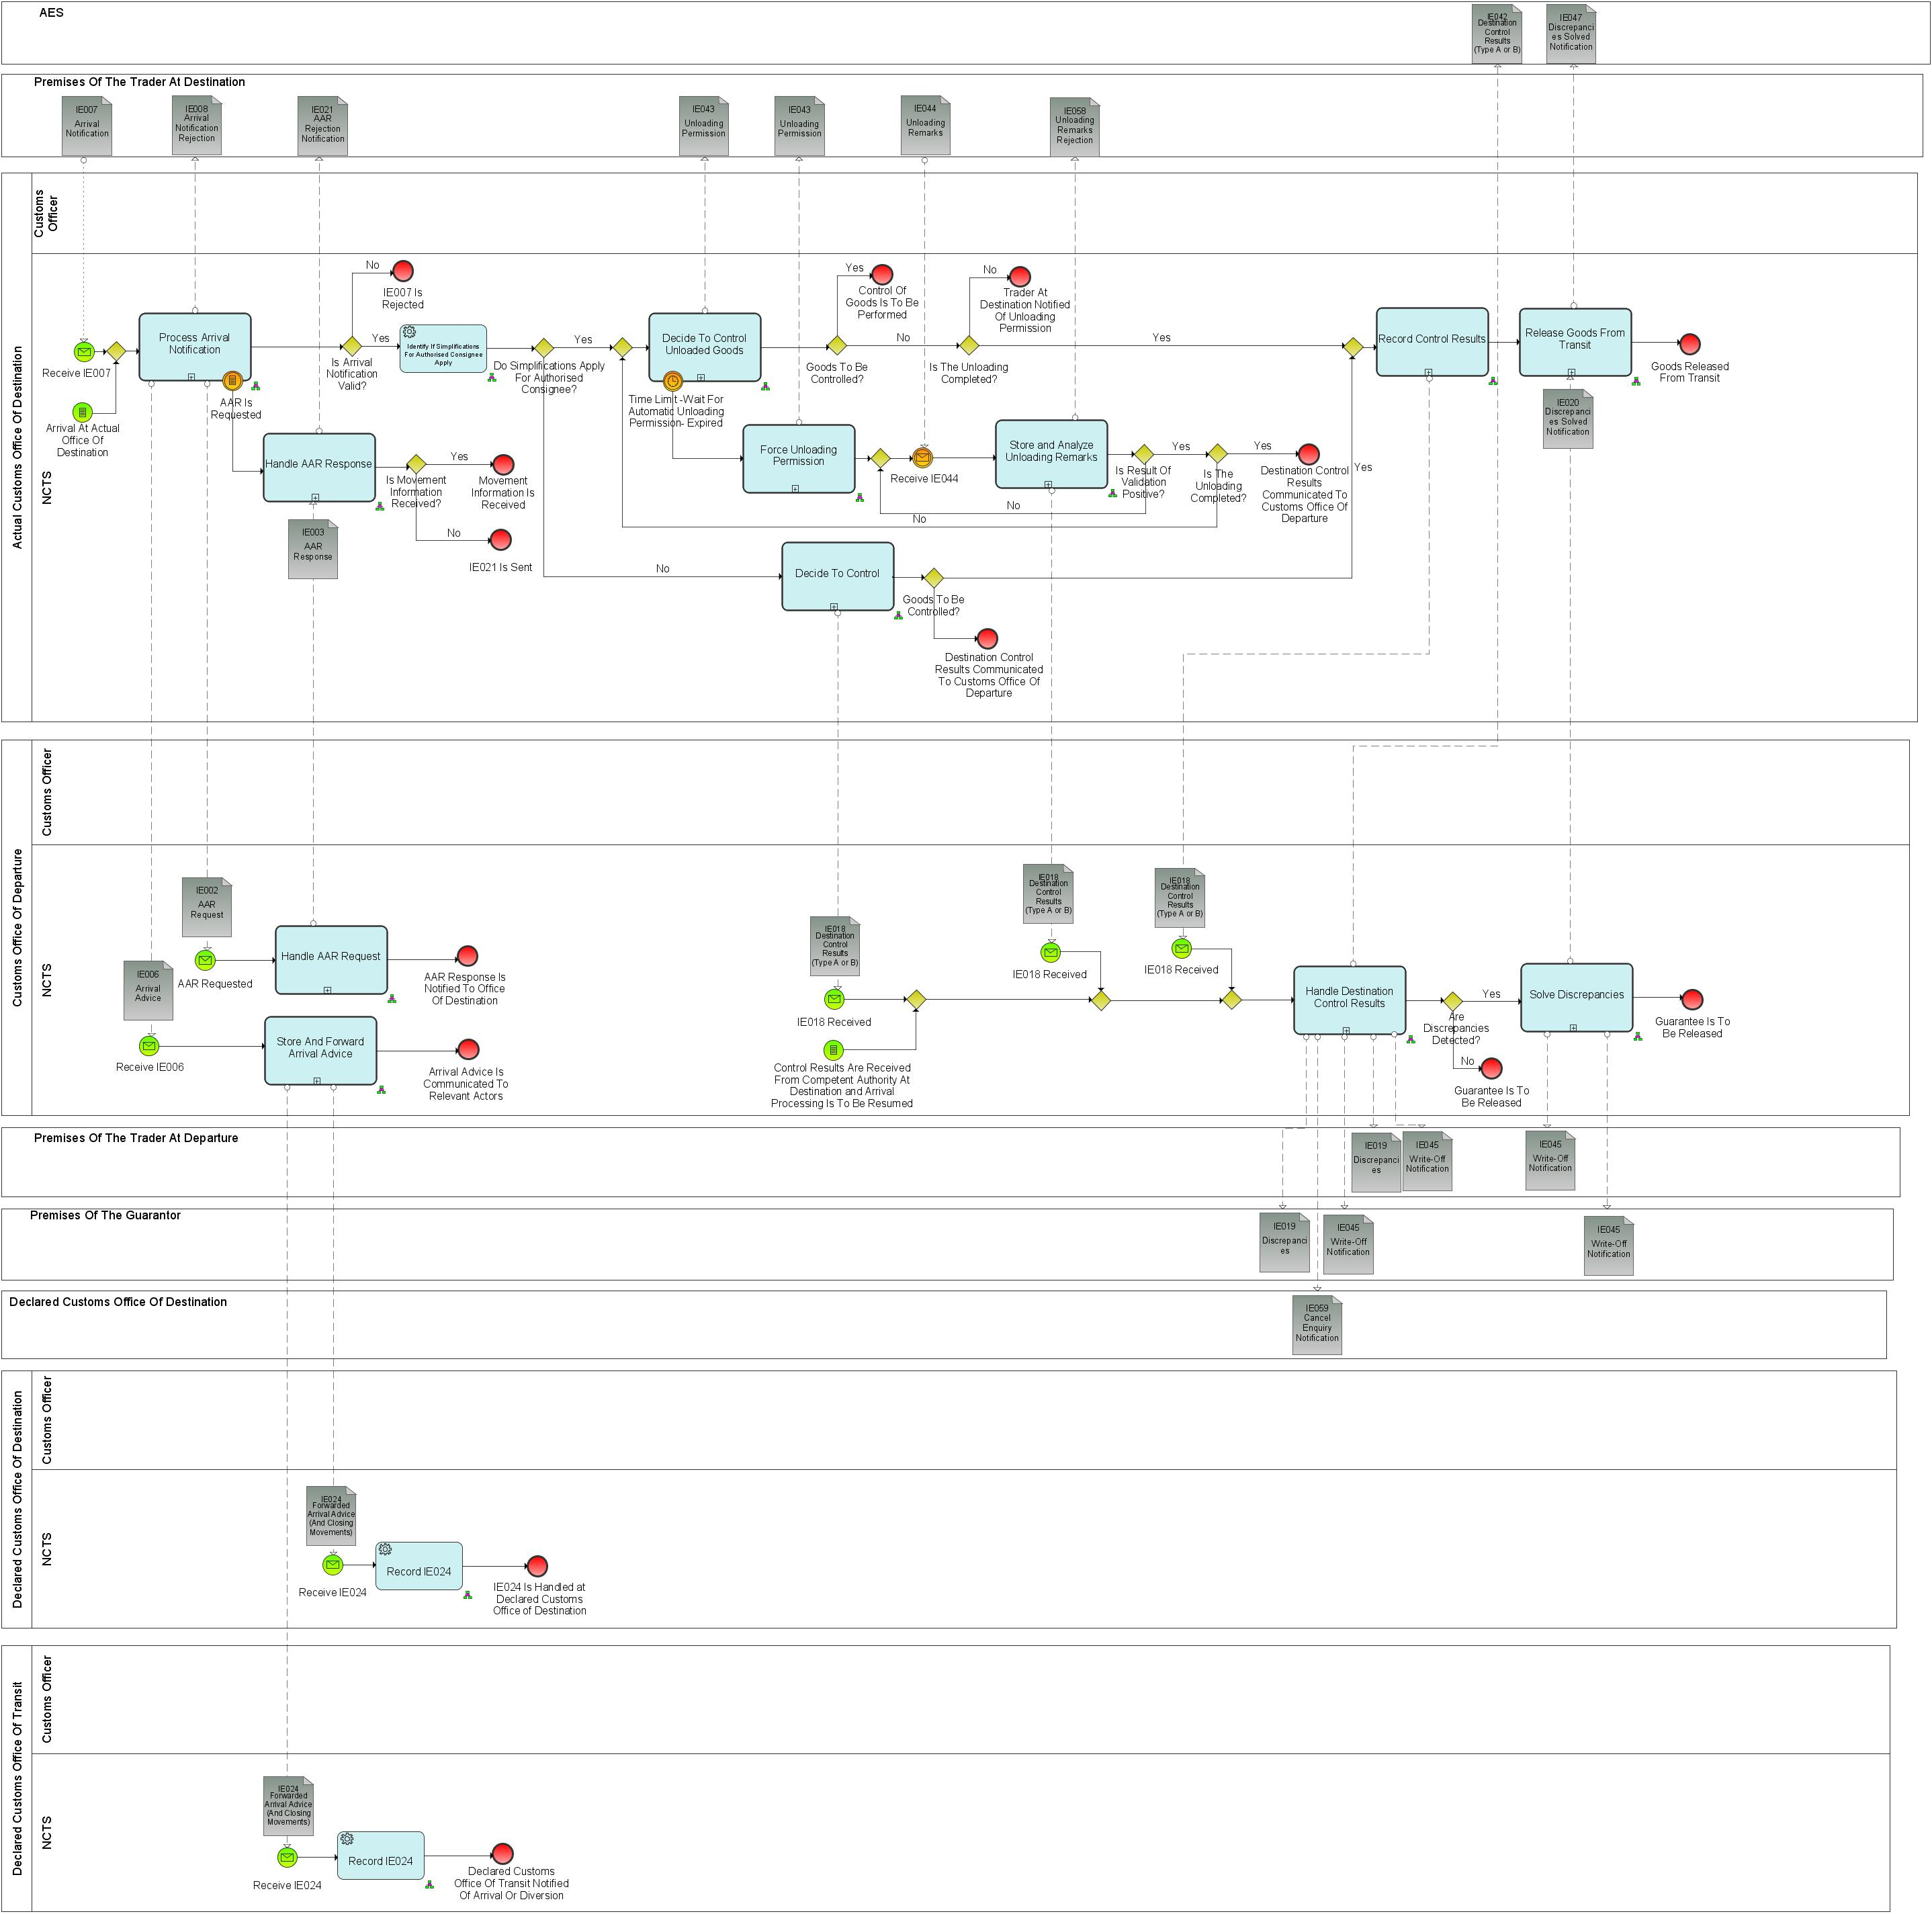

Figure 16: L4-TRA-01-03-Process Arrival (Part C)

Major Event

|  |
| --- |
| Transit consignment arrives at destination |
| Organisation : Trader |
| Location : Premises of the Trader at Destination or Actual Customs Office of Destination |
| The consignment has reached its destination.  The consignment may either be at the Customs Office of Destination or in some other place called the ‘goods place’ which will be specified to the Customs Office of Destination (designated location, authorized place, approved place, other). If the consignment is under the responsibility of an Authorised Consignee, the goods lay in the authorised place. |

Minor Events

|  |
| --- |
| Authorised Consignee sends unloading information |
| Organisation : Trader |
| Location : Premises of the Trader at Destination |
| The Authorised Consignee communicates the unloading information. |

|  |
| --- |
| Unloading authorisation timer expired |
| Organisation : National Customs Administration |
| Location : Actual Customs Office of Destination |
| At the expiration of the timer ‘Wait for automatic unloading permission’ the Trader is automatically notified that he can start the unloading of the goods. |

|  |
| --- |
| Goods to be controlled |
| Organisation : National Customs Administration |
| Location : Actual Customs Office of Destination |
| The Customs Officer takes the decision to control the consignment. This event stops the timer ‘Wait for automatic unloading permission’. |

Processes

|  |  |
| --- | --- |
| Process arrival notification | Process: L4-TRA-01-03-01 |
| Organisation : National Customs Administration | |
| Location : Actual Customs Office of Destination | |
| Constraint :  On reception of an arrival notification under simplified procedure, the Customs Office of Destination has to respond within the pre-defined time period defined in the authorisation of Authorised Consignee. | |
| Description :  The consignment has reached its destination or the Customs Office of Destination is notified (IE007) by the Authorised Consignee or by the Holder of Transit procedure representative of the arrival of a consignment.  When an arrival notification (IE007) is presented under simplified procedure (IE007.TRANSIT OPERATION. Simplified procedure flag = ‘Yes’), NCTS checks that the Trader who communicates the arrival (IE007.TRADER AT DESTINATION.TIN) is indeed authorised (Authorised Consignee) to use simplified procedure at that Customs Office of Destination and checks that the location where the consignment can be controlled (IE007. LOCATION OF GOODS. Type Of Location = ‘B’) is amongst the various authorised places specified in the authorisation.  When an arrival notification (IE007) is presented under normal procedure (IE007.TRANSIT OPERATION. Simplified procedure flag = ‘No’), then the location where the consignment can be controlled is either:   * At the Customs Office of Destination, when IE007. ‘Type Of Location’ is not ‘A’ or ‘C’; * At a designated location of goods, when IE007. ‘Type Of Location’= ‘A’ and acceptable by the Customs Office, the system will notify the Customs Officer that he has to validate manually the location, no further processing is foreseen in NCTS to handle this kind of locations; * At an approved place, when IE007. ‘Type Of Location’= ‘C’; in this case NCTS checks it against the various Customs sub places acceptable for the Customs Office of Destination.   When the arrival is invalid, NCTS rejects the arrival notification and notifies (IE008) the Trader that the presentation is invalid with the reason of the rejection.  When the arrival is valid, NCTS looks for the movement information referenced by the MRN brought in by the arrival notification (IE007.TRANSIT OPERATION.MRN).  If the movement information is not available either in case of international diversion[7] or in exceptional situations[8], or in case Customs Office of Incident Registration is considered to be Customs Office of Destination[9], NCTS asks (IE002) that information from the Country of Departure.  If an AAR request is made (IE002) to the Country of Departure, then this process ends by recording that the AAR has been requested.  If no diversion occurred, NCTS notifies (IE006) the Customs Office of Departure that the arrival is accepted and the arrival is recorded into NCTS. In case of simplified procedure, a timer “Wait for automatic unloading permission” is started to protect a non-decision to control the goods that could be taken by the Customs Officer.  Processing common to BPM L4-TRA-01-03-04.  An analysis of risk is done at this stage. NCTS triggers the risk analysis process. Data received is sent to the national risk analysis system and is processed against risk rules (including common risk criteria and standards where applicable). Risk analysis returns the risk analysis result code together with the control recommendation. Risk analysis results, control recommendation and control results communicated by the Customs Office of Departure can be taken into account.  NCTS records the results of the risk analysis.  Final situation :  If the arrival notification is not valid then it is rejected, the state of the Transit Operation remains ‘AAR Created’;  If there is an international diversion or it is decided to stop the movement after registration of incidents En route, the Customs Office of Destination awaits the information from the Customs Office of Departure, the state of the Transit Operation is set to ‘AAR Requested’;  In the other cases, the arrival is accepted and recorded into NCTS, the Customs Office of Departure is notified of the arrival,the state of the Transit Operation is set to ‘Arrival Accepted’.  The risk analysis is carried out and the result is recorded in NCTS. | |

|  |  |
| --- | --- |
| **Handle AAR request** | **Process: L4-TRA-01-03-02** |
| **Organisation :** National Customs Administration | |
| **Location :** Customs Office of Departure | |
| **Constraint :**  This business process is used to obtain data on a Transit Operation for which data is not available in the country of the actual Customs Office of Destination (international diversion or exceptional case). Automated response should be returned to Customs Office of Destination in maximum 60 seconds.  Safety and security risk analysis results shall be exchanged between the EU member states and other CTC countries only if there is a legal basis for doing so. | |
| **Description :**  The Country of Departure is asked (IE002) by the Customs Office of Destination to provide information about a movement. NCTS retrieves the movement information referenced by the MRN brought in the received information (IE002.TRANSIT OPERATION.MRN).  If an incident or a diversion has occurred during the journey, NCTS identifies if information regarding the incident/diversion is available. If this information is available, the response (IE003) shall contain the updated IE001 data, amended with the incident/diversion information included in IE039. NCTS automatically sends (IE003) back to the Customs Office of Destination the required information about the movements. If the provided request (IE002) relates to a transit movement which is also used for safety and security (IE001. TRANSIT OPERATION. Security =’1’ (ENS), ‘2’ (EXS) and ‘3’ (ENS and EXS), if the requested data is available at departure, then the response (IE003) shall contain the relevant additional safety and security data elements.  The safety and security risk analysis results shall be sent in IE003 if all of the following conditions are met:   * The requesting (actual) Customs Office of Destination is located in an EU Member State; * The declared Customs Office of Departure is located in an EU Member State.   **Final situation :**  IE003 is sent to the Customs Office of Destination. | |

|  |  |
| --- | --- |
| Store and forward arrival advice | Process L4-TRA-01-03-03 |
| Organisation : National Customs Administration | |
| Location : Customs Office of Departure | |
| Constraint :  When two or more Offices of Transit or a Customs Office of Transit and the Customs Office of Destination belong to the same National Administration, then only one IE024 is sent to the National Administration in question. | |
| Description :  The Customs Office of Departure is notified (IE006) about the acceptance of an arrival by the Customs Office of Destination. Based on the MRN brought in the arrival advice (IE006.TRANSIT OPERATION.MRN), NCTS records the arrival or diversion of the consignment.  NCTS notifies (IE024) the declared Customs Office of Destination (in case of diversion) and the declared Offices of Transit (which have not notified that the consignment has crossed the frontier) related to the movement of the arrival at destination. In addition, if a Customs Office has asked for IE003 or IE115, but these messages are not used, then an IE024 will also be sent to these offices in order to close the IE003, and/or the IE115.  If the case occurs, NCTS notifies the Customs Officer that the movement has ended in a Contracting Party other than the one declared so that the Customs Office of Departure can take, where necessary, measures to regularise the situation.  In case of use of Guarantee codes ‘0’ and ‘1’, NCTS asks the Customs Office of Guarantee to credit the reference amount.  When an enquiry at another Customs Office of Destination is in progress, NCTS records the cancellation of the enquiry and notifies (IE059) all Customs Offices (except the one which sent the control results) that were requested to answer to the enquiry about the cancellation.  If during an enquiry the Customs Office of Departure is notified via IE143 with code 3 (return copy returned on) about the arrival by the Customs Office of Destination, the Customs Office of Departure awaits the arrival of the alternative proof and NCTS records the arrival of the consignment. When the Customs Office of Departure receives the alternative proof (see L4-TRA-01-06-02-Check Provided Information, L4-TRA-01-07-05-Waiting For Paper Control Result To Arrive), the IE024 is sent to all involved offices to close the movement in their system.  Final situation :  The Customs Office of Departure is notified of the arrival of the movement at destination, the state of the Transit Operation is set to ‘Arrived’; the credit of the reference amount is asked. | |

|  |  |
| --- | --- |
| Handle AAR response | Process: L4-TRA-01-03-04 |
| Organisation : National Customs Administration | |
| Location : Actual Customs Office of Destination | |
| Constraint :  Goods may be diverted to a Customs Office of Destination which at the same time may be the Customs Office of first Entry into the Union.  Therefore, if the Office receiving the AAR-response is the Customs Office of first Entry it shall perform risk analysis for safety and security purpose. | |
| Description :  The Customs Office of Destination receives (IE003) the answer from the Customs Office of Departure about a Transit movement.  If the answer does not contain the requested AAR (IE003.TRANSIT OPERATION. AAR rejection reason is present), NCTS rejects the arrival and notifies (IE021) the Trader about the rejection.  In case of use of additional information codes ‘20100’ or ‘20200’, NCTS notifies the Customs officer at the Customs Office of Destination that the goods shall be kept under its control and not allow their removal other than to the Union or Common Transit Country having jurisdiction over the Customs Office of Departure, unless specifically authorised by the latter.  The provided AAR-response (IE003) contains the relevant safety and security data elements under following conditions:   * The requested AAR-data is provided (IE003.TRANSIT OPERATION. AAR rejection reason is not present) * NCTS is used for safety and security (IE003.TRANSIT OPERATION. Security = ‘1’ (ENS)),   For the rest of the processing, see common processing described in BPM L4-TRA-01-03-01.  Diversion: If the constraint is met (Office is considered to be the Customs Office of first Entry into the Union):   * Full safety and security related risk analysis for all the goods shall be initiated by NCTS and performed by the national risk application according to the rules set out by the risk management framework. * The national risk analysis system generates the risk analysis code. If the identified risk relates to a specific goods item of the transit declaration, the relevant goods item number shall be identified by the national risk analysis system. * The national risk analysis system records the risk analysis results in the NCTS transit declaration. If the risk analysis result relates to a specific goods item, then the relevant goods item is recorded (RISK ANALYSIS. Item number). In any other case the ’RISK ANALYSIS. Item number is not used. * Random risk parameters shall be used additionally. * If risk is identified: * The Customs Officer is alerted and asked to register a control decision. * Normal procedure: Next step is L4-TRA-01-03-08 -Decide to control. * Simplified procedure: The sending of the unloading permission is blocked. Next step is “Control of the goods” (Manual Process).   When diversion occurred (movement information not available at the Customs Office of Destination), NCTS records the movement information (IE003.C_AAR_SND) into the system and notifies (IE006) the Customs Office of Departure that the arrival is accepted. In case of simplified procedure, a timer “Wait for automatic unloading permission” is started to protect a non-decision to control the goods that could be taken by the Customs Officer.  Final situation :  Where the AAR is not provided the Trader is informed consequently.  The diversion is recorded into NCTS, the Customs Office of Departure is notified of the arrival,andthe state of the Transit Operation is set to ‘Arrival Accepted’. | |

|  |  |
| --- | --- |
| Decide to control unloaded goods | Process: L4-TRA-01-03-05 |
| Organisation : National Customs Administration | |
| Location : Actual Customs Office of Destination | |
| Constraint :  This process can only occur for movements under simplified procedure. | |
| Description :  In case controls are decided to be performed, NCTS records this decision.  In case it is decided not to control the goods and the unloading is not completed, NCTS records this decision and notifies (IE043) the Authorised Consignee of the decision allowing him to continue the unloading (IE043.TRANSIT OPERATION. Continue unloading present).  In case it is decided not to control the goods and the unloading is completed, NCTS notifies the Customs Officer at the Customs Office of Destination that he has to analyse the unloading remarks in order to translate them into control results.  Final situation :  One of the following decision is taken:  No control at all, the state of the Transit Operation is set respectively to ‘Unloading’ (if the unloading is not completed).  A control has been decided, the state of the Transit Operation is set to ‘Under control’. | |

|  |  |
| --- | --- |
| Force unloading permission | Process: L4-TRA-01-03-06 |
| Organisation : National Customs Administration | |
| Location : Actual Customs Office of Destination | |
| Constraint :  This process can only occur for movements under simplified procedure. | |
| Description :  The Customs Officer at Destination didn’t take the decision to control the goods within the agreed time period. Thus, NCTS notifies (IE043) the Trader that he can start the unloading of the goods and records the unloading permission.  Final situation :  The Trader is notified that he can start the unloading of the goods. The state of the Transit Operation is set to ‘Unloading’. | |

|  |  |
| --- | --- |
| Store & analyse unloading remarks | Process: L4-TRA-01-03-07 |
| Organisation : National Customs Administration | |
| Location : Actual Customs Office of Destination | |
| Constraint :  This process can only occur for movements under simplified procedure. | |
| Description :  The Customs Office of Destination receives (IE044) unloading information from the Authorised Consignee. NCTS checks the validity of the received information.  NCTS notifies (IE058) the Trader at Destination in case the validity checks are not successful.  Based on the MRN (IE044.TRANSIT OPERATION.MRN), NCTS link properly the unloading remarks information (IE044.UNLOADING REMARK) with the transit movement.  When the unloading is completed (IE044.UPLOADING REMARK. Uploading Completion is set to yes) without unloading remarks, then NCTS records that the goods are ready for the next procedure / activity (e.g. temporary storage, import procedure).  NCTS notifies (IE018) the Customs Office of Departure about the control results set to “Considered satisfactory”. When the Customs Office of Destination is waiting for discrepancies resolution (IE018.CONTROL RESULT. Waiting For Discrepancies Resolution is set to yes) the timer “Awaiting Receipt of IE020 Message” is started (setting time limit of 6 calendar days).  When the unloading process is not completed (IE044.UNLOADING REMARK.Unloading Completion = No) and unloading remarks exist, then the Customs Officer is notified by NCTS that a decision to control or not control the consignment must be taken.  Final situation :  The goods are ready for the next procedure / activity (e.g. temporary storage, import procedure), the state of the Transit Operation is set to ‘Goods released’; or  The Customs Officer has to decide to control or not the consignment, the state of the Transit Operation is set to ‘Unloading Remarks’. | |

|  |  |
| --- | --- |
| Decide to control | Process: L4-TRA-01-03-08 |
| Organisation : National Customs Administration | |
| Location : Actual Customs Office of Destination | |
| Constraint :  This process can only occur for movements under Normal Procedure. | |
| Description :  The process is started when an Arrival Notification is accepted. The Customs Officer registers his/her decision whether to control or not the Goods. If the decision is 'Goods to be Controlled' then a manual control of the Goods is performed. If not, when Customs Office of Destination notifies the Customs Office of Departure about the control results (IE018. CONTROL RESULTS) and the Custom Office of Destination is waiting for discrepancies resolution (IE018.CONTROL RESULT. Waiting for Discrepancies Resolution is set to yes) the timer “Awaiting Receipt of IE020 Message” is started (setting time limit of 6 calendar days).  Final situation :  Either no control is performed at all, the state of the Transit Operation is set to ‘Goods released’, or a control will be performed, the state of the Transit Operation is set to ‘Under Control’. | |

|  |  |
| --- | --- |
| Handle destination control results | Process: L4-TRA-01-03-09 |
| Organisation : National Customs Administration | |
| Location : Customs Office of Departure | |
| Constraint : | |
| Description :  The Customs Office of Departure receives (IE018) the control results from the Customs Office of Destination. Based on the MRN brought in the control results (IE018.TRANSIT OPERATION.MRN), NCTS records these control results and the timer “Awaiting Receipt Of Control Results” is stopped. In case, Transit follows Export, NCTS notifies AES (IE042) about the Control Results (Type A or B) as well.  When there are major discrepancies detected (IE018.CONTROL RESULT. Control result type is equal to “B1”) then:   * The Customs Officer or NCTS records that the Holder of Transit procedure responsibility is extended and notifies (IE019) the Guarantor and the Holder of Transit procedure about their extended responsibility. * When the Customs Officer at the Customs Office of Destination decided to wait for the discrepancies resolution before releasing of the goods (IE018.CONTROL RESULT. Waiting for discrepancies resolution is set on yes), NCTS notifies the Customs Officer at Departure that the Customs Office of Destination is waiting for the discrepancies resolution.   When there are minor or no discrepancies detected (IE018.CONTROL RESULT. Control result type equal to “A”) then:   * The Customs Officer or NCTS records the write-off; * NCTS asks the release of the guarantee (see process “L4-TRA-02-05 Release Guarantee”); * When an enquiry was in progress, NCTS notifies (IE045) the Holder of the Transit Procedure and the Guarantor that the movement is written-off.   When an enquiry is in progress about the movement, the Competent Authority of Enquiry, is notified (IE059) that the enquiry related to the movement identified by IE059.TRANSIT OPERATION.MRN can be cancelled. Final situation :  If there are no discrepancies then the movement is written-off; the release of the guarantee is asked; any enquiry is cancelled; the state of the Transit Operation is set to ‘Movement written off’. If there are discrepancies, these have first to be solved; the state of the Transit Operation is set to ‘Movement under resolution’. | |

|  |  |
| --- | --- |
| Solve discrepancies | Process: L4-TRA-01-03-10 |
| Organisation : National Customs Administration | |
| Location : Customs Office of Departure | |
| Constraint :  If the Customs Office of Destination decided to wait for the discrepancies resolution, the Customs Office of Departure is notified of that decision. The Customs Officer at the Customs Office of Departure is then aware that the release of the goods is suspended until the end of the resolution. | |
| Description :  This is a procedure to be handled if control results are of type ‘B1’ (IE018.CONTROL RESULT. Control result type equal to ‘B’). If the Customs Office of Destination decided to wait for the discrepancies resolution, the Customs Officer at the Customs Office of Departure is notified of that decision by the system (IE018.CONTROL RESULT. Waiting for discrepancies resolution is set on yes). He is then aware that the further process of the goods is suspended until the entire clarification of the irregularities.  This procedure mainly consists of exchanging information between the Customs Office of Destination or the Holder of Transit procedure and the Customs Office of Departure. Papers related to the movement are checked against the data in the system. During the procedure the IE144 and IE145 can be used to exchange information or questions, whereas the IE144 is sent only by the Customs Office of Departure and IE145 is sent only by the Customs Office of Destination. This information exchange can be started either by the Customs Office of Departure or the Customs Office of Destination, no reply is needed since it can be only information sent and not a question asked. NCTS will provide Customs Officer at Customs Office of Departure and Customs Office of Destination with:   1. Access to the information about that movement, based on the MRN brought in the control results (IE018.TRANSIT OPERATION.MRN); 2. Τools to allow them to record and track the operations performed in order to solve those discrepancies (see section 2.14 - ‘Assist users in their daily work’). IE144 and IE145 can be used to exchange information during the procedure.   NCTS will provide Customs Officer at Customs Office of Departure and Customs Office of Destination with:   * Access to the information about that movement, based on the MRN brought in the control results (IE018.TRANSIT OPERAT ION.MRN); * Tools to allow them to record and track the operations performed in order to solve those discrepancies (see section 2.14 - ‘Assist users in their daily work’). IE144 and IE145 can be used to exchange information.   After the discrepancies are solved:   * NCTS records the write-off, notifies (IE045) the Holder of Transit procedure and the Guarantor that the movement is written-off and asks the release of the guarantee. * When the Customs Office of Destination decided to wait for the discrepancies resolution (IE018.CONTROL RESULT. Waiting for discrepancies resolution is present), NCTS notifies (IE020) this Customs Office of Destination that the discrepancies are solved so that Customs Office of Destination can release the goods.   Final situation :  When the discrepancies are solved, then the movement is written-off; the release of the guarantee is asked; the state of the Transit Operation is set to ‘Movement written off’.  If requested, the Customs Office of Destination is notified of the discrepancies resolution. | |
|  | |

|  |  |
| --- | --- |
| Record control results | Process: L4-TRA-01-03-11 |
| Organisation : National Customs Administration | |
| Location : Actual Customs Office of Destination | |
| Constraint : | |
| Description :  The Customs Officer at the Customs Office of Destination has to record the results of a control after he returns from the control of the goods (IE1206) or (only under Simplified Procedure) he has to translate unloading remarks received (IE044) from an Authorised Consignee into control results of type A or B.  In case of control results of type B, before releasing the goods, the Customs Officer at the Customs Office of Destination decides if he/she will wait for the resolution of discrepancies performed at the Customs Office of Departure. The Customs Office of Departure will be informed if the Customs Office of Destination decided so (IE018). When the Customs Office of Destination is waiting for discrepancies resolution (IE018.CONTROL RESULT. Waiting For Discrepancies Resolution is set to yes) the timer “Awaiting Receipt of IE020 Message” is started (setting time limit of 6 calendar days).  NCTS records the control results.  When there are no discrepancies or the Customs Officer decides not to wait for the discrepancies resolution at the Customs Office of Departure, then NCTS records that the goods are ready for the next procedure / activity (e.g. temporary storage, import procedure).  When the Customs Officer decides to wait for the discrepancies resolution at the Customs Office of Departure, then NTCS records the fact that the Customs Office of Destination is waiting.  NCTS notifies (IE018) the Customs Office of Departure about the control results.  Final situation :  Control results are stored into NCTS. The Customs Office of Departure is notified of the control results; the goods are either ready for the next procedure / activity (e.g. temporary storage, import procedure), the state of the Transit Operation is set to ‘Goods released’ or discrepancies have first to be solved by the Customs Office of Departure, the state of the Transit Operation is set to ‘Waiting for discrepancies resolution’. | |

|  |  |
| --- | --- |
| Release goods from Transit | Process: L4-TRA-01-03-12 |
| Organisation : National Customs Administration | |
| Location : Actual Customs Office of Destination | |
| Constraint : | |
| Description :  When the Customs Office of Destination is notified (IE020) by the Customs Office of Departure within the time limit of 6 calendar days from the day IE018 was received the timer “Awaiting Receipt of IE020 Message” is stopped. NCTS determines automatically if the discrepancies of the movement (IE020.TRANSIT OPERATION.MRN), are resolved or not at the Customs Office of Departure (ΙΕ020. TRANSIT OPERATION. Discrepancy Solved Notification code). In case Transit follows Export, AES is notified (IE047) about the discrepancies solved.  NCTS records that the goods are ready for the next procedure / activity (e.g. temporary storage, import procedure). In case of internal Union Transit, the goods are released from transit (the Trader can dispose of the goods). NCTS notifies (IE025) the Trader of that fact.  Final situation :  The goods are ready for the next procedure / activity (e.g. temporary storage, import procedure). In case of internal Union Transit, the goods are released from transit (the Trader can dispose of the goods), the state of the Transit Operation is set to ‘Goods released’. | |

|  |  |
| --- | --- |
| Close frontier | Process: L4-TRA-01-03-03 |
| Organisation : National Customs Administration | |
| Location : Declared Customs Office of Transit | |
| Constraint : | |
| Description :  The declared Customs Office of Transit, related to the movement, is notified (IE024) by the Customs Office of Departure about the arrival of the consignment at destination. The same occurs in case the Customs Office of Transit requested an IE115, but has not (yet) confirmed the crossing of the border (IE118 not sent) to the Office of Departure. Based on the MRN brought in the forwarded arrival advice (IE024.TRANSIT OPERATION.MRN), NCTS records the arrival of the consignment and so avoids any future usage of that MRN.  Final situation :  The relevant Office(s) of Transit is/are notified about the arrival of the movement at destination; the state of the Transit Operation is set to ‘Arrived’. | |

|  |  |
| --- | --- |
| Record diversion | Process: L4-TRA-01-03-03 |
| Organisation : National Customs Administration | |
| Location : Declared Customs Office of Destination | |
| Constraint : | |
| Description :  The Declared Customs Office of Destination is notified (IE024) by the Customs Office of Departure about a diversion. The same occurs in case the Customs Office of Destination has requested an IE003, but has not used it. Based on the MRN brought in the forwarded arrival advice (IE024.TRANSIT OPERATION.MRN), NCTS records the arrival of the consignment.  Final situation :  The relevant Office(s) of Destination no longer waits/wait for a movement with that MRN, the state of the Transit Operation is set to ‘Arrived’. | |

|  |  |
| --- | --- |
| Control of the goods | Process: Manual Process |
| Organisation : National Customs Administration | |
| Location : Actual Customs Office of Destination, Premises of the Trader at Destination | |
| Constraint : | |
| Description :  This manual process is performed only if the Customs Officer decided to do it.  Final situation :  Seals, documents and consignment are controlled. | |

|  |  |
| --- | --- |
| Cancel enquiry process | Process: L4-TRA-01-03-09 |
| Organisation : National Customs Administration | |
| Location : Declared Customs Office of Destination | |
| Constraint : | |
| Description :  The Customs Office, requested for enquiry,is notified (IE059) that the enquiry related to the movement identified by IE059.TRANSIT OPERATION.MRN can be cancelled. NCTS records the cancellation.  Final situation :  Customs Office requested for enquiry is notified of its cancellation and any work related to that enquiry can stop. | |

Major Result

|  |
| --- |
| Movement written-off |
| Organisation: National Customs Administration |
| Location: Customs Office of Departure |
| The Transit Movement is written-off. |

Minor Results

|  |
| --- |
| Goods released from Transit |
| Organisation: National Customs Administration |
| Location: Premises of the Trader at Destination or Actual Customs Office of Destination |
| The goods are ready for the next procedure / activity (e.g. temporary storage, import procedure). In case of internal Union Transit, the goods are released from transit (the Trader can dispose of the goods). The information confirming that the goods are ready for the next procedure/ activity, is communicated where necessary to the Authorised Consignee or to the Holder of the Transit Procedure representative (e.g. for EU T2 Transit operation issued to cross Common Transit Countries). |

|  |
| --- |
| Presentation rejected at destination |
| Organisation: National Customs Administration |
| Location: Premises of the Trader at Destination or Actual Customs Office of Destination |
| The Trader is notified of the fact that the presentation is not valid. |

|  |
| --- |
| AAR rejected at destination |
| Organisation: National Customs Administration |
| Location: Premises of the Trader at Destination or Actual Customs Office of Destination |
| The AAR is rejected. The Customs Officer takes a business decision. |

|  |
| --- |
| Authorised Consignee notified of the unloading permission |
| Organisation: National Customs Administration |
| Location: Premises of the Trader at Destination |
| The Authorised Consignee receives the unloading permission. |

|  |
| --- |
| Unloading information rejected at destination |
| Organisation: National Customs Administration |
| Location: Premises of the Trader at Destination |
| The Authorised Consignee is notified of the fact that the unloading information is not valid. |

|  |
| --- |
| Customs Office of Departure notified of arrival (or diversion) |
| Organisation: National Customs Administration |
| Location: Customs Office of Departure |
| The arrival advice is received by the Customs Office of Departure. |

|  |
| --- |
| Credit reference amount for guarantee codes 0 and 1 has been asked |
| Organisation: National Customs Administration |
| Location: Customs Office of Departure |
| This result activates the event “Customs Office of Departure requests for credit reference amount” which triggers the process “L4-TRA-02-04-Credit Reference Amount” at the Customs Office of Guarantee. |

|  |
| --- |
| Declared Offices of Transit notified of arrival or diversion |
| Organisation: National Customs Administration |
| Location: Declared Customs Office of Transit |
| The arrival advice is received by the declared/relevant Office(s) of Transit. |

|  |
| --- |
| Declared Customs Office of Destination notified of diversion |
| Organisation: National Customs Administration |
| Location: Declared Customs Office of Destination |
| The arrival advice (which indicates a diversion) is received by the declared/relevant Office(s) of Destination. |

|  |
| --- |
| Holder Of Transit procedure notified of the responsibility extension |
| Organisation: National Customs Administration |
| Location: Premises of the Trader at Departure |
| The Holder of Transit procedure receives a description of the encountered discrepancies. This implies that his liability is still engaged. |

|  |
| --- |
| Guarantor notified of the responsibility extension |
| Organisation: National Customs Administration |
| Location: Premises of the Guarantor |
| The Guarantor receives a description of the encountered discrepancies. This implies that his liability is still engaged. |

|  |
| --- |
| Customs Offices requested for enquiry notified of cancellation |
| Organisation: National Customs Administration |
| Location: Declared Customs Office of Destination |
| A Customs Office of Destination was requested by the Customs Office of Departure to respond to an enquiry. Another Customs Office which was also requested to respond to this enquiry answered positively the request. By this notification to all requested Customs Offices, the Customs Office of Departure prevents them to perform useless work. |

|  |
| --- |
| Holder of Transit procedure notified of the write-off |
| Organisation: National Customs Administration |
| Location: Premises of the Trader at Departure |
| The Holder of Transit procedure is informed of the write-off of the movement. |

|  |
| --- |
| Guarantor notified of the write-off |
| Organisation: National Customs Administration |
| Location: Premises of the Guarantor |
| The Guarantor is notified of the write-off of the movement. |

|  |
| --- |
| Release of the guarantee has been asked |
| Organisation: National Customs Administration |
| Location: Customs Office of Departure |
| This result activates the event “Customs Office of Departure requests for release of guarantees” which triggers the process “L4-TRA-02-05 Release Guarantee” at the Customs Office of Guarantee. |

|  |
| --- |
| AES notified of destination control results |
| Organisation : National Customs Administration |
| Location : Customs Office of Exit for AES |
| The Customs Office of Exit for AES is notified of destination control results. |

Remarks

1. Once controls are decided to be performed at the Authorised Consignee’s premises, NCTS records the control type and control results per type.
2. Neither the Authorised Consignee nor the Holder of the procedure’s representative at destination is notified by the Customs that the movement is written-off.
3. Once the goods are released from Transit, they are submitted to another customs procedure or put in a temporary storage, as far as they are not fully released. These procedures are not in the scope of NCTS.
4. Safety and security related data and risk analysis results sent (IE001/IE003) by the Customs Office of Departure to the Customs Office of Destination shall not be forwarded to the trader at destination by means of the unloading permission (IE043).
5. Safety and security related data shall not to be included neither in the unloading remarks (IE044) nor in the Destination control results (IE018).

## L4-TRA-01-04-Process Movement at Customs Office of Transit

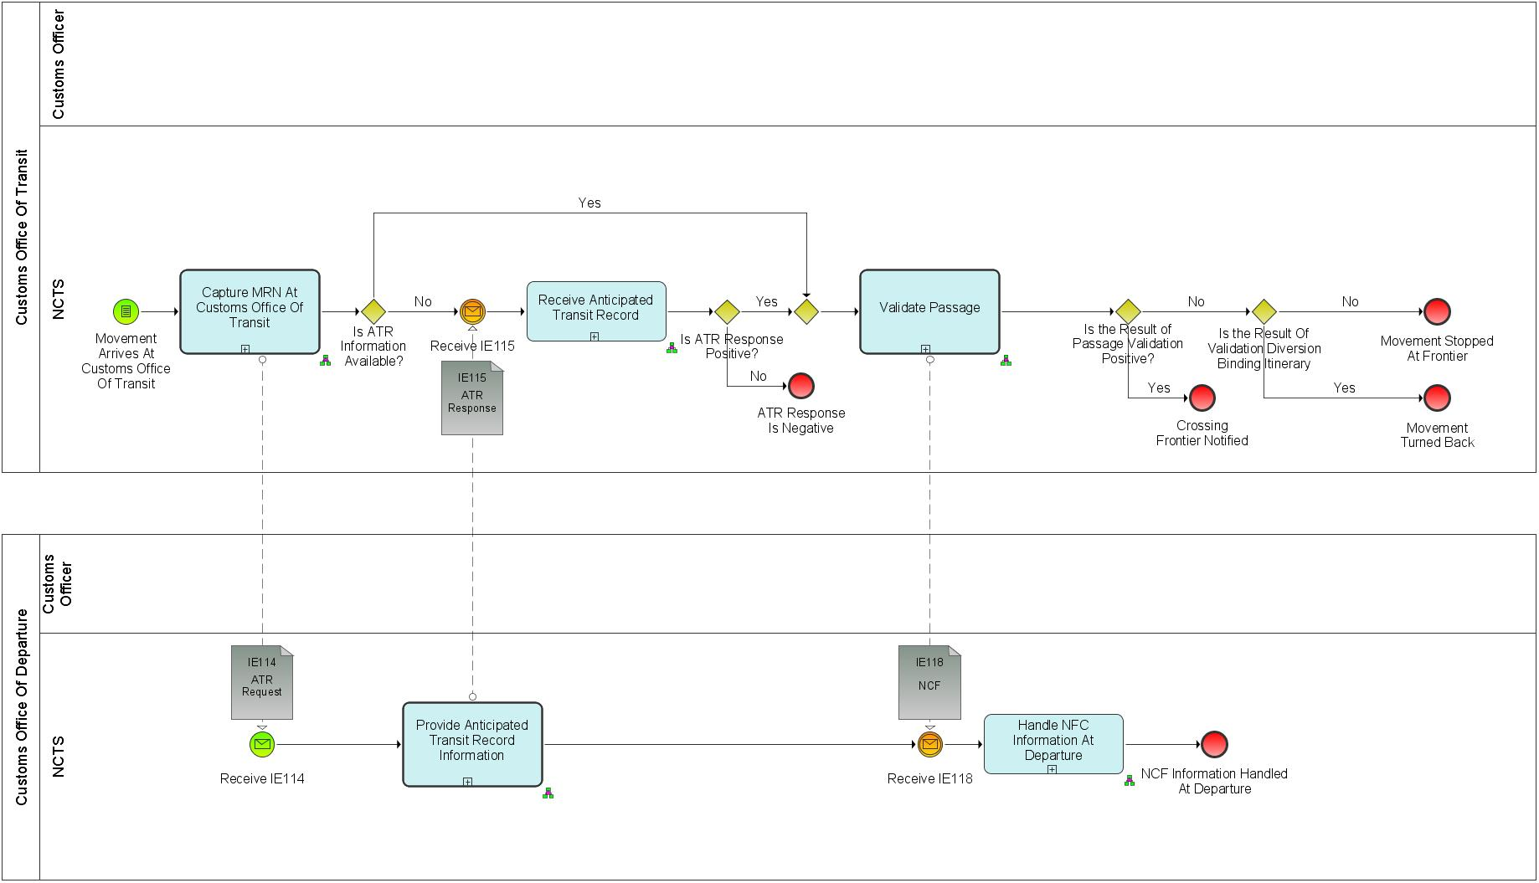

Figure 17: L4-TRA-01-04-Process Movement at Customs Office of Transit Major Event

|  |
| --- |
| Movement arrives at Customs Office of Transit |
| Organisation : National Customs Administration |
| Location : Customs Office of Transit |
| The consignment and the NCTS Accompanying Document or MRN of Transit Declaration in an electronically readable format are presented to the Office of Transit Officer. In normal procedure, as per Article 41 of Appendix 1 of CTC, in case of CTC country, Customs Office of Departure has to provide printout of TAD to the Declarant. |

Processes

|  |  |
| --- | --- |
| Capture MRN at Customs Office of Transit | Process: L4-TRA-01-04-01 |
| Organisation : National Customs Administration | |
| Location : Customs Office of Transit | |
| Constraint :  This process must be done as soon as possible in order not to slow down the traffic flow. | |
| Description :  The Customs Officer is notified by the Goods Carrier about the arrived consignment and he captures the MRN of Transit declaration into NCTS.  NCTS looks for the Anticipated Transit Record (ATR) information:   1. when the movement information is not available either in case of international diversion[10] or in exceptional situations[11], NCTS asks (IE114) that information to the Country of Departure and warns the Customs Officer; 2. when the ATR information is available then the passage can be validated by the Customs Officer.   Final situation :  If the ATR-information is available the passage can be validated.  If there is an international diversion, the Customs Office of Transit waits for the information from the Customs Office of Departure; the state of the Transit Operation is set to ‘ATR Requested’. | |

|  |  |
| --- | --- |
| Provide ATR-information | Process: L4-TRA-01-04-02 |
| Organisation : National Customs Administration | |
| Location : Customs Office of Departure | |
| Constraint: This process must be done as soon as possible in order not to slow down the traffic flow.  Safety and security risk analysis results shall be exchanged between the EU MS and CTC countries only if there is a legal basis for doing so. | |
| Description :  This process is automatically performed by the system without a human intervention.  The Country of Departure is asked (IE114) by the Customs Office of Transit to provide the ATR-information about a movement.  NCTS looks for the movement information identified by IE114.TRANSIT OPERATION.MRN and automatically sends (IE115) back the required ATR-information about the movement or the reason of their rejection. If the provided request (IE114) relates to a transit movement which is also used for safety and security (IE001.TRANSIT OPERATION. Security = ‘1’ (ENS), and if the requested data is available at departure, then the response (IE115) shall contain the relevant additional safety and security data elements.  If en-route information is available, related to the transit movement then the response (IE115) shall contain the relevant additional Incident data elements.  The safety and security risk analysis results shall be sent in IE115 if all the following conditions are met:   * The requesting (actual) Customs Office of Transit is located in an EU Member State; * The declared Customs Office of Departure is located in an EU Member State.   Final situation :  The response about the ATR-information is sent to the Customs Office of Transit. | |

|  |  |
| --- | --- |
| Receive ATR-information | Process: L4-TRA-01-04-03 |
| Organisation : National Customs Administration | |
| Location : Customs Office of Transit | |
| Constraint :  If the Office receiving the ATR-response is the Customs Office of first Entry of the Union or if it cannot determine, whether or not it is the first Customs Office of Entry of the Union, it shall apply the safety and security regulation and perform all related tasks within the prescribed time limits (see regulation) under following conditions:   * NCTS is also used for the purpose of safety and security; * The (actual) Customs Office of Transit is located in an EU Member State. | |
| Description :  The Customs Office of Transit receives (IE115) the ATR-information from the Customs Office of Departure. If the provided ATR response (IE115) contains the requested ATR (IE115.TRANSIT OPERATION.ATR rejection reason is not present) and if it is used for safety and security (IE001. TRANSIT OPERATION. Security = ‘1’ (ENS), then the ATR response contains the relevant safety and security data elements. NCTS records automatically the ATR-information about the movement identified by IE115.TRANSIT OPERATION.MRN. If the provided ATR response (IE115) does not contain the requested ATR (IE115.TRANSIT OPERATION.ATR rejection reason is present), the received (IE115) ATR –information is rejected.  If risk analysis results are communicated by the Customs Office of Departure, the results shall be recorded and either be accepted or taken into account when carrying out own risk analysis.  If the constraint is met:   * Full safety and security related risk analysis for all the goods shall be initiated by NCTS and performed by the national risk application according to the rules set out by the risk management framework. The national risk analysis system generates the risk analysis code. If the identified risk relates to a specific goods item of the transit declaration, the relevant goods item number shall be identified by the national risk analysis system. * The national risk analysis system records the risk analysis results in the NCTS transit declaration. If the risk analysis result relates to a specific goods item, then the relevant goods item is recorded (RISK ANALYSIS. Item number). In any other case the ’RISK ANALYSIS. Item number’ remains unused. * Random risk parameters shall be used additionally.   The system notifies the Customs Officer that the information to validate the passage is available. If risk is identified, the Customs Officer is alerted and asked to register a control decision.  Final situation :  The ATR-information is available to support any control which may be appropriate; the state of the Transit Operation is set to ‘ATR Created’ or, the ATR-information is not available to support any control which may be appropriate; the state of the Transit Operation is set to ‘ATR Rejected’. | |

|  |  |
| --- | --- |
| Validate passage | Process: L4-TRA-01-04-04 |
| Organisation : National Customs Administration | |
| Location : Customs Office of Transit | |
| Constraint : This process requires retrieval of data within one minute so as not to hold up traffic.  If the Customs Office of Transit acts as a Customs Office of Entry or if it cannot determine, whether or not it is the first Customs Office of Entry, it shall apply the safety and security regulation and shall perform all related tasks within the prescribed time limits (see regulation) under the following conditions:   * NCTS is also used for the purpose of safety and security * The Customs Office of Transit is located in an EU Member State | |
| Description :  On request of a Customs Officer NCTS retrieves the movement information identified by the MRN and responds with the state of the movement, having performed the following checks:   1. Movement known at Customs Office of Departure. 2. Movement known at Customs Office of Departure but state not consistent with presentation at this Customs Office of Transit (e.g. movement has already arrived at destination). 3. National diversion (movement declared to this country but not this Customs Office of Transit):  * NCTS warns the Customs Officer if the movement is marked as “binding itinerary” (IE115.TRANSIT OPERATION. Binding itinerary flag is present). * NCTS warns the Customs Officer if the movement is already recorded as entered in this country (of the Customs Office of Transit).  1. International diversion (movement not declared to this country):  * NCTS warns the Customs Officer if the movement is marked as “binding itinerary” (IE115.TRANSIT OPERATION. Binding itinerary flag is present); * NCTS warns the Customs Officer if the guarantee is not valid for the country (IE115. CUSTOMS OFFICE Actual Customs Office of Transit. Guarantee not valid for flag is present); * NCTS warns the Customs Officer if the movement is already recorded as entered in this country (of the Customs Office of Transit).  1. Safety and security:  * NCTS warns the Customs Officer if the movement is used for safety and security purposes (IE050/IE115. TRANSIT OPERATION. Security = ‘1’ (ENS); * NCTS warns the Customs Officer if the received ATR/ATR response (IE050/IE115) contains positive risk analysis results from the Customs Office of Departure (IE050/IE115.RISK ANALYSIS is present) and/or if the risk analysis performed upon reception of the IE050/IE115 had identified risk. * If risk analysis had proposed to take measures at the Customs Office of Transit but the Customs Officer decides not to control, then NCTS requires the Customs Officer to confirm the decision not to control.   The Customs Officer takes the appropriate action and NCTS:   * records the action and notifies the Goods Carrier if the consignment has to be controlled prior to the registration of the frontier crossing or if it has to be stopped. * records the action and notifies the Goods Carrier if the consignment has to be turned back. * notifies the Customs Officer that he has to register the NCF-information if the consignment may cross the frontier.   **Register frontier crossing :**  The Customs Officer has decided that the consignment can cross the frontier.  Final situation :  The passage has been validated and the Transit movement either may cross the frontier, the NCF-information is recorded into NCTS, the state of the Transit Operation is set to ‘NCF registered’, or is turned back, the state of the Transit Operation is set to ‘Movement turned-back’, or must be stopped at the frontier, the state of the Transit Operation is set to ‘Movement stopped’. | |

|  |  |
| --- | --- |
| Handle NCF-information at Departure | Process: L4-TRA-01-04-05 |
| Organisation : National Customs Administration | |
| Location : Customs Office of Departure | |
| Constraint : | |
| Description :  This process is performed automatically.  The Customs Office of Departure receives (IE118) the NCF-information for the movement identified by IE118.TRANSIT OPERATION.MRN from a Customs Office of Transit; NCTS records this NCF-information.  The system of Departure performs the required checks to detect anomalies in the pattern of frontiers crossing and notifies the Customs Officer when appropriate.  Final situation :  The NCF-information has been handled at the Customs Office of Departure. | |

Major Results

|  |
| --- |
| Movement may cross frontier |
| Organisation : National Customs Administration |
| Location : Customs Office of Transit |
| No irregularities were detected so the Transit movement may cross the frontier. |

|  |
| --- |
| Movement stopped at frontier |
| Organisation : National Customs Administration |
| Location : Customs Office of Transit |
| The Transit movement has been stopped at the frontier and has to be considered as arrived at destination. The Customs Office of Transit must then be considered as an actual Customs Office of Destination, so the event “Transit consignment arrives at destination” is activated for the process “L4-TRA-01-03-Process Arrival”. |

|  |
| --- |
| Movement turned back |
| Organisation : National Customs Administration |
| Location : Customs Office of Transit |
| In case of diversion and binding itinerary, the Transit movement is not allowed to cross the frontier (i.e. must continue its journey to a different Customs Office of Transit without crossing the frontier). |

|  |
| --- |
| NCF-information handled at Departure |
| Organisation : National Customs Administration |
| Location : Customs Office of Departure |
| The NCF-information (concerning a passage through a Customs Office of Transit) has been handled at departure. |

Minor Result

|  |
| --- |
| Crossing logged |
| Organisation : National Customs Administration |
| Location : Customs Office of Transit |
| The frontier crossing has been logged with the NCF-information. |

Assumptions

1. The logic for the fraud detection (in the context of “bureau de passage” and especially in case of diversion) can only be based on:

* At the Customs Office of Transit (on-line):

1. The existence of the movement in the NCTS will be checked (by retrieving or requesting the ATR-information). If the movement does not exist at the Customs Office of Departure, the NCTS Accompanying Document or MRN of Transit Declaration in an electronically readable format will be considered as forged.
2. A warning will be given by the system if the movement is already recorded as having entered this country (of the Customs Office of Transit). However, it should be noted that two Offices of Transit in the same country can occur. The Customs Office of Entry and Customs Office of Exit in case where a movement exits from a Contracting Party towards a third country.

* At the Customs Office of Departure (off-line):

1. If a diversion has been reported, a check is performed against the consistency of the “frontier crossing pattern”, and the system gives a warning if irregularities are detected. UNgen.060 describes the rules which will be applied to check the consistency.
2. In case of diversion of a movement marked as binding itinerary, the Customs Office of Transit will not request the authorisation from the Customs Office of Departure to allow the Transit movement to cross the frontier. In other words, the aspect of binding itinerary will be limited to a warning to the Customs Officer at the Customs Office of Transit. As stated above, the Customs Office of Transit will only inform the Customs Office of Departure by means of the NCF-information. According to the user need UNtra.040, no further action will be taken by the system towards the declared Offices of Transit.

Remark

In all cases, the Customs Office of Transit will inform the Customs Office of Departure by means of the NCF-information.

## Handle enquiry

### L4-TRA-01-05-Status Request

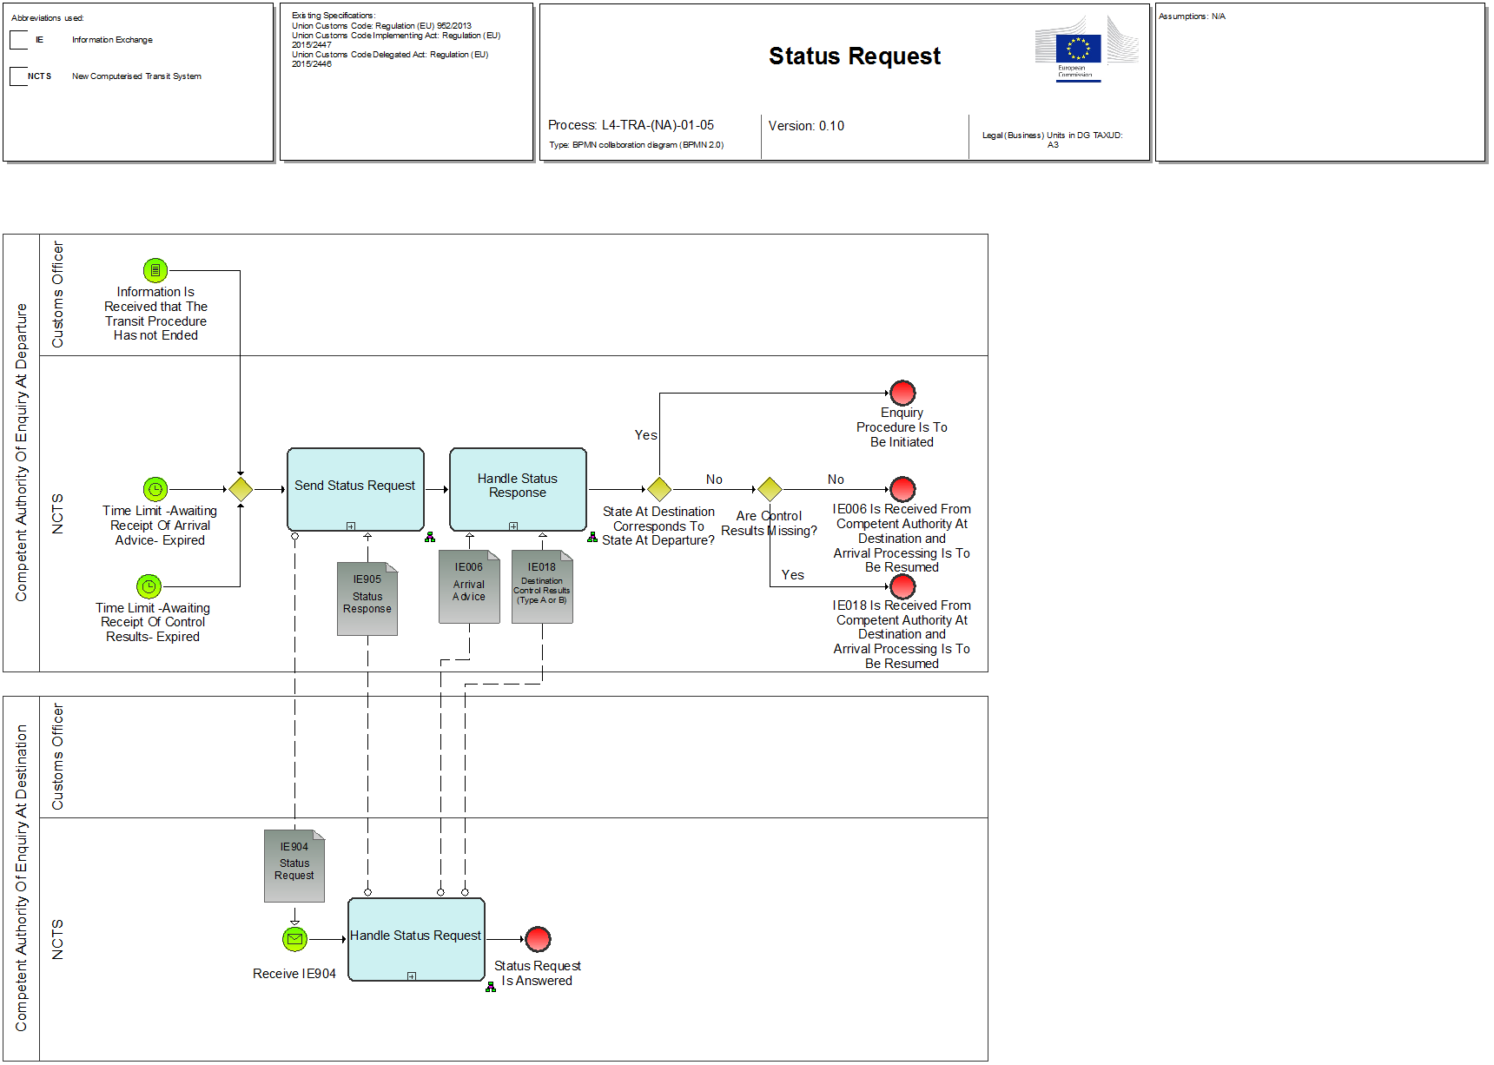

Figure 18: L4-TRA-01-05-Status Request Event

|  |
| --- |
| Time to prepare for Sending Status Request |
| Organisation : National Customs Administration |
| Location : Competent Authority of Country of Departure |
| (Timed event)  The time allotted for the receipt of the arrival advice (IE006) or of the control result (IE018) (See Process L4-TRA-01-02-02-Issue Transit Transaction Data) has expired and the transit movement is set to the ‘Enquiry recommended’ state. These time-out periods that indicate that the status request should be sent are defined by the Competent Authority of Country of Departure using the values permitted in the relevant legal framework.  The value of this/these “timer(s)” may evolve during the lifetime of the movement. Upon receipt of the arrival advice, its value will change. It may also be manually shortened by a Customs Officer.  When the control results are received (IE018) from the Customs Office of Destination, or when the movement is written-off for other reasons, the timer stops.  N.B. This event can also consist of information received by the Competent Authorities of Country of Departure that the transit procedure has not ended, or they suspect that to be the case (Articles 226(3)(a) and 227(2)(a) of the Code, Article 310 (3) UCC IA). |

Processes

|  |  |
| --- | --- |
| Send Status Request | Process: L4-TRA-01-05-01 |
| Organisation : National Customs Administration | |
| Location : Country of Departure | |
| Constraint : | |
| Description :  The master timer 'Recovery recommended' to start the recovery is started. In case the Country of Customs Office of Departure has not received an IE006 it sends the status request (IE904) to the Country of Customs Office of Destination (declared), else in cases where it has received an IE006 and the timer ‘Awaiting Receipt Of Control Results’ to receive IE018 has expired then the status request will be sent to the Country of Customs Office of Destination where the IE006 was issued (can be the declared or the new, actual one).  'This process should be repeated every time before sending another IE142. (This shall not imply to not sending the IE904. It is just to not block the procedure in case the IE905 gets 'lost'.) When NCTS receives the status response (IE905) from the Country of Customs Office of Destination (declared or actual) it is automatically recorded.  Final situation: The state is set to ‘Enquiry recommended’ and the master timer 'recovery recommended' is set. The status request is sent. | |

|  |  |
| --- | --- |
| Handle Status Request | Process: L4-TRA-01-05-02 |
| Organisation : National Customs Administration | |
| Location : Country of Destination | |
| Constraint : | |
| Description :  The NCTS system at the Country of Customs Office of Destination (declared or actual) checks the state and automatically replies to the Country of Departure with the IE905 containing the state at destination.  If the state at destination doesn’t correspond with the one at departure and no error message has been generated the missing message(s) (IE006 and/or IE018) must be sent as well (intelligent IE905 = IE905 and at the same time IE006/IE018 as well without any intervention from a Customs Officer).  If the original messages IE006 and/or IE018 caused an error message, the amended message(s) has (have) to be resent otherwise it should be done automatically.  If this is not possible within a given time limit (Articles 226(3)(a) and 227(2)(a) of the Code, Article 310 ICC IA), the Country of Customs Office of Destination immediately transmits by all possible means the missing information in order to allow the Country of Departure to give the proper follow up of the procedure.  Final situation: The status request is answered. Missing message(s) is/are resent or missing information is forwarded by other means. | |

|  |  |
| --- | --- |
| Handle Status Response | Process: L4-TRA-01-05-03 |
| Organisation : National Customs Administration | |
| Location : Country of Departure | |
| Constraint : | |
| Description :  The NCTS-System at Country of Departure automatically checks if the state at destination is corresponding to the state at departure, and whether in the meanwhile, an IE006 and/or an IE018 has/have been received.  If the state does not correspond and an IE006 and/or IE018 has/have been received the Arrival processing is resumed (see "L4-TRA-01-03-Process Arrival").  If the state does correspond or there is/are no IE006 and/or IE018 received within the given time limit the Competent Authority of Country of Departure shall start the enquiry procedure.  When not done directly by the Competent Authority of Country of Departure, NCTS retrieves the movement information identified by the MRN brought in the timers “Awaiting Receipt Of Arrival Advice” and “Awaiting Receipt Of Control Results” (time allotted for the receipt of the arrival advice and/or the control results from the Customs Office of Destination) started by the process “L4-TRA-01-02-02-Issue Transit Transaction Data” and notifies the Customs Officer, who either starts the enquiry process or postpones it to a later time. In the latter case, he re-sets the relevant timer.  The state remains 'Enquiry recommended'.  Final situation :  Either the movement can be written off, the timer is re-set or the enquiry procedure can be started. | |

Result

|  |
| --- |
| Arrival Processing resumed |
| Organisation : National Customs Administration |
| Location : Competent Authority of Country of Departure |
| The IE006 and IE018 are received and the movement can be written off (see "L4-TRA-01-03-Process Arrival") |

### L4-TRA-01-06-Handle Enquiry - Enquiry Procedure (Option A) – 1st step Contacting the Holder of Transit Procedure

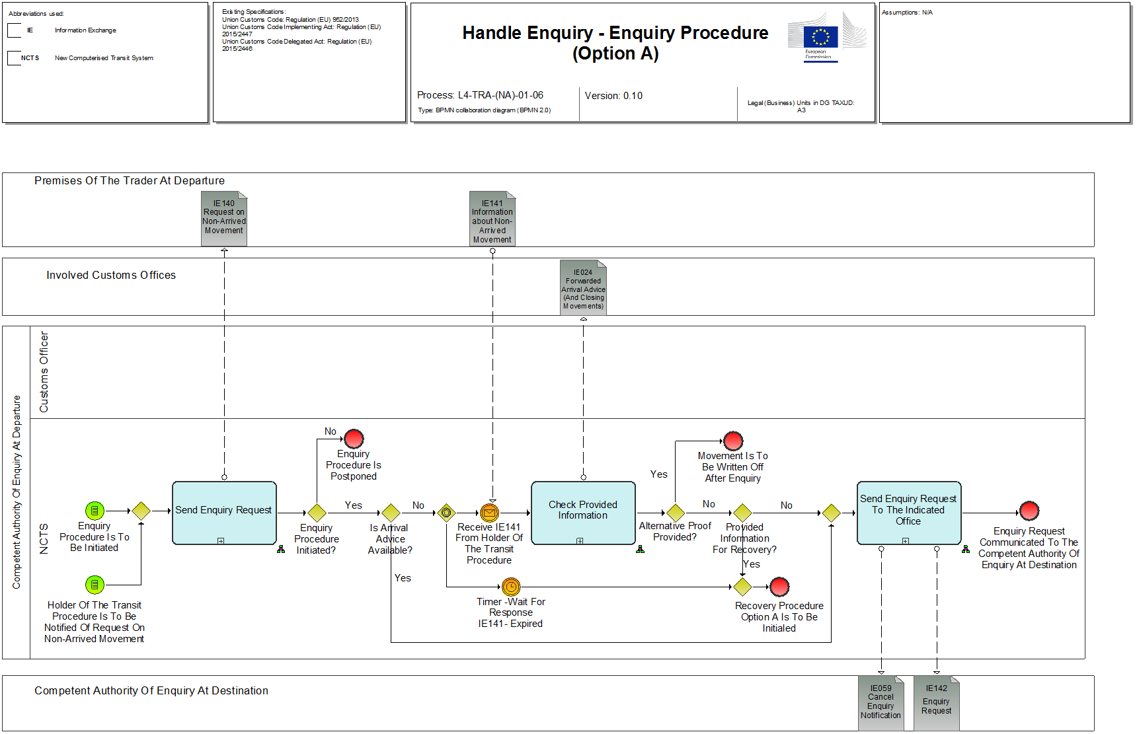

Figure 19: L4-TRA-01-06-Handle Enquiry - Enquiry Procedure (Option A)

Event

|  |
| --- |
| Timer for Holder of Transit procedure to provide information has expired |
| Organisation : Holder of Transit procedure |
| Location : Premises of the Trader at Departure |
| (Timed event)  The Holder of Transit procedure provides no information within the time limit and a time-out has occurred.  This time-out period is defined by the Competent Authority of Country of Departure when the enquiry procedure is initiated, using the values permitted in relevant legal framework. |

|  |
| --- |
| Holder of Transit procedure provides information |
| Organisation : Holder of Transit procedure |
| Location : Premises of the Trader at Departure |
| (Timed event)  The Holder of Transit procedure provides information within the defined time limit. |

Processes

|  |  |
| --- | --- |
| Send Enquiry Request - Start of enquiry procedure | Process: L4-TRA-01-06-01 |
| Organisation : National Customs Administration | |
| Location : Competent Authority of Country of Departure | |
| Constraint : | |
| **Description:**  This process demands always an intervention of a Customs Officer.  The Competent Authority of the country of departure initiates the enquiry procedure by checking if they have received the arrival advice (IE006 - see Process “L4-TRA-01-03-03-Store and Forward Arrival Advice”). If it is available IE142 will be sent directly to the actual Customs Office of Destination asking for the IE018.  If IE006 is not available the Competent Authority of Country of Departure checks the content of TRADER Consignee and decides whether the information is sufficient or not. If it is considered insufficient the Competent Authority starts the enquiry with IE140, the timer “Notify the IE140” is stopped and the timer ‘Wait for response IE141’ is set. The holder of Transit procedure must react within the time limit with an IE141. This time-out period is defined by the Competent Authority of Country of Departure when the enquiry procedure is initiated, using the values permitted in relevant legal framework. If no information is provided within the time limit this is considered to be a negative answer.  If the information in TRADER Consignee is considered sufficient it starts the enquiry procedure to the Declared Customs Office of Destination.  If an arrival advice has already been received (IE006 - see Process “L4-TRA-01-03-03-Store and forward arrival advice”) and/or the information in TRADER Consignee is considered sufficient or the IE140 has already been sent at an earlier stage the Holder of Transit procedure will not be contacted at this point of the operation (Article 310(5)(6)).  Nevertheless, NCTS allows the Customs Officer either to continue with the enquiry process immediately or to postpone it to a later time. In the latter case, NCTS will allow the Customs Officer to reset the timers “Awaiting Receipt Of Arrival Advice” and “Awaiting Receipt Of Control Results as needed.  NCTS records an information request for the requested Trader or an enquiry request for the Requested Office and sets the timers for answering IE140/IE142, using the values permitted in current law and/or in the relevant administrative arrangements, to protect a non-answer of the Trader or the Customs Office of Destination and to be able to inform the Holder of Transit procedure in time (Article 310 UCC IA) (see Process “L4-TRA-01-06-Handle Enquiry - Enquiry Procedure (Option A)”).  The Competent Authority of Country of Departure after having sent the IE140 to the Trader sets the state of the transit movement to ‘Under enquiry procedure’.  The reception of any IE143 (no matter which code it contains) or an IE018 will stop the timer 'wait for enquiry response'.  Final situation: Enquiry procedure has been started.  - The Transit Operation is set to “Under enquiry procedure”,  - the Holder of Transit procedure has been requested for information on the movement and the relevant timer is set, or  - an enquiry is sent to the actual or declared Customs Office of Destination and the relevant timer is set. | |

|  |  |
| --- | --- |
| Check Provided Information | Process: L4-TRA-01-06-02 |
| Organisation :National Customs Administration | |
| Location : Competent Authority of Country of Departure | |
| Constraint : | |
| Description :  If the Holder of Transit procedure provides an alternative proof (in accordance with current law) the movement can be written-off (L4-TRA-01-03-09-Handle Destination Control Results) and the IE024 is sent to all involved offices to close that movement.  If the Holder of Transit procedure provides the Competent Authority of Country of Departure with other sufficient information (no alternative proof) or a new Customs Office of Destination, this information will be forwarded to the Customs Office of Destination (declared or actual).  If the Holder of Transit procedure did not provide information at all within 28 days or if the information provided is not sufficient to discharge the Union Transit procedure and the customs office involved did not reply within 40 days from the date on which it was requested by the Competent Authority of Country of Departure, the recovery procedure (see "L4-TRA-01-08-Handle Recovery - Recovery Procedure (Option A) ") is started.  The movement is set to the ‘Recovery recommended’ state.  Final situation**:**  The arrival process is resumed; additional information is forwarded to the declared or the actual Customs Office of Destination orRecovery procedure will be started. | |

|  |  |
| --- | --- |
| Send enquiry request to the indicated office | Process: L4-TRA-01-06-03 |
| Organisation : National Customs Administration | |
| Location : Competent Authority of Country of Departure | |
| Constraint : | |
| **Description :**  This process demands always an intervention of a Customs Officer.  The Competent Authority of Country of Departure continues the enquiry procedure with a request at the Customs Office of Destination. Based on the information provided by the Trader, the IE142 (indicating additional information is available) will be sent to the actual Customs Office of Destination.  In case there had been a IE142 sent to the Declared Customs Office of Destination or any other Customs Office, which is different from the one provided by the Trader before, this IE142 shall be cancelled beforehand by sending the IE059 There shall never be more than one IE142 pending. NCTS records the cancellation. If it is the same office information exchange via IE144/IE145 takes place (see L4-TRA-01-07-01-Information Exchange IE144/IE145 At Competent Authority Of Enquiry At Departure, L4-TRA-01-07-02-Information Exchange IE144/IE145 At Competent Authority Of Enquiry At Destination) and a 2nd IE142 shall be sent giving reference to the additional information In the IE144.  The movement remains in the ‘Under enquiry procedure’ state.  The timer 'Wait for enquiry response' is set.  Final situation: An enquiry request has been sent to the Actual Customs Office of Destination and the timer is set. An eventual pending enquiry is cancelled (state remains ‘Under enquiry procedure’) and the Customs Office requested for enquiry is notified of its cancellation and any work related to that enquiry can stop, or additional info is forwarded to the Requested Office. | |

Results

|  |
| --- |
| Holder of Transit procedure Notified to Provide Information |
| Organisation : Holder of the Transit Procedure |
| Location : Premises of the Holder of Transit procedure at Departure |
| The Holder of Transit procedure is notified to provide information. |

|  |
| --- |
| Carry out enquiry at Destination |
| Organisation : National Customs Administration |
| Location : Competent Authority of Country of Departure |
| The enquiry procedure is carried out at destination. |

|  |
| --- |
| Arrival Processing resumed |
| Organisation : National Customs Administration |
| Location : Competent Authority of Country of Departure |
| Alternative proof allows to write off the movement. |

### L4-TRA-01-07-Handle Enquiry - Enquiry Procedure (Option B)- 1st step Contacting Customs Office of Destination

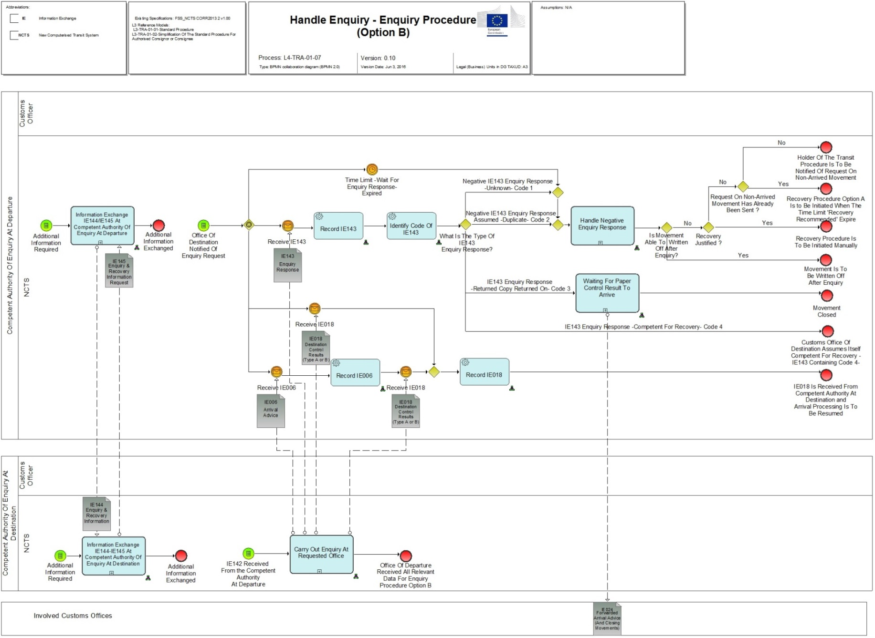

Figure 20: L4-TRA-01-07-Handle Enquiry - Enquiry Procedure (Option B) Part A

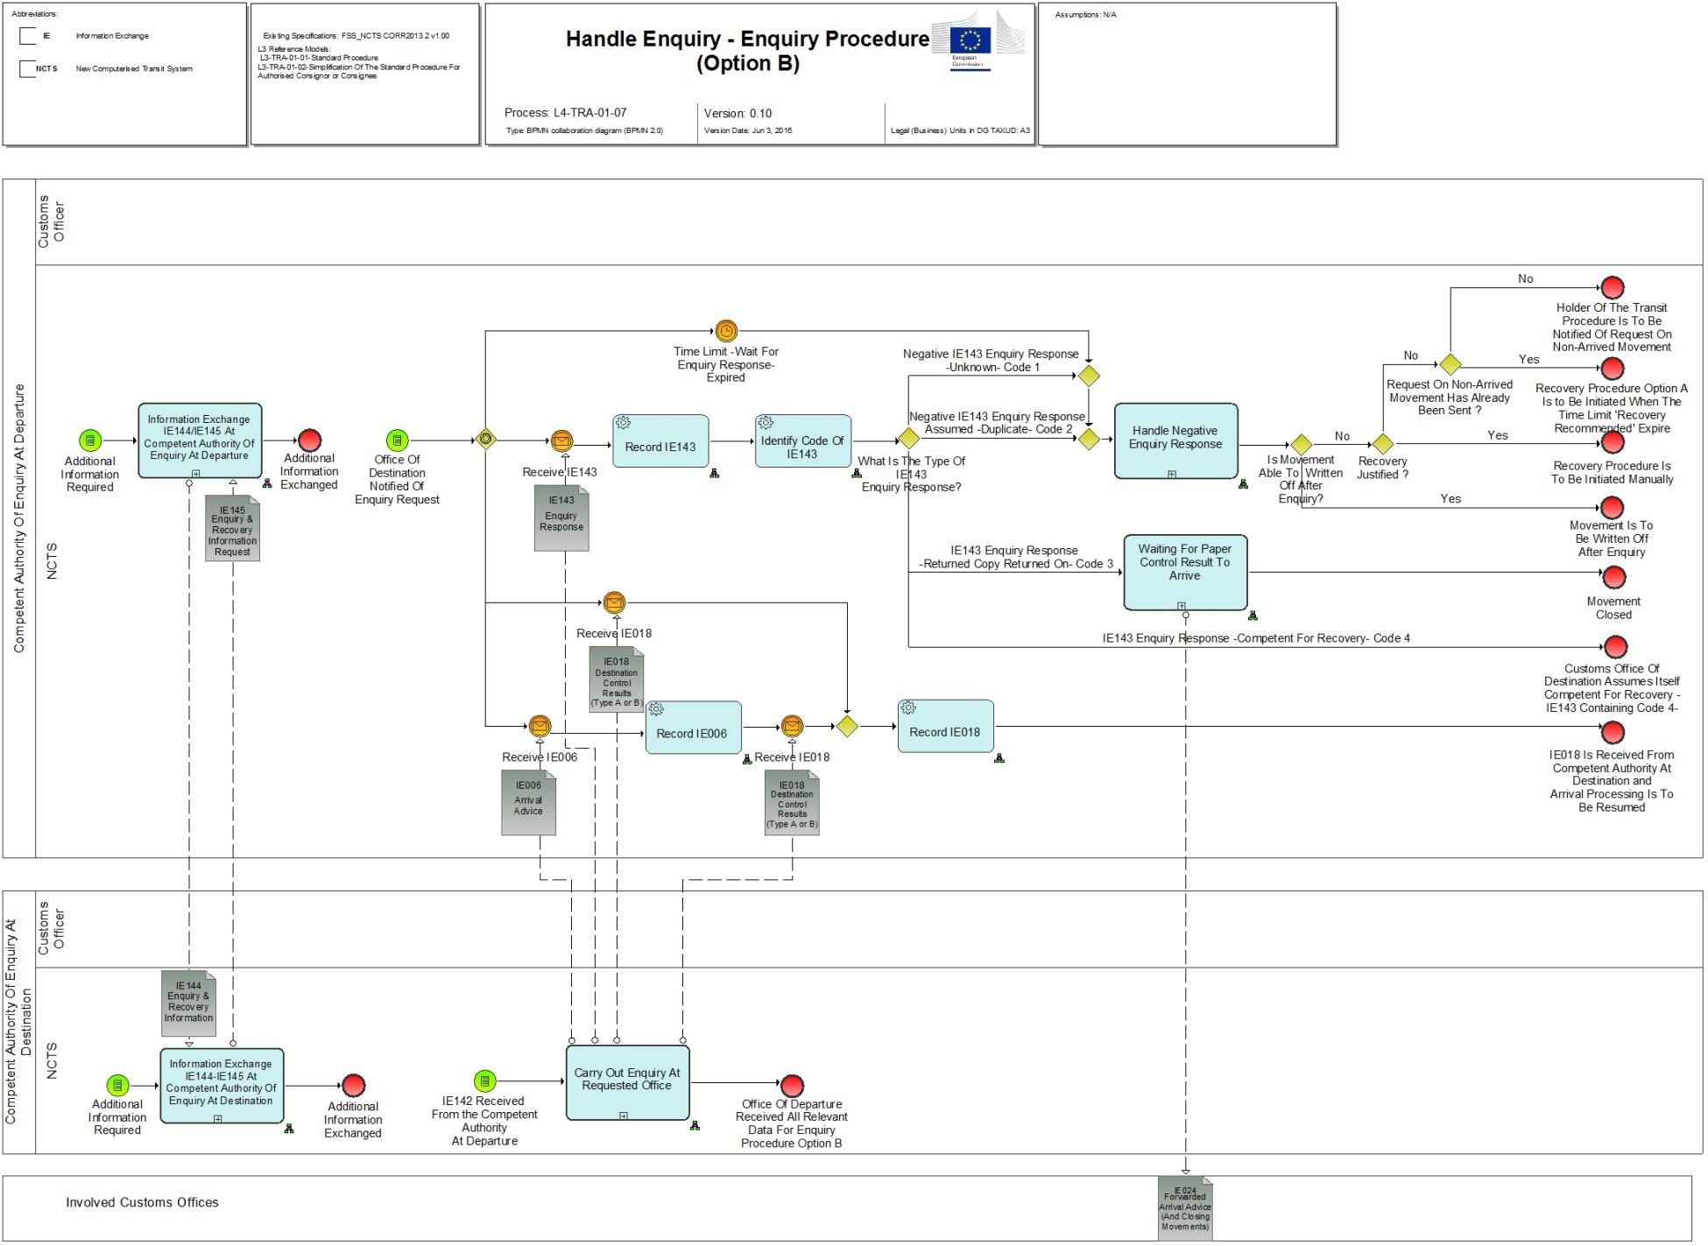

Figure 21: L4-TRA-01-07-Handle Enquiry - Enquiry Procedure (Option B) Part B

Events

|  |
| --- |
| **Timer expired without answer** |
| Organisation : National Customs Administration |
| Location : Competent Authority of Country of Departure |
| The timer for answering the IE142 expired and no answer has been received. |

|  |
| --- |
| Recovery request from any other office |
| Organisation : National Customs Administration |
| Location : Any office |
| Any office can send an IE150 asking for competency for recovery. |

Processes

|  |  |
| --- | --- |
| Information Exchange IE144/IE145 at Competent Authority of Enquiry at Departure | Process: L4-TRA-01-07-01 |
| Organisation : National Customs Administration | |
| Location : Competent Authority of Country of Departure | |
| Constraint : It is only allowed to use message IE144 after the enquiry procedure has been started and until the enquiry/recovery procedure is completed or for movements in the state ‘Movement under resolution’. | |
| Description :  For additional information or question exchange the messages IE144 and IE145 can be used whereas the IE144 is sent only by the Customs Office of Departure and IE145 is sent only by the Customs Office of Destination. This information exchange can be started either by the Customs Office of Departure or the Customs Office of Destination, no reply is needed since it can be only information sent and not a question asked. Additional documents will be sent by other than NCTS means. These two messages can be sent during the whole process of enquiry and recovery or for movements in the state ‘Movement under resolution’ to assure the exchange of information between the offices involved.  Final situation: information and/or questions have been sent. | |

|  |  |
| --- | --- |
| Information Exchange IE144/IE145 at Competent Authority of Enquiry at Destination | Process: L4-TRA-01-07-02 |
| Organisation : National Customs Administration | |
| Location : Competent Authority of Country of Destination | |
| Constraint : It is only allowed to use message IE145 after the enquiry procedure has been started and until the enquiry/recovery procedure is completed or for movements in the state ‘Movement under resolution’. | |
| Description :  For additional information or question exchange the messages IE144 and IE145 can be used whereas the IE144 is sent only by the Customs Office of Departure and IE145 is sent only by the Customs Office of Destination. This information exchange can be started either by the Customs Office of Departure or the Customs Office of Destination, no reply is needed since it can be only information sent and not a question asked. Additional documents will be sent by other than NCTS means. These two messages can be sent during the whole process of enquiry and recovery or for movements in the state ‘Movement under resolution’ to assure the exchange of information between the offices involved.  Final situation: information and/or questions have been sent. | |

|  |  |
| --- | --- |
| Carry out enquiry at requested Office | Process: L4-TRA-01-07-03 |
| Organisation : National Customs Administration | |
| Location : Requested Customs Office of Destination | |
| Constraint : The NCTS must warn the requested Customs Office of Destination when an enquiry request has arrived. | |
| **Description :**  Remark : This process may be interrupted upon reception (IE059) of an enquiry cancellation (see Process L4-TRA-01-03-09).  The Customs Officer performs the required action in order to provide the enquiry results to the Competent Authority of Country of Departure.  This might include completing the actual controlling of the consignment if it was delayed for some reason. Or it might merely be that the control results were not recorded into the system yet. Or, consignees may be contacted to establish the whereabouts of the movement. The general "Customs’ movements' state system" will be available to support these actions (see "section 2.14 - Assist Users in their daily work ").  When the Customs Office of Destination needs the available additional information (indicated in IE142) from the Competent Authority of Country of Departure, an exchange of extra information (via IE144 and IE145) will take place (see L4-TRA-01-07-01, L4-TRA-01-07-02) whereas the IE144 is sent only by the Customs Office of Departure and IE145 is sent only by the Customs Office of Destination. This information exchange can be started either by the Customs Office of Departure or the Customs Office of Destination, no reply is needed since it can be only information sent and not a question asked.  When the consignment is not located, the Customs Office of Destination sends (IE143) the negative enquiry response to the Competent Authority of Country of Departure, confirming that the movement was never presented at this Customs Office of Destination or a duplicate (in particular two MRNs for the same consignment) has been found.  When the movement is located (arrived) and control results are available these must be communicated with the IE006/IE018, no IE143 is needed in these cases since the IE006 and the IE018 or where the IE006 has already been received earlier the IE018 are positive answers to the IE142. In rare, exceptional cases where it is not possible to send the available IE006/IE018, the IE143 containing code 3 and the paper control result must be sent (“Case of business continuity procedure (Annex 72-04)”). The principle 'What starts in NCTS must end in NCTS!' remains valid.  The sending of the IE006 and IE018 or the IE018 is only allowed when the transit operation has ended within the prescribed time limits and there is no withdrawal from Customs supervision. It has to be a regular ended procedure within the time limit (e.g. registration of TAD forgotten) or an acceptance of a late presentation in accordance with current law.  In case the Customs Office of Destination assumes itself competent for recovery it sends an enquiry response (IE143 containing code 4) to the Competent Authority of Country of Departure asking for competency for recovery.  Final situation: Either the Competent Authority of Country of Departure has been informed with a negative response, or normal arrival processing can be resumed (positive response), or recovery is requested by the Customs Office of Destination. | |

|  |  |
| --- | --- |
| Handles negative enquiry response | Process: L4-TRA-01-07-04 |
| Organisation : National Customs Administration | |
| Location : Customs Administration of Departure | |
| Constraint : In case an IE006 has been received, the answer IE143 containing code 1 (movement unknown at destination) cannot be used. | |
| Description :  If the timer ‘Wait for Enquiry response’ has expired and no response was received or a negative IE143 ('unknown') from Customs Office of Destination has been received, a check will be performed if the Trader was informed via IE140 at an earlier stage. In case the 'request on non-arrived movement' (IE140) has not already been sent to the Holder of the Transit Procedure the Competent Authority of Country of Departure proceeds to Process L4-TRA-01-06-01-Send Enquiry Request. The state remains 'Under enquiry procedure'.  In case it has already been sent the Competent Authority of Country of Departure shall wait - regarding further actions - until the state is set to ‚Recovery recommended’ (Article 311 UCC IA). Once this state is reached, recovery procedure shall be started.  If a negative answer ‘duplicate’ was received the Customs Office of Departure has to perform the required checks. A negative enquiry response (IE143 ‚unknown’; ‚duplicate’) which indicates that enquiries at the Customs Office of Destination are completed stops the timer 'Wait for enquiry response'. A new IE142 can be sent to another office or to the same office if additional information from the Holder of Transit procedure is available (see L4-TRA-01-06-Handle Enquiry - Enquiry Procedure (Option A)). In case the timer ‘Wait for Enquiry response’ has not yet expired but the Customs Officer has serious proof that justify the start of a recovery procedure (see L4-TRA-01-08-Handle Recovery - Recovery Procedure (Option A)) he can force the movement into recovery by manually expire the timer. In these cases, the movement is set to 'Recovery recommended'. This can be done at any time after the movement has been released.  Final situation: A check will be performed whether the Holder of Transit procedure was informed, if not IE140 is sent or another IE142 is sent or ‘duplicate’ will be checked, or recovery starts. | |

|  |  |
| --- | --- |
| Waiting for paper control result to arrive | Process: L4-TRA-01-07-05 |
| Organisation : National Customs Administration | |
| Location : Customs Administration of Departure | |
| Constraint : The process is applied only within the business continuity procedure. | |
| Description :  The Customs Office of Departure is informed by IE143 containing Code 3 (Return Copy returned on) that the movement has arrived and can be written off based on the paper copy that will arrive. If the time between the IE143 and the arrival of the mentioned proof is unexpectedly long it can use the IE144/145 to solve the issue (Case of business continuity (Annex 72-04)).  When the proof arrives the Customs Office of Departure sends the IE024 to all involved offices to close that movement.  Final situation: Paper control result arrived, arrival process can be resumed, all involved offices are informed about the closing. | |

Results

|  |
| --- |
| Arrival Processing resumed |
| Organisation : National Customs Administration |
| Location : Customs Office of Destination |
| IE006 and/or IE018 had been sent and the movement will be written off. |

|  |
| --- |
| Write off |
| Organisation : National Customs Administration |
| Location : Customs Office of Destination, Offices of Transit |
| IE024 had been sent to all involved offices and the movement is written off. |

|  |
| --- |
| Handle cancellation request |
| Organisation : National Customs Administration |
| Location : Customs Administration of Departure |
| See "L4-TRA-01-10-Process Cancellation". |

## Handle Recovery

### L4-TRA-01-08-Handle Recovery - Recovery Procedure (Option A)

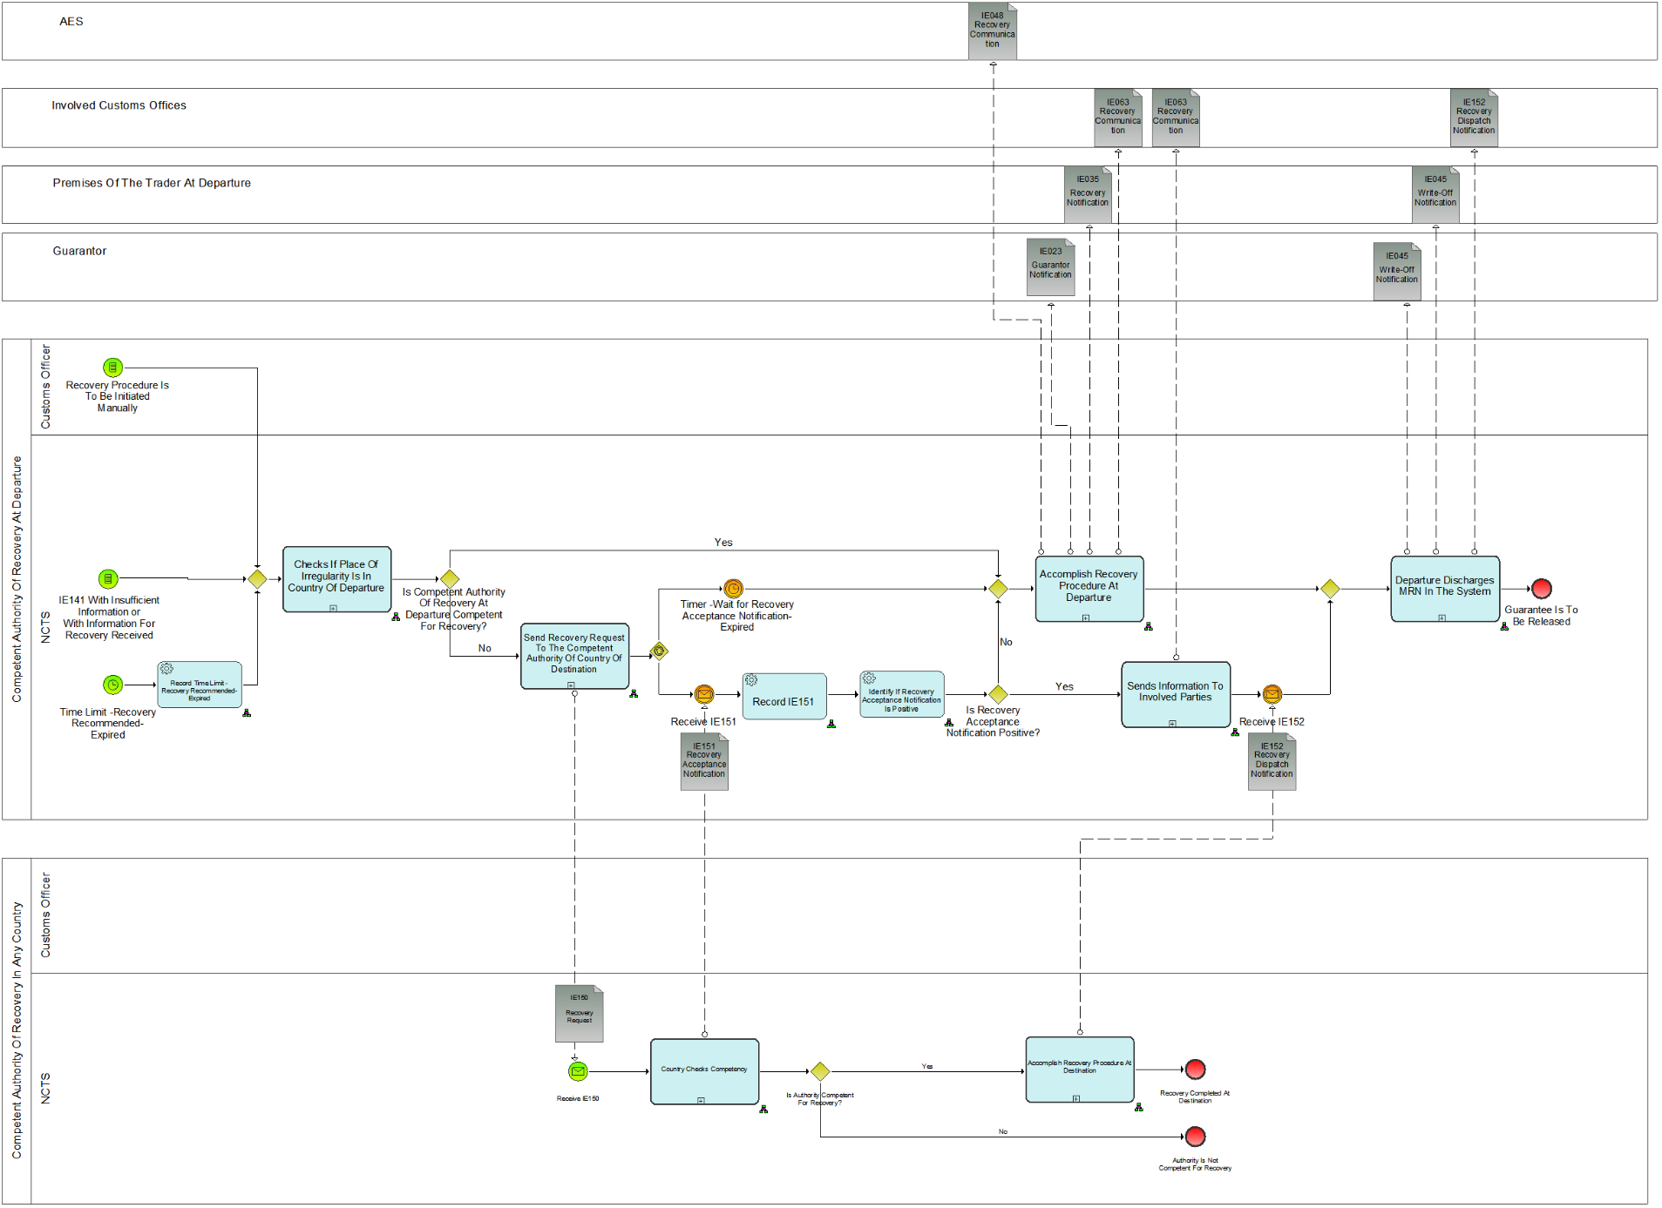

Figure 22: L4-TRA-01-08-Handle Recovery - Recovery Procedure (Option A) Part A

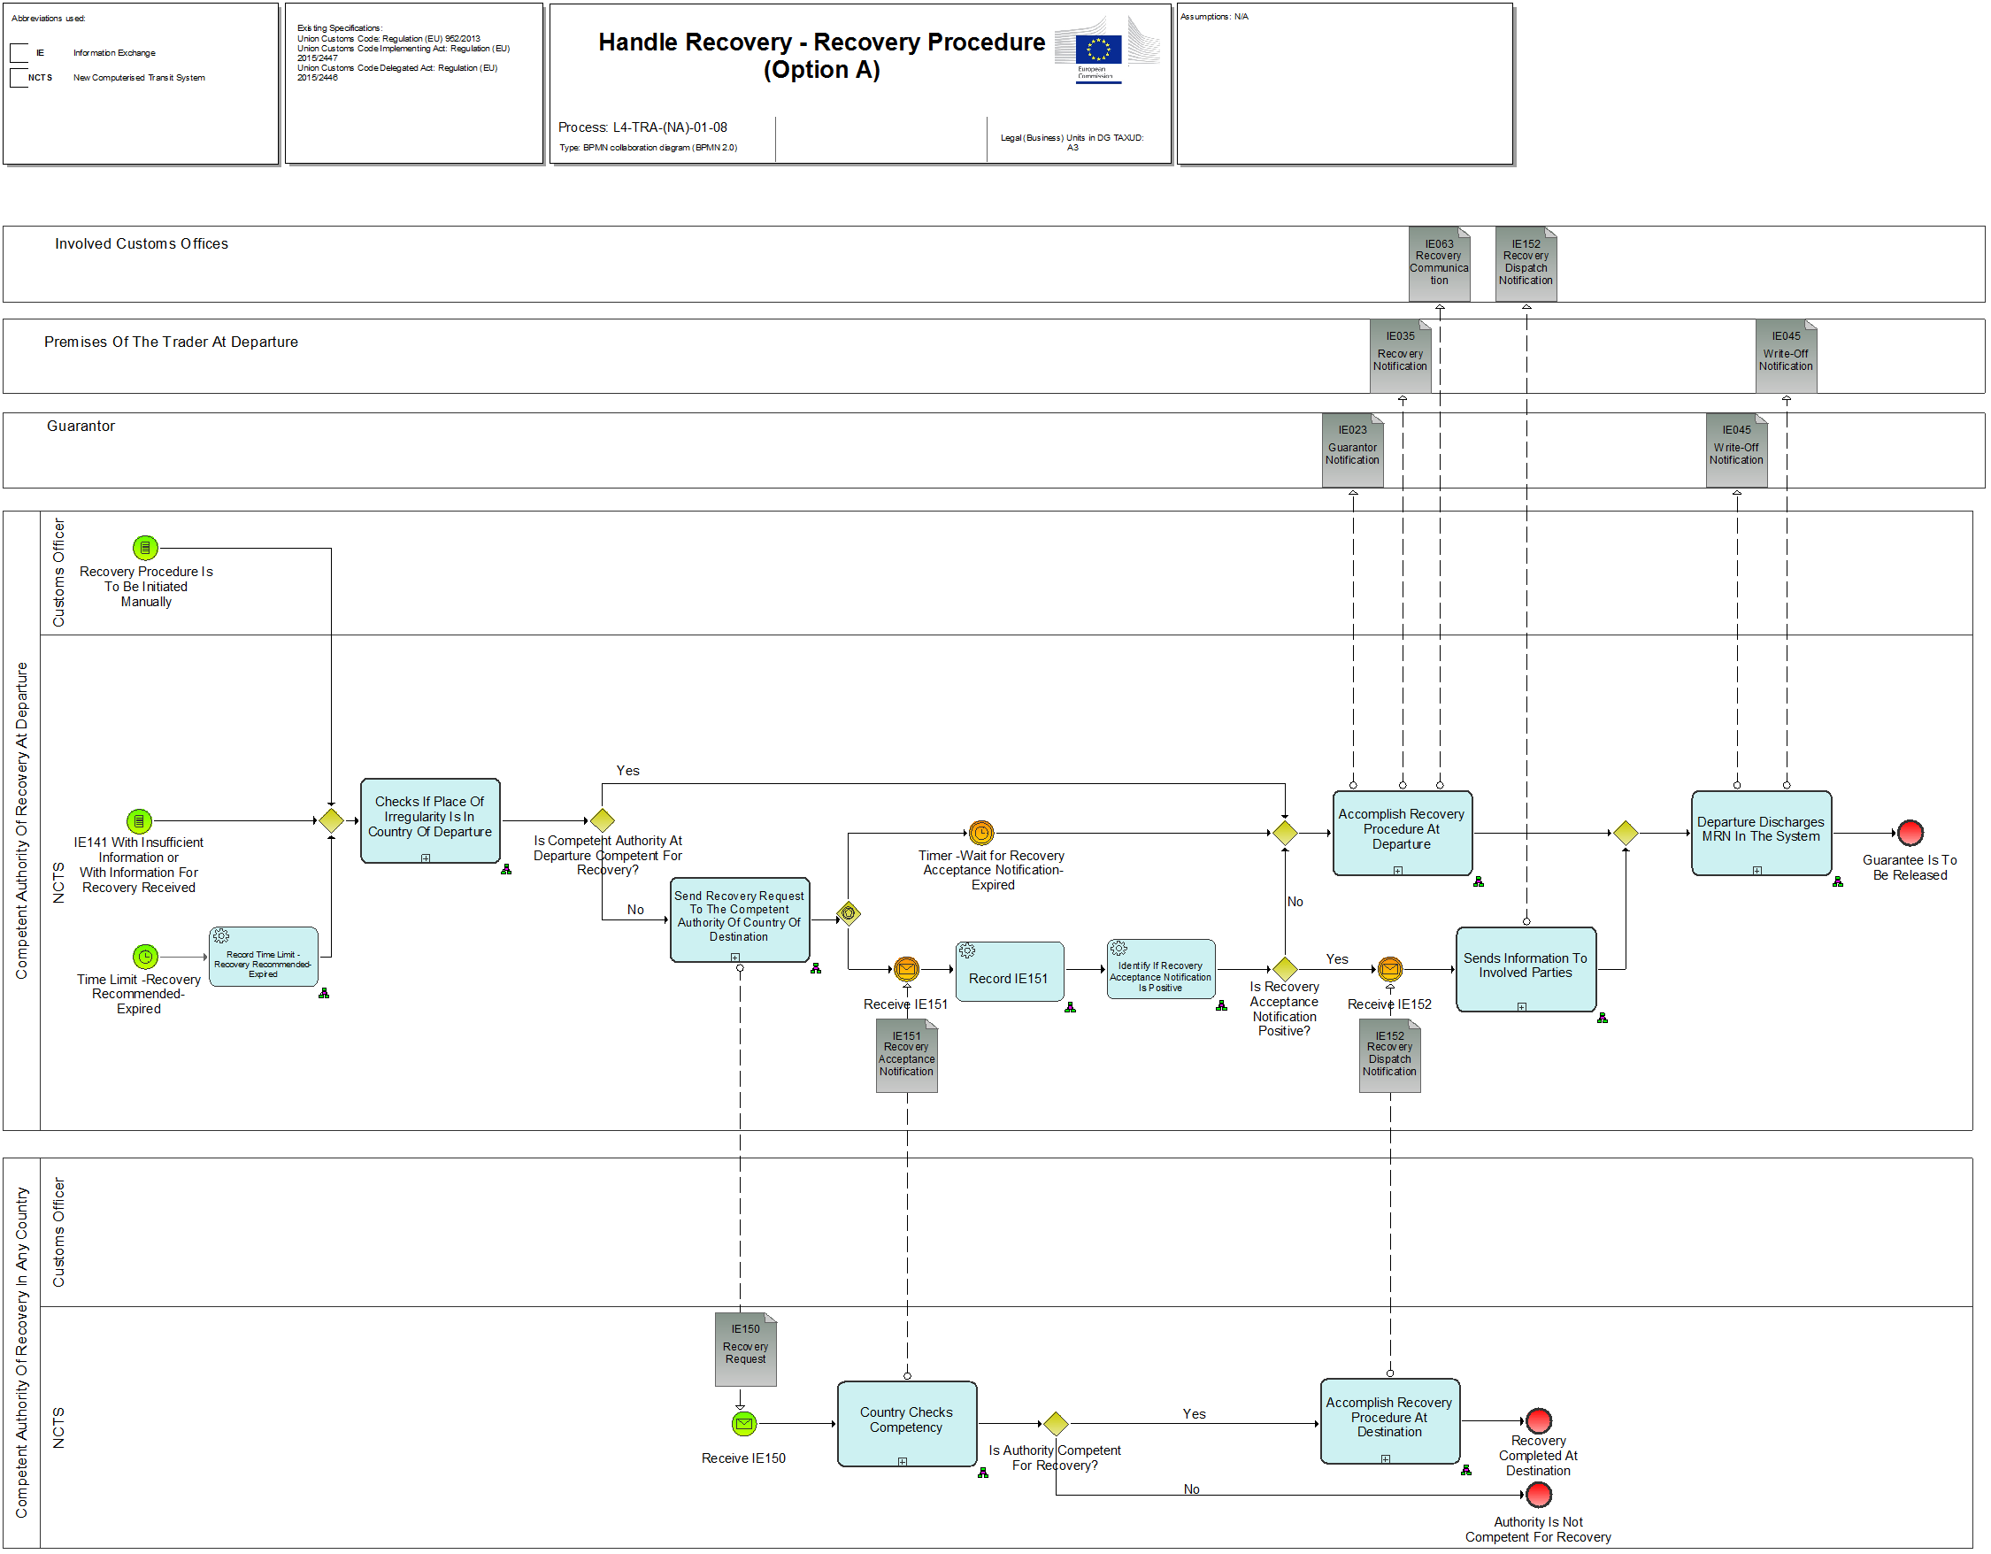

Figure 23: L4-TRA-01-08-Handle Recovery - Recovery Procedure (Option A) Part B

Events

|  |
| --- |
| Start recovery |
| Organisation : National Customs Administration |
| Location : Competent Authority of Country of Departure |
| (Timed event)  The master timer 'Recovery recommended' has expired. This time out indicates that recovery procedure should be started.  This time-out period is defined by the Competent Authority of Country of Departure using the values permitted in relevant legal framework.  A Customs Officer can also start the Recovery procedure manually at any time after the release of the movement. |

|  |
| --- |
| IE141 with insufficient information or with information for recovery or no IE141 received |
| Organisation : National Customs Administration |
| Location : Competent Authority of Country of Departure |
| No IE141 within the given time limit (see process L4-TRA-01-06-02-Check Provided Information) or an IE141 with insufficient information or with information for recovery has been received. |

|  |
| --- |
| IE143 'Request for Recovery' or IE150 received |
| Organisation : National Customs Administration |
| Location : Competent Authority of Country of Departure |
| An IE143 containing code 4 (request for Recovery at Destination) from the actual Customs Office of Destination has been received or an IE150 from any other office has been received. |

Processes

|  |  |
| --- | --- |
| Checks if place of irregularity is in Country Of Departure | Process: L4-TRA-01-08-01 |
| Organisation : National Customs Administration | |
| Location : Competent Authority of Country of Departure | |
| Constraint : | |
| Description :  The Competent Authority at departure investigates if the place of irregularity is in the Country of Departure to decide if it is competent or not. If it is in its own country it is competent and shall carry out recovery. The movement remains in the 'Recovery recommended' state. For the case of missing or insufficient IE141, the state has already been set to 'Recovery recommended' in L4-TRA-01-06-02-Check Provided Information.  If the irregularity did not take place in the Country of Departure the competency shall be transmitted to the responsible Country (may also be the country of transit). The movement stays in the ‘Recovery recommended’ state. Upon reception of acceptance of competency, the state shall be changed into 'Under recovery procedure'.  Final situation: Recovery will be started or recovery request will be sent. | |

|  |  |
| --- | --- |
| Send Recovery request to the Competent Authority of Country of Destination | Process: L4-TRA-01-08-02 |
| Organisation : National Customs Administration | |
| Location : Competent Authority of Country of Departure | |
| Constraint : | |
| Description :  In case the Competent Authority at Departure is not competent a Recovery request (IE150) is sent to the Competent Authority in another country. The timer 'Wait for Recovery Acceptance Notification' is set.  In cases where there is an IE118 the IE150 will be send to the country where the last Customs Office of Entry is situated.  Final situation :  Recovery request is sent and timer started. | |

|  |  |
| --- | --- |
| Country checks competency | Process: L4-TRA-01-08-03 |
| Organisation : National Customs Administration | |
| Location : Competent Authority of Recovery in any Country | |
| Constraint : | |
| Description :  The request for Recovery is received and recorded, the Competent Authority decides if it is competent or not. The answer (competent or not) is sent with the message 'Recovery acceptance notification' (IE151). In cases where there is an IE118 the IE151 from the same country may only contain the answer 'yes'.  If the requested Competent Authority is competent it will start the Recovery Procedure.  Final situation :  The answer is sent to Competent Authority of Recovery at Departure. Eventually Recovery will be started at Destination. | |

|  |  |
| --- | --- |
| Accomplish recovery procedure at destination | Process: L4-TRA-01-08-04 |
| Organisation : National Customs Administration | |
| Location : Competent Authority of Country of Destination | |
| Constraint : | |
| **Description :**  The amount of duties and other taxes to be recovered is calculated.  The Recovery Procedure seeks to recover the duties, taxes and interest on arrears first from the Holder of Transit procedure or from any identified debtor (IE035); if this is not possible, from the Guarantor (unless the movement was covered by a cash guarantee or guarantee waiver was granted).  Upon completion of the Recovery Procedure, with successful recovery of duties and taxes from the Holder of Transit procedure or Guarantor, the Competent Authority for Recovery at Destination informs the Competent Authority at Departure with a Recovery dispatch notification (IE152) of the outcome, the movement will then be written off (L4-TRA-01-03-Process Arrival) and, the relevant Customs Office of Guarantee is informed about the outcome.  Final situation :  The recovery procedure has been completed the Competent Authority of Country of Departure is informed and the movement can be written-off (L4-TRA-01-05-02-Handle Status Request). | |

|  |  |
| --- | --- |
| Accomplish Recovery procedure at Departure | Process: L4-TRA-01-08-05 |
| Organisation : National Customs Administration | |
| Location : Competent Authority of Country of Departure | |
| Constraint : | |
| **Description :**  If the Country of Departure is competent or an IE151 with a negative answer (no answer within the time limit is considered to be a negative one) was sent, the Competent Authority at Departure starts the Recovery and all involved offices that have received an IE001, IE003, IE050 or IE115, related to the movement, are notified (IE063). Based on the MRN brought in the recovery communication (IE063.TRANSIT OPERATION.MRN), NCTS records the start of the recovery procedure. The state is set to 'Under recovery procedure'. Upon the start of recovery, in case Transit follows Export, AES is notified (IE048) about the recovery as well.  The IE035 is sent to the Holder of Transit procedure and the IE023 is sent to the Guarantor.  The amount of duties and other taxes to be recovered is calculated.  The recovery procedure seeks to recover the duties and taxes first from the Holder of Transit procedure or from any identified debtor; if this is not possible, from the Guarantor (unless the movement was covered by a cash guarantee) within three years of the date of acceptance of the Transit declaration (Article 117(3) Appendix I, Convention/Art. 85(2) Delegated Act).  Upon completion of the recovery procedure, with successful recovery of duties, taxes and interest on arrears from the Holder of Transit procedure or Guarantor, the Competent Authority for Recovery at Departure writes off the movement (L4-TRA-01-03-Process Arrival) and, the relevant Customs Office of Guarantee is informed about the outcome.  Final situation: The Recovery Procedure has been completed and the movement can be written-off (L4-TRA-01-03-Process Arrival). The Holder of Transit procedure and the Guarantor are informed about the Recovery Procedure, the declared Customs Office of Destination no longer waits for a movement with that MRN and every involved Customs Office is informed about recovery via IE063. | |

|  |  |
| --- | --- |
| Sends information to involved parties | Process: L4-TRA-01-08-06 |
| Organisation : National Customs Administration | |
| Location : Competent Authority of Country of Departure | |
| Constraint : | |
| Description :  The Recovery acceptance notification (IE151) on the request for Recovery is received and recorded (positive answer). Upon positive answer of Recovery acceptance notification (IE151) the Recovery dispatch notification (IE152) is received and recorded.  The Competent Authority of the Country of Departure forwards the files by other means to the Competent Authority in the other country. The Holder of Transit procedure will be informed by other means about the new Competent Authority. All involved offices that have received an IE001, IE003, IE050 or IE115, related to the movement, are notified (IE063). Based on the MRN brought in the recovery communication (IE063.TRANSIT OPERATION.MRN), NCTS records the start of the recovery procedure. The movement is set in the state ‘Under recovery procedure’.  Final situation :  Recovery will be started at departure or in another country. All involved offices are informed via IE063 and do no longer wait for a movement with that MRN. | |

|  |  |
| --- | --- |
| Departure discharges MRN in the system | Process: L4-TRA-01-08-07 |
| Organisation : National Customs Administration | |
| Location : Competent Authority of Country of Departure | |
| Constraint : | |
| **Description :**  Upon completion of the Recovery Procedure, with successful recovery of duties and taxes from the Holder of Transit procedure or Guarantor, the Competent Authority for Recovery at Departure writes off the movement (L4-TRA-01-03-Process Arrival) and, the relevant Customs Office of Guarantee is informed about the outcome.   * NCTS records the write-off and notifies (IE045) the Holder of Transit procedure that the movement is written-off. * NCTS notifies (IE045) the Guarantor (unless the movement was covered by a cash guarantee) that the movement is written-off. * NCTS notifies (IE152) all involved offices from which it has not already received an IE152 of the collection of duties.   Final situation :  The movement is written-off; the release of the guarantee is recorded into NCTS; the state of the Transit Operation is set to 'Movement written off', the Holder of Transit procedure and the Guarantor are informed about the Recovery Procedure. | |

### L4-TRA-01-09-Handle Recovery - Recovery Procedure (Option B)– IE143 'Recovery request' or IE150 from any office

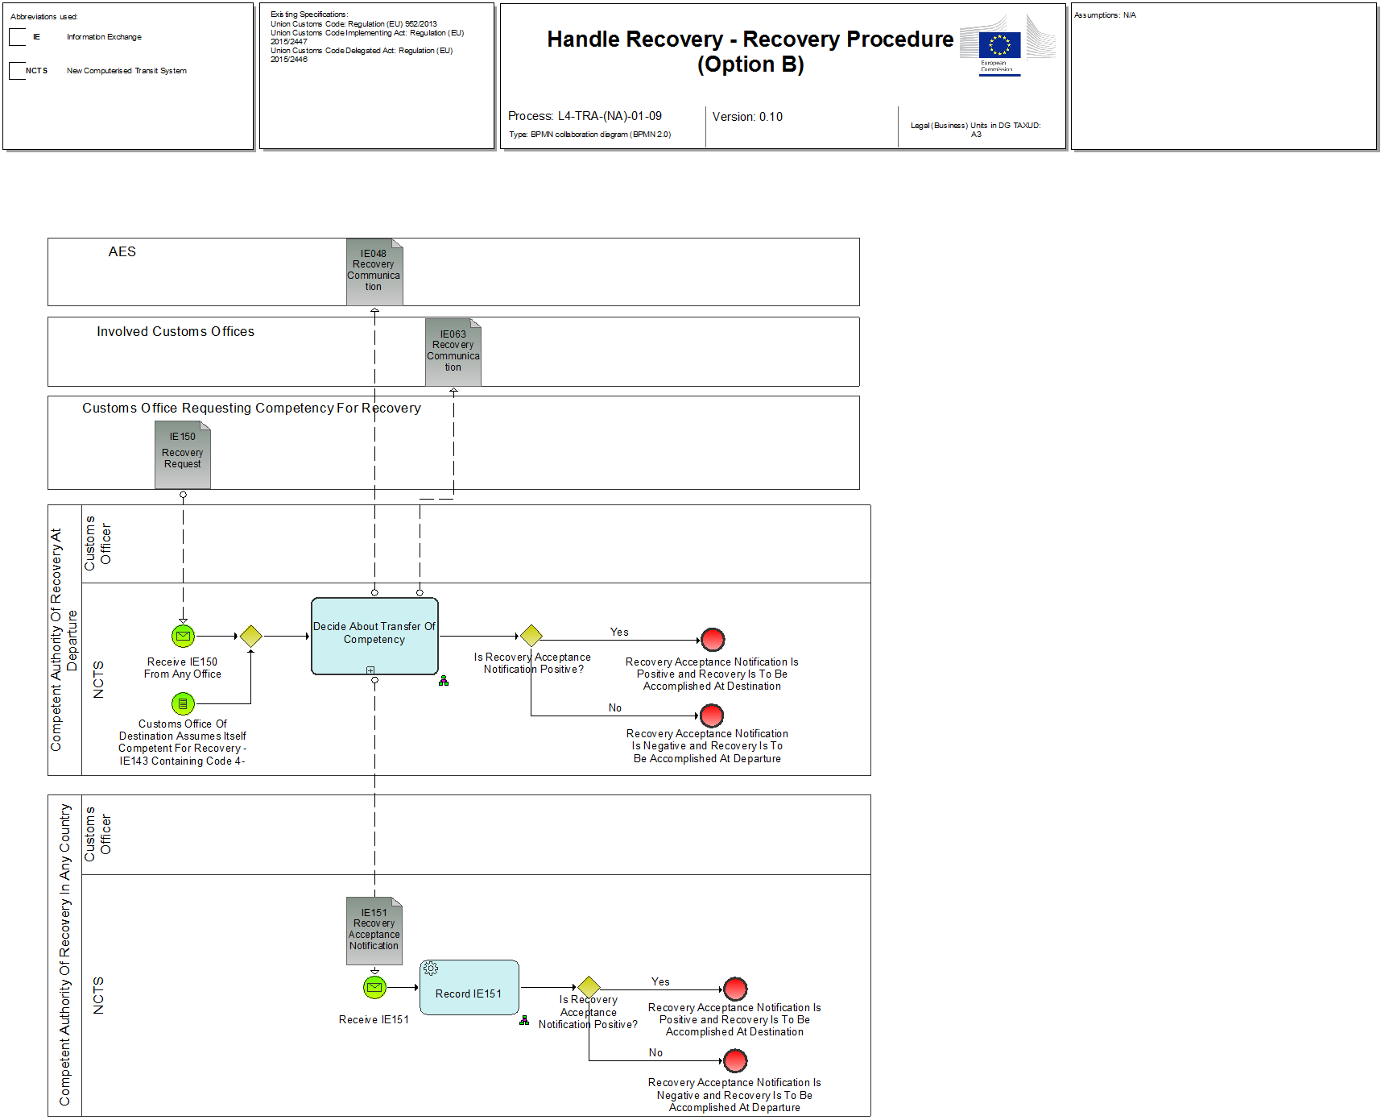

Figure 24: L4-TRA-01-09-Handle Recovery - Recovery Procedure (Option B)

Events

|  |
| --- |
| Customs Office Of Destination Assumes Itself Competent For Recovery -IE143 Containing Code 4- |
| Organisation : National Customs Administration |
| Location : Competent Authority of Country of Departure |
| An IE143 containing code 4 (request for Recovery at Destination) from the Actual Customs Office Of Destination has been received.  The IE143 with 'competent for recovery' is received by the Competent Authority of Enquiry at Departure because, based on the information available, the Customs Office of Destination assumes itself as competent for recovery. |

|  |
| --- |
| Receive IE150 From Any Office |
| Organisation : National Customs Administration |
| Location : Competent Authority of Country of Departure |
| Alternatively, a recovery request (IE150) has been received from any other country which assumes itself as competent for recovery. This may occur at any time within an enquiry or recovery procedure.  An IE150 from any other office has been received. |

|  |  |
| --- | --- |
| Decide about transfer of competency | Process: L4-TRA-01-09-01 |
| Organisation : National Customs Administration | |
| Location : Competent Authority of Country Departure | |
| Constraint : | |
| Description :  An IE143 with the request for recovery (containing code 4) or an IE150 has arrived. The Competent Authority of Country of Departure decides whether the competency shall be transferred or not.  If the Competent Authority of Country of Departure has decided to not transfer the competency, the IE151 with a negative answer is sent to the Requesting Office and the process continues as described in L4-TRA-01-08-05-Accomplish Recovery Procedure at Departure.  In case the Requesting Office has additional information the IE144/145 can be used.  Ifthe Competent Authority of Country of Departure has decided to transfer the competency, the IE151 with a positive answer is sent to the requesting office. The process continues as described in L4-TRA-01-08-04-Accomplish Recovery Procedure at Destination.  Final situation: Decision about transferring competency has been taken, Recovery Procedure at Departure or at Destination will start. | |

Major Result

The result “Movement written-off” is explained in the paragraph “L4-TRA-01-03-Process Arrival”.

Minor Results

|  |
| --- |
| Holder of Transit procedure notified about recovery |
| Organisation : National Customs Administration |
| Location : Premises of the Trader at Departure |
| The Holder of Transit procedure or any identified debtor is notified of the recovery and its amount. |

|  |
| --- |
| Guarantor notified about recovery |
| Organisation : National Customs Administration |
| Location : Premises of the Guarantor |
| The relevant Guarantor is notified of the recovery and its amount. |

|  |
| --- |
| All involved Offices notified about start of recovery |
| Organisation: National Customs Administration |
| Location: Declared Customs Office of Transit |
| The recovery communication is received by all involved Offices. |

|  |
| --- |
| Writing off the movement |
| Organisation: National Customs Administration |
| Location: Customs Office of Departure |
| The movement is written off in the system. |

|  |
| --- |
| Info about end of Recovery |
| Organisation: National Customs Administration |
| Location: all involved Customs Offices |
| All involved Customs Offices are informed about the end of the recovery procedure. |

|  |
| --- |
| Requesting office informed about rejection |
| Organisation: National Customs Administration |
| Location: requesting office |
| Requesting office is informed about non-handing over of competency. |

Remark

The results “Guarantor notified of the write-off”, “Holder of Transit procedure notified of the write-off” and “Movement written-off” are explained in the paragraph “L4-TRA-01-03-Process Arrival”.

|  |  |
| --- | --- |
| Handling of discrepancies | Process: Manual Process |
| Organisation : National Customs Administration | |
| Location : Customs Office of Departure | |
| Constraint : | |
| Description :  The Customs Office of Departure decides upon the discrepancies whether the procedure can be discharged. Exceptional handling shall be sorted out via the Helpdesks (for technical problems) or via the Transit Coordinators (for other problems) or via any other means outside NCTS.  Final situation :  Movement is written off. | |

## L4-TRA-01-10-Process Invalidation/Cancellation

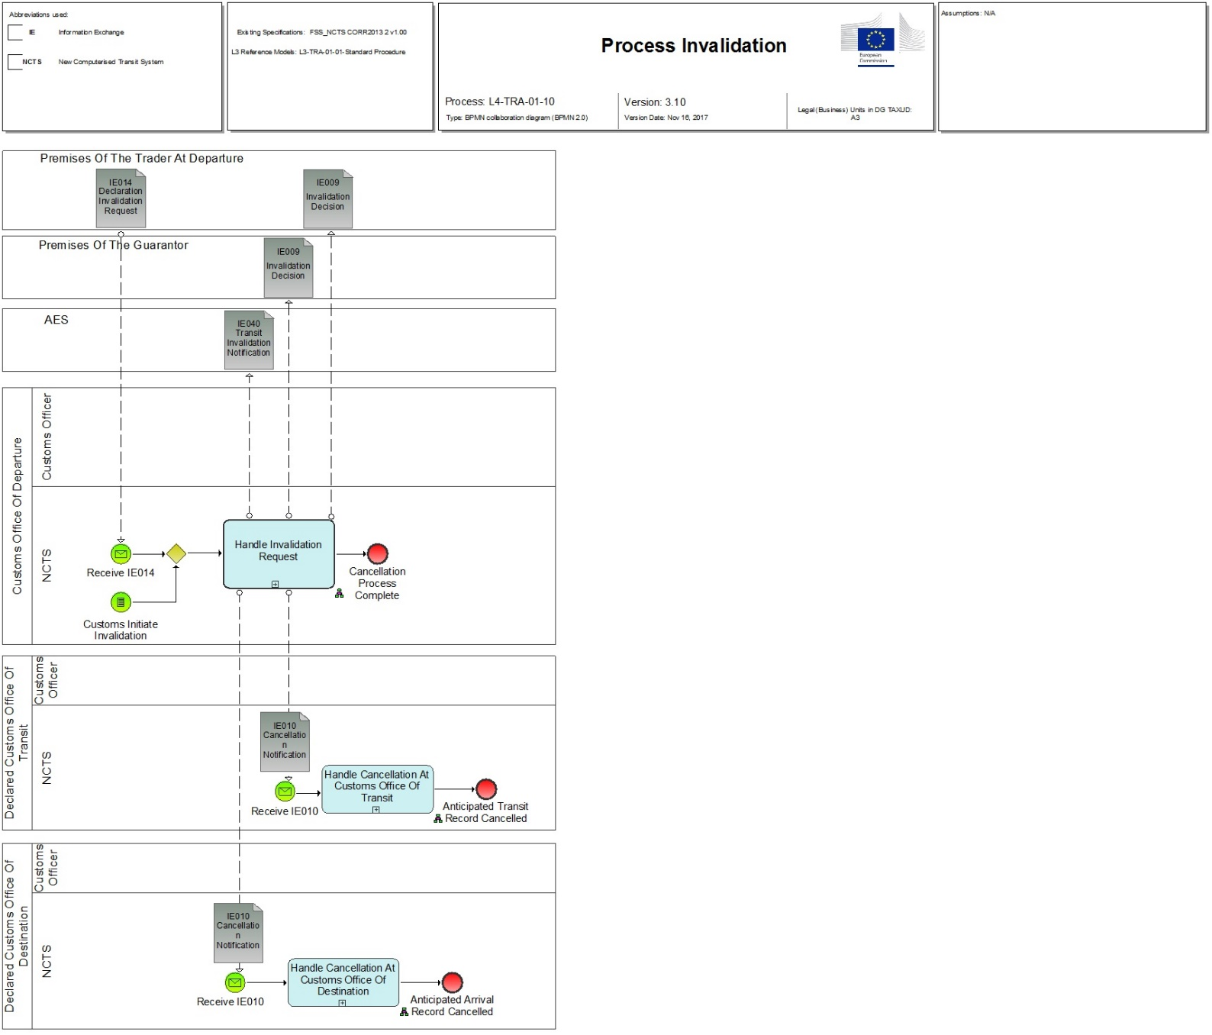

Figure 25: L4-TRA-01-10-Process Invalidation/Cancellation

Major Events

|  |
| --- |
| Holder of Transit procedure requests an Invalidation |
| Organisation : Trader |
| Location : Premises of the Trader at Departure or Customs Office of Departure |
| The Holder of Transit procedure submits an Invalidation request of his declaration, which has previously been accepted. |

|  |
| --- |
| Customs invalidates a declaration |
| Organisation : National Customs Administration |
| Location : Customs Office of Departure |
| The Customs Officer wants to invalidate the decision to accept the declaration or cancel the release of goods. |

Processes

|  |  |
| --- | --- |
| Handle Invalidation/Cancellation request | Process: L4-TRA-01-10-01 |
| Organisation : National Customs Administration | |
| Location : Customs Office of Departure | |
| Constraint :  When two or more Offices of Transit belong to the same National Administration, or an (some) Office(s) of Transit and the Customs Office of Destination belong to the same National Administration, then only one IE010 is sent to the National Administration in question. | |
| Description :  The Process can be initiated either when the Customs Office of Departure receives (IE014) an Invalidation request from a Holder of Transit procedure (prior of movement release for Transit) or when the Customs Officer wants to invalidate the decision to accept the declaration or cancel the release of goods. Movement can only be cancelled post goods release, in every other case is invalidated.  In both cases the invalidation/cancellation of a movement is handled manually.  The Holder of Transit procedure must furnish the proof (IE014.TRANSIT OPERATION. Invalidation reason) that goods were declared in error or due to special circumstances, the placing of the goods under Transit is no longer justified.  When the Customs Officer of the Customs Office of Departure cannot accept the invalidation request, he/she communicates (IE009) the rejection of the invalidation request (IE009.TRANSIT OPERATION. Invalidation decision = ‘No’) with reasons (e.g. a NCF (IE118) was already received from a Customs Office of Transit).  When the Customs Officer of the Customs Office of Departure accepts the invalidation request from a Holder of Transit procedure, he/she communicates (IE009) the invalidation request of the movement to the Holder of Transit procedure (IE009.TRANSIT OPERATION. Invalidation Initiated by Customs = ‘No’ and IE009.TRANSIT OPERATION. Invalidation decision = ‘Yes’).  When the invalidation is on Customs initiative, the Customs Officer communicates (IE009) to the Holder of Transit procedure that an invalidation is required by Customs (IE009.TRANSIT OPERATION. Invalidation Initiated by Customs = ‘Yes’).  When the Customs Officer accepts the invalidation request after the movement was already released for Transit, this means that the declared Office(s) of Transit and the declared Customs Office of Destination have already been notified (IE050 and IE001) of the release for Transit. He/she communicates (IE009) the acceptance of the invalidation to the Holder of Transit procedure and also a cancellation notification is sent (IE010) to all declared Office(s).  When the movement is invalidated then the already registered guarantee is released (see process L4-TRA-02-06 Cancel Guarantee Usage) and NCTS communicates the invalidation decision (IE009) to the Guarantor.  Final situation :  When the invalidation request is accepted, the state of the Transit Operation is set to ‘Invalidated’.  When invalidation request is refused, the state of the Transit Operation is not changed.  The Holder of Transit procedure, the declared Customs Office of Destination and all declared Office(s) of Transit are notified that the Declaration is invalidated. | |

|  |  |
| --- | --- |
| Handle Cancellation at Customs Office of Transit | Process: L4-TRA-01-10-02 |
| Organisation : National Customs Administration | |
| Location : Declared Customs Office of Transit | |
| Constraint : | |
| Description :  The declared Customs Office of Transit receives (IE010) a cancellation notification from the Customs Office of Departure. The already registered Anticipated Transit Record (ATR) is cancelled.  Final situation :  The movement information at the declared Customs Office of Transit is cancelled, the state of the Transit Operation is set to ‘ATR Cancelled’. | |

|  |  |
| --- | --- |
| Handle Cancellation at Customs Office of Destination | Process: L4-TRA-01-10-03 |
| Organisation : National Customs Administration | |
| Location : Declared Customs Office of Destination | |
| Constraint : | |
| Description :  The declared Customs Office of Destination receives (IE010) a cancellation notification from the Customs Office of Departure. The already registered Anticipated Arrival Record (AAR) is cancelled.  Final situation :  The movement information at the declared Customs Office of Destination is cancelled, the state of the Transit Operation is set to ‘AAR Cancelled. | |

Major Results

|  |
| --- |
| Invalidation accepted or required by Customs Authority |
| Organisation : National Customs Administration |
| Location : Premises of the Trader at Departure or Customs Office of Departure |
| The Transit movement is invalidated by the Holder of Transit procedure or by Customs. |

|  |
| --- |
| Invalidation refused by Customs Authority |
| Organisation : National Customs Administration |
| Location : Premises of the Trader at Departure or Customs Office of Departure |
| The Holder of Transit procedure cannot invalidate his/her declaration. |

Minor Results

|  |
| --- |
| Customs Office of Transit notified of cancellation |
| Organisation : National Customs Administration |
| Location : Declared Customs Office of Transit |
| Each declared Customs Office of Transit is notified of the cancellation of a movement. |

|  |
| --- |
| Customs Office of Destination notified of cancellation |
| Organisation : National Customs Administration |
| Location : Declared Customs Office of Destination |
| The declared Customs Office of Destination is notified of the cancellation of a movement. |

The result “Cancellation of the guarantees has been asked” is explained under Heading “2.4. L4-TRA-01-01 Process Departure - Acceptance and Controls.

## L4-TRA-01-11-Process Query Movement Information

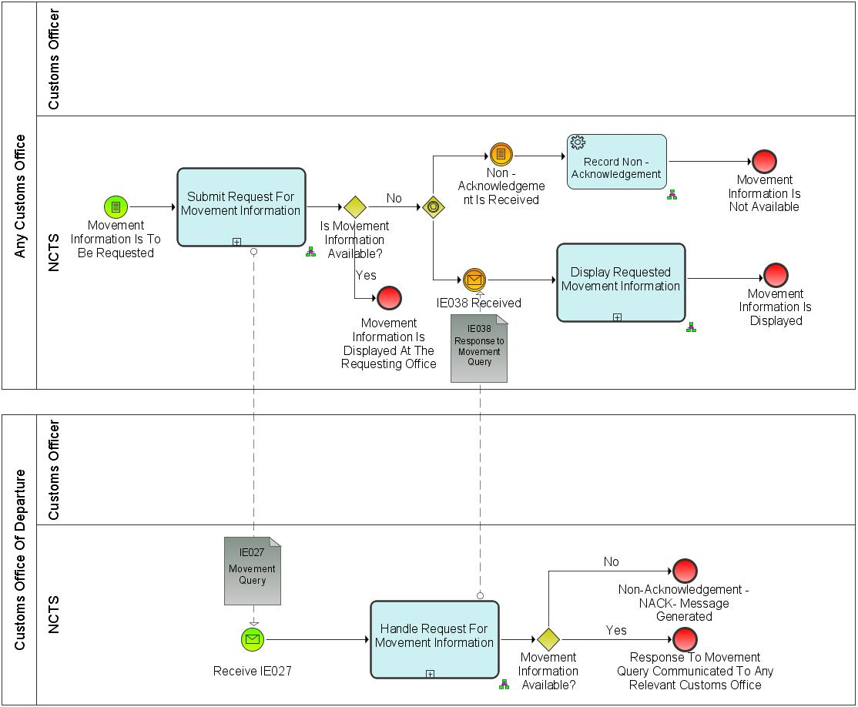

Figure 26: L4-TRA-01-11-Process Query Movement Information

Major Event

|  |
| --- |
| Customs Officer requests movement information |
| Organisation : National Customs Administration |
| Location : Customs Office of Departure, Customs Office of Destination, Customs Office of Guarantee, Customs Office of Transit |
| A Customs Officer with an appropriate level of authorisation and access to NCTS at any Customs Office, requests the movement information for a movement with a given MRN.  N.B. This includes the case of an en-route control, if access to the NCTS is available. |

Processes

|  |  |
| --- | --- |
| Submit request for movement information | Process: L4-TRA-01-11-01 |
| Organisation : National Customs Administration | |
| Location : Customs Office of Departure, Customs Office of Destination, Customs Office of Guarantee, Customs Office of Transit | |
| Constraint :  The movement information may be located in a different country (that of the Customs Office of Departure). | |
| A Customs Officer submits a request for movement information based on a given MRN.  NCTS looks for the movement:   * when the movement information is available at the Office where the request is submitted, NCTS retrieves and displays it to the Customs Officer immediately. * when the movement information is not available at the Office where the request is submitted, NCTS notifies the Customs Officer that the information is not available and automatically sends (IE027) a request to the Country of Departure.   The requesting Customs Offices receives (IE038) the response to the request. NCTS displays the received information or the received error message.  Final situation :  The movement information is returned or a request for movement information is submitted to the Customs Office of Departure. | |

|  |  |
| --- | --- |
| Handle request for movement information | Process: L4-TRA-01-11-02 |
| Organisation : National Customs Administration | |
| Location : Customs Office of Departure | |
| Constraint :  If the provided request (IE027) relates to a transit movement which is used for safety and security (IE001.TRANSIT OPERATION. Security = ‘1’ (ENS), ‘2’ (EXS) and ‘3’ (ENS and EXS), then the response (IE038) shall contain the relevant additional safety and security data elements.  Safety and security risk analysis results shall be exchanged between an EU Member State and a CTC country only if there is a legal basis for doing so. | |
| The Country of Departure receives (IE027) a request for movement information from a Customs Office. NCTS looks for the movement based on the MRN identified by IE027.TRANSIT OPERATION.MRN and provides (IE038) the requesting Customs Office with the movement information or, according to Section IX, ‘EXCEPTION HANDLING, Pt 2.1.3 with an advice of non-acknowledgement (NACK) if the movement doesn’t exist at the Customs Office of Departure.  Safety and security related risk analysis results shall be included in IE038 if all of the following conditions are fulfilled:   * The Customs Office of Departure and the Office performing the movement query are both located in an EU Member State.   Final situation :  If available, the movement information is conveyed to the requester, otherwise a non-acknowledgement (NACK) is conveyed. | |

|  |  |
| --- | --- |
| Display requested movement information | Process: L4-TRA-01-11-03 |
| Organisation : National Customs Administration | |
| Location : Customs Office of Departure, Customs Office of Destination, Customs Office of Guarantee, Customs Office of Transit | |
| Constraint :  If the provided response (IE038) relates to a transit movement which is used for safety and security (IE001. TRANSIT OPERATION. Security = ‘1’ (ENS), ‘2’ (EXS) and ‘3’ (ENS and EXS), then the response (IE038) contains the relevant additional safety and security data elements. | |
| The requesting Customs Offices receives (IE038) the response to the request. NCTS displays the received information or the received error message.  Final situation :  The requested movement information is displayed. | |

Result

|  |
| --- |
| Movement information displayed |
| Organisation : National Customs Administration |
| Location : Customs Office of Departure, Customs Office of Destination, Customs Office of Guarantee, Customs Office of Transit |
| The information on the requested movement is displayed. |

## L4-TRA-01-12-Process Incidents En Route

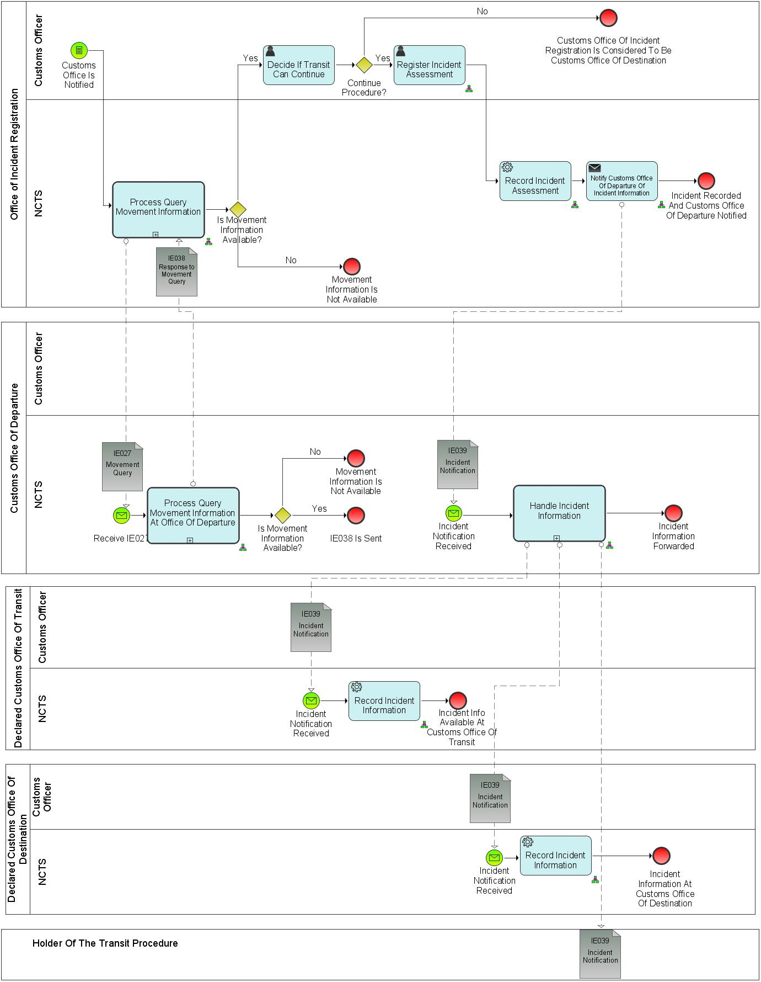

Figure 27: Process Incidents En Route (Part A)



Figure 28: Process Incidents En Route (Part B)

Major Event

|  |
| --- |
| Customs Office is notified |
| Organisation : National Customs Administration |
| Location : Customs Office of Incident Registration |
| Customs Office of Incident Registration is notified that an incident occurred during a transit movement. |

Processes

|  |  |
| --- | --- |
| Process Incidents En Route | Process: L4-TRA-01-12 |
| Organisation : National Customs Administration | |
| Location : Customs Office of Incident Registration | |
| Constraint :  - Nearest Customs Office to the place of the incident occurred is notified of the incident.  - In justified cases, Customs Officer may decide to perform a control of the goods (part of decision by Customs to continue or end the movement). | |
| **Description :**  The process is triggered when an en-route incident occurs to a Transit movement. Such an incident can be:  (a) the carrier is obliged to deviate from the itinerary prescribed in accordance with Article 298 of UCC/IA Regulation due to circumstances beyond his control;  (b) seals are broken or tampered with in the course of a transport operation for reasons beyond the carrier's control;  (c) under the supervision of the customs authority, goods are transferred from one means of transport to another means of transport;  (d) imminent danger necessitates immediate partial or total unloading of the sealed means of transport;  (e) there is an incident which may affect the ability of the holder of the procedure or the carrier to comply with his obligations;  (f) any of the elements constituting a single means of transport as referred to in Article 296(2) UCC/IA is changed.  The carrier presents without undue delay after the incident the goods together with the NCTS Accompanying Document or MRN of Transit Declaration in an electronically readable format, to the nearest customs authority (Customs Office of Incident Registration) of the Member State in whose territory the means of transport is located. When the incident occurs, the Carrier must add the details of the transport operation in to the NCTS Accompanying Document and the Customs Authorities at the Office of Transit or Office of Destination, as the case may be, have the obligation to incorporate into the system the added data on the transit accompanying document. (COMMISSION DELEGATED REGULATION (EU) 2015/2446 pp 272).  In case the Customs Office of Incident Registration was not included in the declared Transit movement and Movement Information is not available, then it requests the consignment information from the Customs Office of Departure based on the MRN provided (see Process L4-TRA-01-11-Process Query Movement Information).  If the Movement information is available then the Customs Office of Incident Registration can proceed with deciding whether to continue the transit movement. If the Customs Officer decides that the transit movement cannot continue then the Customs Office of Incident Registration becomes the actual Customs Office of Destination and starts performing the relevant transit formalities (see Process L4-TRA-01-03-Process Arrival).  If the Customs Office of Incident Registration decides that the transit movement can continue, incident information is recorded in the system (NCTS) and communicated to the Customs Office of Departure.  If an incident occurs at Customs Office of Transit or at Customs Office of Destination, then this particular office acts first as a Customs Office of Transit or Customs Office of Destination accordingly and then as Customs Office of Incident Registration.  **Final situation :**   * When the Transit cannot continue the Customs Office where the Incident was registered performs the Actual Customs Office of Destination formalities. * The Incident information is registered to the system. | |

|  |  |
| --- | --- |
| Handle Incident Information | Process: L4-TRA-01-12-01 |
| Organisation : National Customs Administration | |
| Location : Customs Office of Departure | |
| Constraint : | |
| Description :  The Customs Office of Departure is notified (IE039) by the Customs Office of Incident Registration of the incident.  When Incident Information is recorded, Customs Office of Departure checks if a Customs Office of Transit is involved and identifies if (IE118) NCF-information was received earlier for that particular movement. In case a Customs Office of Transit is involved and no IE118 is received, Customs Office of Departure notifies the particular Customs Office of Transit of the incident information.  Customs Office of Departure notifies the incident to the Declared Customs Office of Destination. It is determined at national level how the Holder of the Transit Procedure is to be informed.  Final situation :  Incident information communicated to the particular parties. | |

Major Result

|  |
| --- |
| **Customs Office Of Incident Registration performs the Actual Customs Office of Destination formalities** |
| Organisation : National Customs Administration |
| Location : Office Incident Registration |
| Customs Office Of Incident Registration performs the Actual Customs Office of Destination formalities |

|  |
| --- |
| Holder of Transit procedure notified of incident |
| Organisation : Trader |
| Location : Customs Office Of Incident Registration |
| The Holder of the Transit procedure is notified by the Customs Office of Departure that an incident occurred to the transit movement, with the relevant incident details and impact. |

|  |
| --- |
| Customs Office of Transit notified of en-route incident |
| Organisation : National Customs Administration |
| Location : Customs Office of Transit |
| The Customs Office of Transit notified by the Customs Office of Departure that an incident occurred to a transit movement |
| Customs Office of Destination notified of incident |
| Organisation : National Customs Administration |
| Location : Customs Office of Destination |
| The Customs Office of Destination notified by the Customs Office of Departure that an incident occurred to a transit movement |

## L4-TRA-01-13- Process Formalities Prior To Exit Of Goods At Customs Office Of Exit For Transit

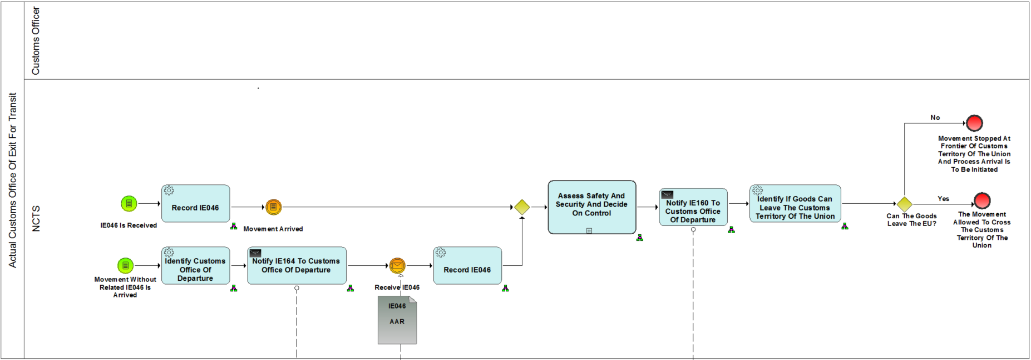

Figure 29: Process Formalities Prior To Exit Of Goods At Customs Office Of Exit For Transit (Part A)

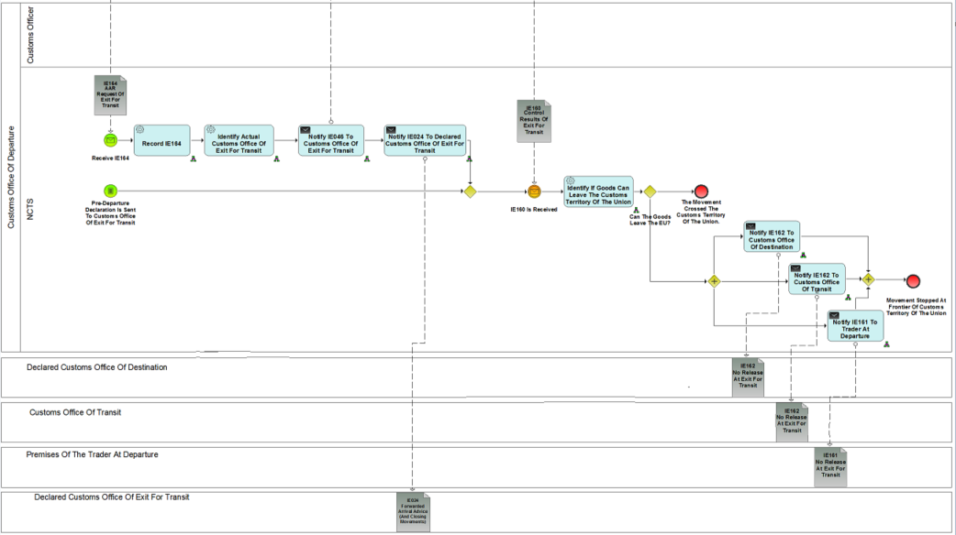

Figure 30: Process Formalities Prior To Exit Of Goods At Customs Office Of Exit For Transit (Part B)

Major Event

|  |
| --- |
| Notification that goods lodged in the EU for goods leaving the EU to a CTC country |
| Organisation : National Customs Administration |
| Location : Actual Customs Office of Exit For Transit |
| Customs Office of Exit for Transit is notified that the goods are Released for Transit with a declaration containing EXS particulars, risk analysis results and control recommendation from the Customs Office of Departure. Movement is lodged in the EU for goods leaving the EU to a CTC country (other than Norway or Switzerland). |

Processes

|  |  |
| --- | --- |
| Process Formalities Prior To Exit of Goods At Customs Office Of Exit For Transit | Process: L4-TRA-01-13 |
| Organisation : National Customs Administration | |
| Location : Actual Customs Office of Exit For Transit | |
| Constraint : | |
| **Description:**  Τhe Customs Office of Exit for Transit as per Article 329(1) of the UCC IA, shall be the customs office competent where the goods leave the Customs Territory of the Union for a destination outside that territory.  The process starts when the goods are Released for Transit and a Customs Office of Exit for Transit is identified. Prior to the arrival of the movement to borders of the Customs Territory of the Union, Customs Office of Departure notifies the Customs Office of Exit for Transit with the IE046 containing the Transit declaration data along with EXS particulars (IE046. TRANSIT OPERATION.Security), risk analysis results (IE046. RISK ANALYSIS RESULT) and control recommendation.  In case the movement arrives in a Customs Office of Exit for Transit other than the declared, the Actual Customs Office of Exit for Transit has no information regarding the movement due to the diversion of the route. Based on the MRN of the movement, the Customs Office of Exit for Transit requests the movement information needed from the Customs Office of Departure (IE164), in order to perform a safety and security assessment. The declared Customs Office of Exit for Transit is informed (IE024) by the Customs Office of Departure that the movement arrived in another destination closing the movement. When the IE046 is received from the Customs Office of Departure and the movement arrives at the Customs Office of Exit for Transit, NCTS requests an automatic national risk analysis (profile of risk analysis is based on the Exit movement) as to be determined if the goods can be exited from the Customs territory of the Union (Process L4-TRA-01-13-01- Safety and Security Assessment at Customs Office of Exit for Transit). The Customs Officer combines all the information needed (the movement information retrieved by NCTS via the allocated MRN and the result of risk analysis), in order to decide if control is required. The control decision is registered: a. if no control is decided then it is recorded to the System. b. If control is performed the respective result is registered and recorded to the System.  When the Control result is available, a notification IE160 will be sent to the Customs Office of Departure, informing the result in the Customs Office of Exit for Transit.  In case goods can leave the Customs Territory of the Union (ΙΕ160. CROSS UNION CUSTOMS TERRITORY. Cross Union Customs Territory = ‘Yes’) the movement crosses the Frontier.  In case goods cannot leave the Customs Territory of the Union (ΙΕ160. CROSS UNION CUSTOMS TERRITORY. Cross Union Customs Territory = ‘Νo’), the movement is not allowed to cross the Frontier. The Customs Office of Exit for Transit acts as Customs Office of Destination for the movement and the Process Arrival is triggered.  The Office of Departure informs (IE162) for non-release of goods to cross the Customs Frontier of the Union all the participants in the movement who previously received the Anticipated Arrival Record (IE001) or the Anticipated Transit Record (IE050). The same information (IE161) is also communicated to the declarant who is responsible to lodge a new declaration for the movement in order the goods to reach to the destination. | |

|  |  |
| --- | --- |
| Safety and Security Assessment At Customs Office of Exit For Transit | Process: L4-TRA-01-13-01 |
| Organisation : National Customs Administration | |
| Location : Actual Customs Office of Exit for Transit | |
| Constraint : | |
| Description :  Process is initiated upon movement arrival at the Customs Office Of Exit for Transit. NCTS requests an automatic national risk analysis (the profile of risk analysis is based on the Exit Movement) as to reach decision whether the goods are eligible to be exited from the Customs territory of the Union. The Customs Officer combines all the information needed (the movement information retrieved by NCTS via the allocated MRN and the result of risk analysis), in order to decide if control is required.  The control decision is registered: a. if no control is decided then it is recorded to the System. b. If control is performed the respective result is registered and recorded to the System.  Final situation :  Safety and Security assessment is performed and result recorded in the system. | |

Major Result

|  |
| --- |
| Movement Stopped At Frontier Of Customs Territory Of the Union And Process Arrival Is To Be Initiated |
| Organisation : National Customs Administration |
| Location : Actual Customs Office of Exit for Transit |
| Movement is not allowed to cross the Customs Frontier of the Union. The Customs Office Of Exit for Transit acts as Customs Office Of Destination for the movement and process Arrival is triggered. |

|  |
| --- |
| Movement Allowed To Cross The Customs Frontier Of The Union |
| Organisation : National Customs Administration |
| Location : Actual Customs Office of Exit for Transit |
| Movement Crosses Frontier |

Minor Events

|  |
| --- |
| Declared Custom Office of Destination is notified of not release for Transit. |
| Organisation : National Customs Administration |
| Location : Declared Custom Office of Destination |
| Declared Custom Office of Destination is notified of not release for exit the Customs territory of the Union from Custom Office of Departure. |

|  |
| --- |
| Customs Office of Transit is notified of not release for Transit. |
| Organisation : National Customs Administration |
| Location : Declared Custom Office of Transit |
| Custom Office of Transit is notified of not release for exit the Customs territory of the Union from Custom Office of Departure via message IE162 (No Release At Exit For Transit). |

|  |
| --- |
| Trader at Departure is notified of not release for Transit. |
| Organisation : Trader |
| Location : Premises of Trader at Departure |
| Custom Office of Departure notifies the Trader at Departure, via message IE161 (No Release At Exit For Transit), that the transit movement is "ended" because the goods are not authorised to exit the Customs territory of the Union. |

## Assist users in their daily work

Beside the processes described in the previous parts of this section, the NCTS must provide systems to help users in their daily work by providing the services described below. Those services are presented for information to guide development at National level and so, they are only indicative.

A major concern for users, either Customs Officer or Trader, is to know the states of the Transit movements (i.e. which processes they passed through) in order to organise the work in the Customs (or Traders) Offices and to track a specific movement.

The identification of the main states of a Transit operation is presented ARIS State Transition Diagrams’. The diagram is used to serve both the identification of the ‘history’ and the ‘follow-up’ of the movement.

### Services

### Customs’ movements state system

##### **The Customs Officer at departure**

The Customs Officer needs a system to manage the accepted declarations, from the acceptance to the release for Transit.

He needs a system in order to be able to:

1. List the declarations in a tabular view with the following columns:

* LRN (required because it is possible to load declaration from magnetic or optic media; so, those declarations are treated in batch mode and the Trader doesn’t know immediately the MRN);
* MRN;
* declaration type;
* state (as defined in the state transition diagram);
* date: the date related to the state change: e.g. acceptance date if the movement is not yet released for Transit;
* TIN (Trader Identification Number);
* Security (Y/N);
* risk analysis result (an integer value between 0 and 100);
* delay of the authorisation (only present for simplified procedures);
* reminder delay to control.

1. This list can be filtered using the following criteria:

* MRN in a given range;
* type of declaration set to a given value;
* state set to a given value;
* date (related to the current state) between two given dates: this filter can only be used in conjunction with the ‘state’ filter;
* a given Customs Office of Departure;
* a given Customs Office of Destination;
* a given TIN (Holder of Transit procedure);
* a given TIN (Authorised Consignee);
* Simplified/Normal procedure: Yes or No or All;
* Security (Y/N);
* risk analysis result greater or equal to a given value;
* Proposed for control: Yes or No or All.

1. Remark: those criteria are cumulative and the current selection may be printed.
2. After selection of a declaration:

* access the declaration details view in update mode[12] (corrections), with possibility to:

1. print declaration description information;
2. access full NCTS information on item referenced in the declaration (navigation mode): countries, commodity codes, Customs Offices and other reference lists.

* update the state of the declaration (decide to control, decide to release, …);
* register decision to control;
* register departure control results;
* enter/modify the amount calculated/proposed for duties & taxes;
* modify the default value for the allowed travel time;
* modify the calculated value for the date when the control results are expected;
* perform a risk analysis;
* overrule a risk analysis result;
* describe a binding itinerary;
* access the ‘forecast events system’ (agenda);
* access the declaration state history;
* access the declaration data history;
* access the guarantee information (GU11 - ‘Check Guarantee Integrity’);
* access movement related parameters (enquiry timer, …).

##### **The DTI Trader at destination**

The DTI Trader needs a system to capture and to manage his movement data.

He needs a system in order to be able to:

1. List the movement data in a tabular view with the following columns:

* MRN;
* declaration type;
* date: the date related to the state change: e.g.

1. expected arrival date;
2. arrival date;
3. release from Transit date.

* state (see state transition diagram);
* TIN (Trader Identification Number).

1. This list can be filtered using the following criteria:

* MRN in a given range;
* type of declaration set to a given value;
* date (related to the current state) between two given dates;
* state set to a given value;
* a given Customs Office of Departure;
* a given TIN;
* simplified/normal procedure: Yes or No or All.

1. Remark: those criteria are cumulative, and the current selection may be printed.
2. After selection of a movement data:

* access the movement data view in read only mode, with possibility to:

1. print the description information;
2. access full NCTS information on item referenced in the declaration (navigation mode): countries, commodity codes, Customs Offices and other reference lists.

* capture and submit arrival data (incident & transhipment);
* capture and submit unloading remarks and completion;
* access the movement state history.

##### **The Customs Officer at destination**

The Customs Officer needs a system to manage movement data, from the AAR arrival to the release from Transit.

He needs a system in order to be able to:

1. List the movement data in a tabular view with the following columns:

* MRN;
* declaration type;
* state (as defined in the state transition diagram);
* date : the date related to the state change: e.g.

1. expected arrival date, if the movement is not yet arrived at destination;
2. arrival date, if the movement is arrived at destination.

* TIN (Trader Identification Number of the Holder of the Transit Procedure’s representative at Destination);
* TIN (Trader Identification Number of the Authorised Consignee, in case of simplified procedure);
* Security (Y/N);
* risk analysis result (an integer value between 0 and 100);
* delay of the authorisation (only present for simplified procedures);
* reminder delay to control.

1. This list can be filtered using the following criteria:

* MRN in a given range;
* type of declaration set to a given value;
* state set to a given value;
* date (related to the current state) between two given dates: this filter can only be used in conjunction with the ‘state’ filter;
* a given Customs Office of Departure;
* a given Customs Office of Destination;
* a given TIN (Trader Identification Number of the Holder of Transit procedure representative at Destination);
* a given TIN (Trader Identification Number of the Authorised Consignee, in case of simplified procedure);
* simplified/normal procedure: Yes or No or All;
* Security (Y/N);
* risk analysis result greater or equal to a given value;
* Proposed for control: Yes or No or All.

1. Remark: those criteria are cumulative and the current selection may be printed.
2. After selection of a movement data:

* access the movement data view in read only mode, with possibility to:

1. print the description information;
2. access full NCTS information on item referenced in the declaration (navigation mode): countries, commodity codes, Customs Offices and other reference lists.

* capture and submit arrival data (incident & transhipment);
* capture and submit unloading remarks and completion;
* update the state of the movement (decide to control, decide to release, …);
* register decision to control;
* register destination control results;
* perform a risk analysis ;
* overrule a risk analysis result;
* access the ‘forecast events system’ (agenda);
* access the movement data state history;
* access the movement data history.

#### Forecast events system

The Customs Officer needs a system in order to be able to:

1. list forecast events about all movements (see preceding paragraph) in a tabular view with the following columns: expected date, MRN, type of event, associated free text and state of the event. Additional features include:

* this list can be filtered using the following criteria: expected date between two given dates, one type of event, state set to a given value; those criteria are cumulative;
* the current selection can be printed.

1. after the selection of an event which is always related to a movement:

* access the same functionality as in the customs’ movements' state system, after the selection of a movement.

#### Customs’ declarations state system

The Customs Officer needs a system to capture and to manage declaration of those Traders who are not electronically (neither EDI nor DTI) connected to the system.

He needs a system in order to be able to:

1. List his declarations in a tabular view with the following columns:

* LRN;
* declaration type;
* the date related to the state change: e.g.

1. creation date if the declaration is currently in preparation and has not yet been submitted in order to be formally validated;
2. submission date if the declaration is ready and has been submitted in order to be formally validated;
3. rejection date if the acceptance failed.

* state (see state transition diagram);
* TIN (Holder of Transit procedure identification number).

1. Remark: MRN is not amongst the columns because when the MRN is known the Customs Officer will use the **‘Customs movements' state system’.**
2. This list can be filtered[13] using the following criteria:

* LRN in a given range;
* type of declaration set to a given value;
* date (related to the current state) between two given dates;
* state set to a given value;
* a given TIN (Holder of Transit procedure identification number);
* a given user (the declaration can have been prepared by the current user himself of by one of his colleagues).

1. Remark: those criteria are cumulative, and the current selection may be printed.
2. After selection of a declaration:

* access the declaration details view in update mode[14] (corrections), with possibility to:

1. print declaration description information;
2. access full NCTS information on item referenced in the declaration (navigation mode): countries, commodity codes, Customs Offices and other reference lists.

* submit the declaration;
* amend the declaration;
* rectify minor discrepancies;
* access the declaration state history;
* access the declaration data history;
* access the guarantee information (L4-TRA-02-01-Check Guarantee Integrity).

#### Trader’s declarations state system

The DTI Trader needs a system to capture and to manage his declarations.

He needs a system in order to be able to:

1. List his declarations in a tabular view with the following columns:

* LRN;
* MRN if available;
* declaration type;
* date: the date related to the state change: e.g.

1. creation date if the declaration is currently in preparation and has not yet been submitted in order to be formally validated;
2. submission date if the declaration is ready and has been submitted in order to be formally validated;
3. acceptance date if the movement is not yet released for Transit;
4. release for Transit date.

* state (see state transition diagram).

1. This list can be filtered using the following criteria:

* LRN in a given range;
* MRN in a given range;
* type of declaration set to a given value;
* date (related to the current state) between two given dates;
* state set to a given value.

1. Remark: those criteria are cumulative, and the current selection may be printed.
2. After selection of a declaration:

* access the declaration details view in update mode[15] (corrections), with possibility to:

1. print declaration description information;
2. access full NCTS information on item referenced in the declaration (navigation mode): countries, commodity codes, Customs Offices and other reference lists.

* submit the declaration;
* amend the declaration;
* access the declaration state history;
* access the declaration data history;
* ask for release;
* access the guarantee information (L4-TRA-02-01-Check Guarantee Integrity).

#### Listing system

Traders, using NCTS through DTI, need a system in order to be able to pre-prepare the input for a declaration with several items:

1. create, update, remove and view lists. A list will be identified by a local list number; each item in the list will include the following:

* number of the item;
* container number(s), packages (marks & numbers, number and kind);
* description of the goods and optionally its commodity code;
* optionally, quantity;
* optionally additional information;
* country of dispatch/export;
* net mass;
* gross mass (in Kg);
* optionally the consignor;
* optionally the consignee.

#### Enquiry state system

The Customs Officers need a system in order to be able to:

1. list enquiry requests in a tabular view with the following columns: MRN, received date, state (see ‘State Transitional Diagram’), reminder flag (equivalence of TC20/ TC22)[16], origin (country, town, Office), Holder of Transit procedure, movement “known or not” flag. Additional features include:

* this list can be ordered by MRN or received date or state or origin;
* this list can be filtered using the following criteria: MRN in a given range (thus filtered on origin), received date between two given dates, Holder of Transit procedure set to a given identification, state set to a given value; those criteria are cumulative;
* the current selection may be type printed.

1. at Customs Office of Departure, after selection of an enquiry request:

* access Holder of Transit procedure information (telephone/fax number, address, responsible persons);
* access the movement details view as in the customs’ movements' state system.

#### Recovery state system

The Customs Officers need a system in order to be able to:

1. list of recoveries in progress in a tabular view with the following columns: MRN, received date, state (see ‘State Transitional Diagram’), origin (country, town, Office), Holder of Transit procedure l/Guarantor, movement “known or not” flag. Additional features include:

* this list can be ordered by MRN or received date or state or origin;
* this list can be filtered using the following criteria: MRN in a given range (thus filtered on origin), received date between two given dates, Holder of the Transit Procedure/Guarantor set to a given identification, state set to a given value; those criteria are cumulative;
* the current selection may be printed.

1. at Customs Office of Departure, after selection of a recovery request:

* access Holder of Transit procedure /Guarantor information (telephone/fax number, address, responsible persons);
* access the movement details view as in the customs’ movements' state system.

1. For guarantee management, these are general or dependent on a particular guarantee type rather than related to a specific business thread; they are thus expressed for the business area as a whole rather than detailed by Transit business thread.
2. This is used to indicate automated tasks which does not involve an IE, yet the ARIS object is called a service task.
3. Collapsed if activities are visualised in another diagram. Note that this is only to be used if the subprocess occurs in one lane, as no pools/lanes are modelled in a subprocess diagram.
4. The purpose of a **result** (major or minor) and a **final situation** (being part of the textual description of the process) is quite different. Starting from a unique event, the flow of processes up to the completion of the thread will depend on the conditions met by each executed process, this flow defining a path. While a path is gone through, each executed process leaves the system in a stable situation which is described under the **final situation** and one or more **results** (major or minor) are produced in order to describe what the business has provided in the different encountered circumstances.
5. Including the random selection of movement to control.
6. *IE119 & IE120 are not actual electronic information messages but printed out documents used to facilitate consignment control process performed by the Customs Officers.*
7. International diversion: movement diverted to another country than the one of the declared Customs Office of Destination.  
   National diversion: movement diverted to another Customs Office of Destination but in the same country than the one of the declared Customs Office of Destination.
8. These exceptions situations are analysed in Section IX “Exception handling”.
9. If an incident occurred during the journey (see process L4-TRA-01-12-Process Incidents En Route) and the Customs Office of Incident Registration decides that the transit movement cannot continue then the particular Customs Office becomes the actual Customs Office of Destination and starts performing the relevant transit formalities.
10. International diversion: movement diverted to another country than the one of the declared Customs Office of Transit.
11. These exceptions situations are analysed in Section IX “Exception handling”.
12. Any data captured must follow the same rules that those of the corresponding IE and business rules expressed in the logical data model.
13. meaning that the grid will only contain rows matching the value of the filter.
14. Any data captured must follow the same rules that those of the corresponding IE and business rules expressed in the logical data model.
15. Any data captured must follow the same rules that those of the corresponding IE and business rules expressed in the logical data model.
16. Reminder only to be used for movements released before 01.07.2009 (old enquiry procedure).